Disability Equality Scotland
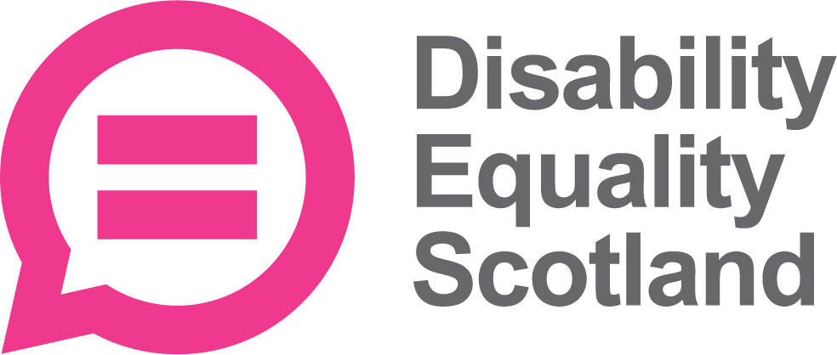

Our Strategic Plan
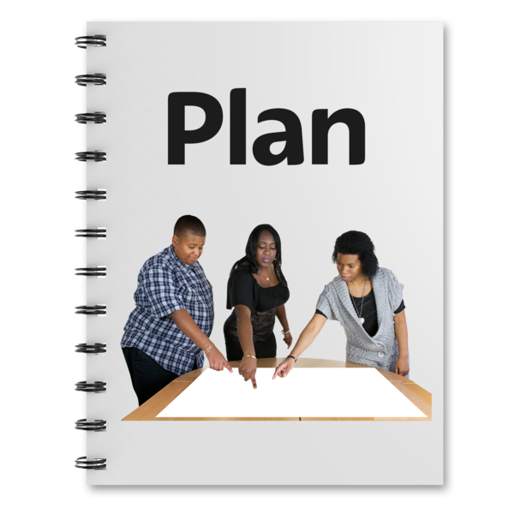
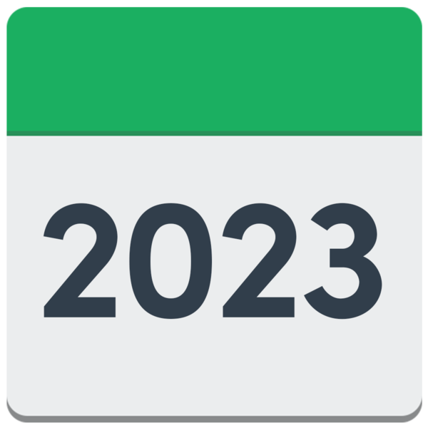
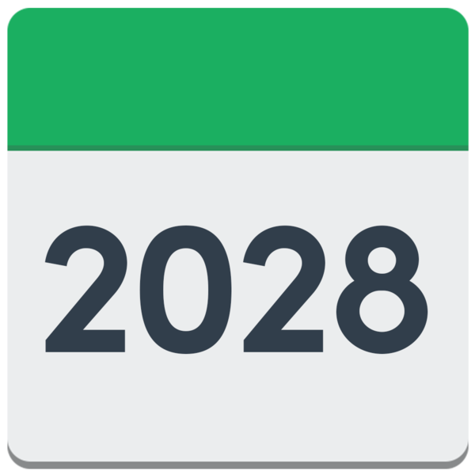
2023 to 2028

Easy Read
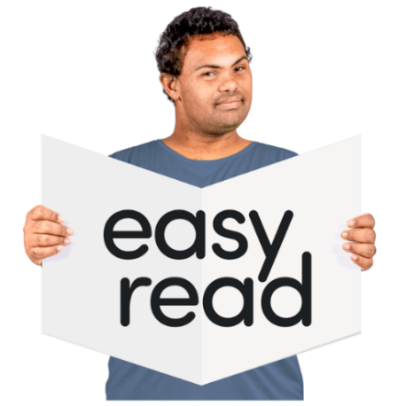


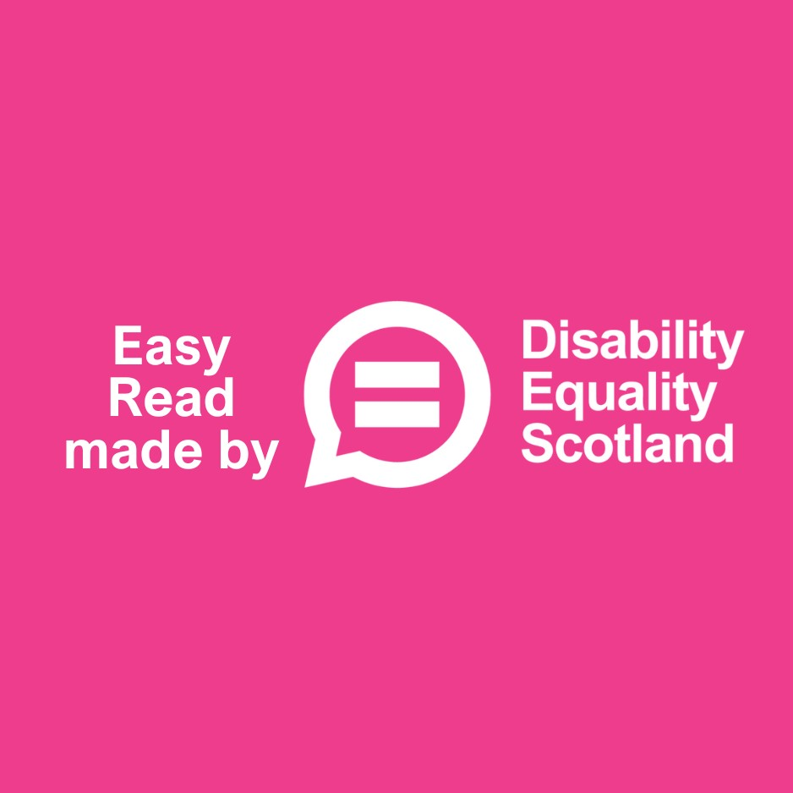

About this Easy Read document

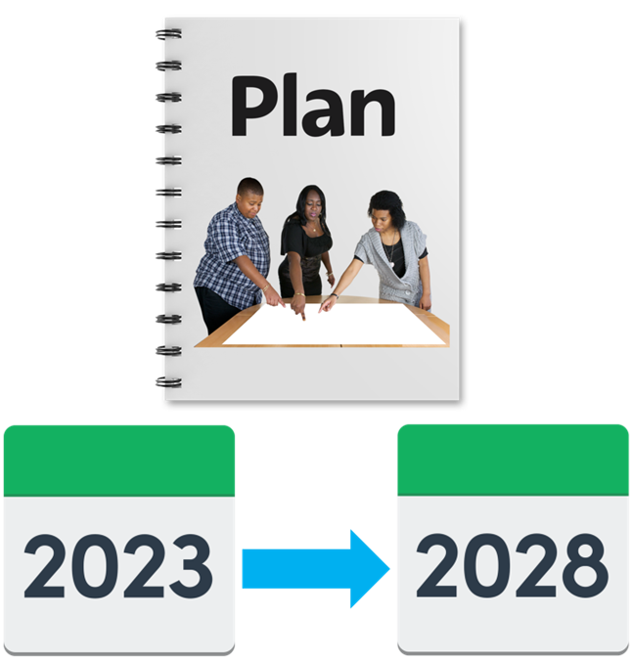 | This Easy Read document will tell you about our special 5 year plan.  It is called our Strategic Plan 2023 to 2028.
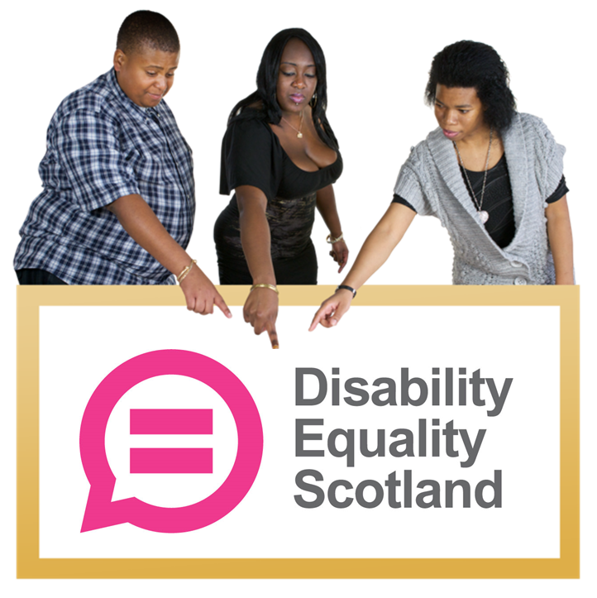 | It tells you about:  - the things we think are important  - the things we plan to do

About Disability Equality Scotland
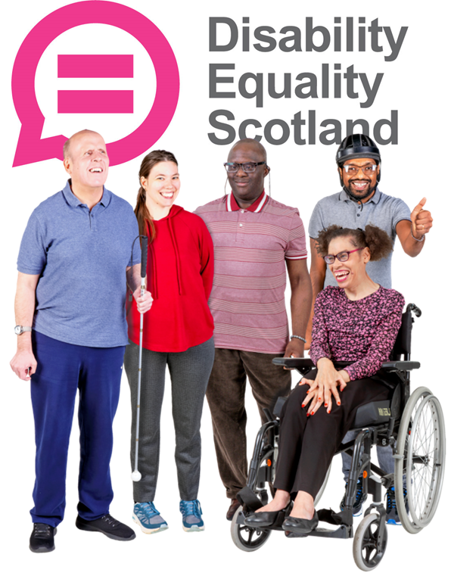 | We are Disability Equality Scotland.  We are a charity that:  - works for disabled people across Scotland  - is led by disabled people
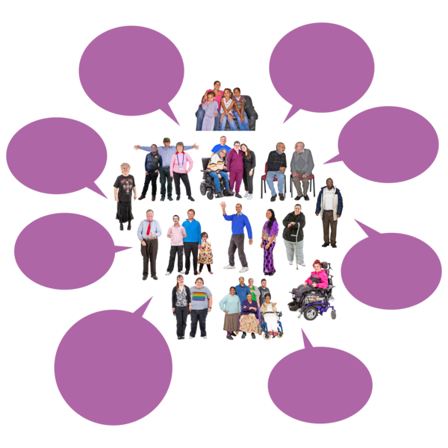 | Disability Equality Scotland has over 1 thousand 4 hundred members.  Some of our members are people.  Some of our members are organisations.

Our Vision and our Mission

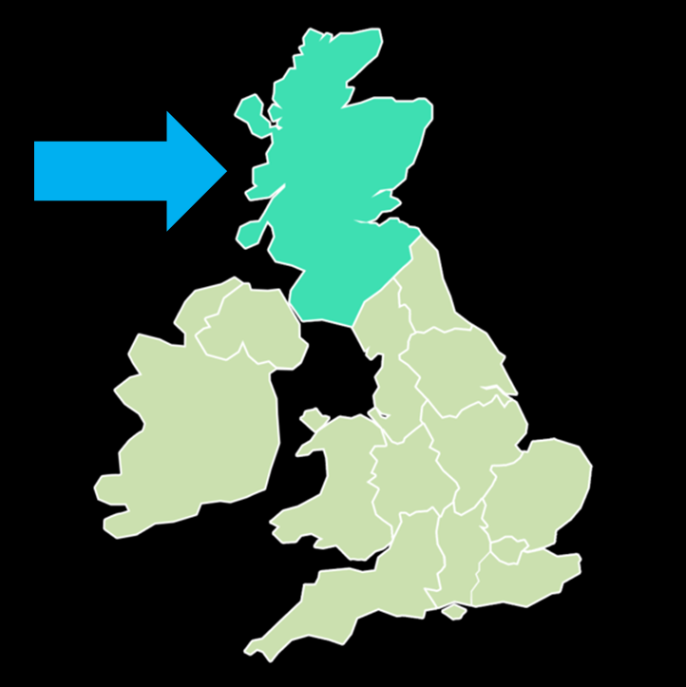 | Our vision means what we want to see happen.
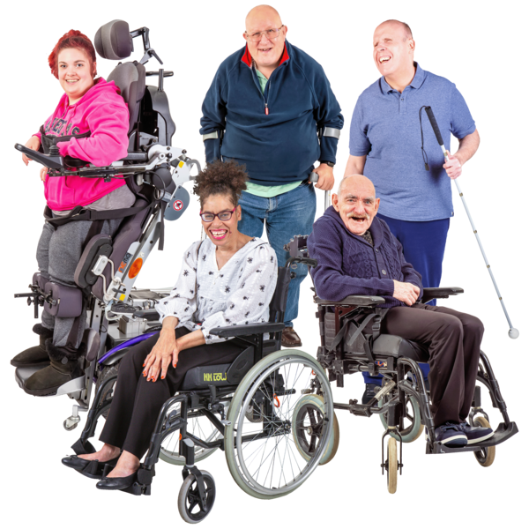 | Our vision is that we see more of these things for disabled people in Scotland:  - equality  - inclusion  - taking part in all parts of life
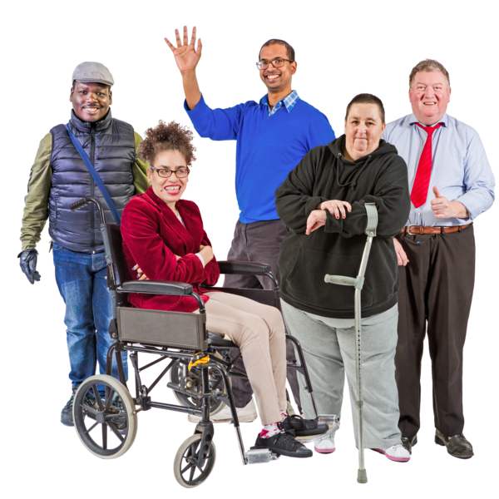 | Equality means treating people fairly and giving people the same choices and chances.
 | Inclusion means making sure that no one is left out.
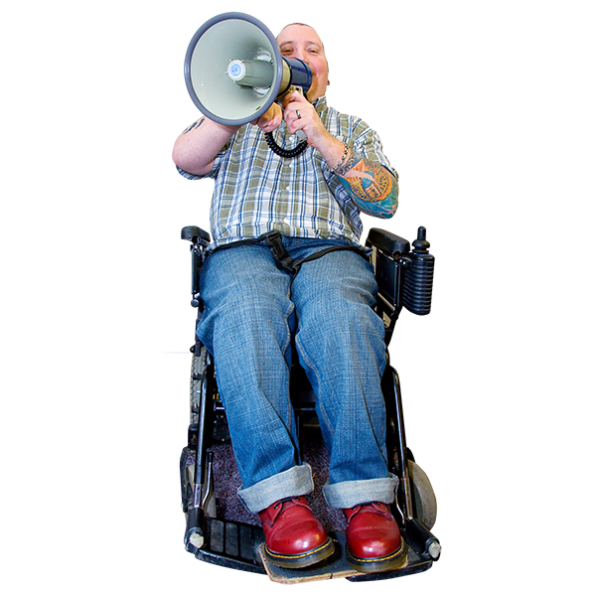 | Our mission means what we want to do.  Our mission is to speak up for disabled people in Scotland.  We want to do this with trust, care and empathy.
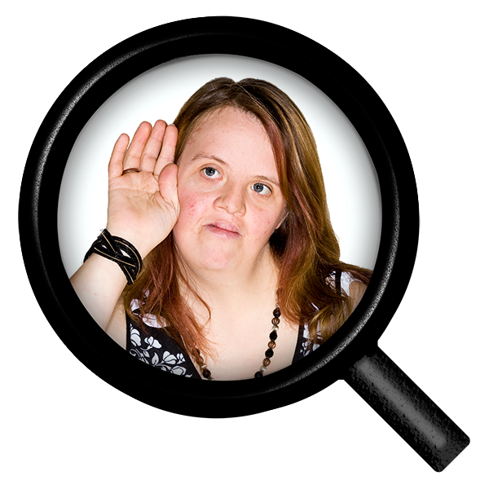 | Empathy means understanding how someone else might be feeling.

Who we work with

 | Disability Equality Scotland works with these 3 different groups.
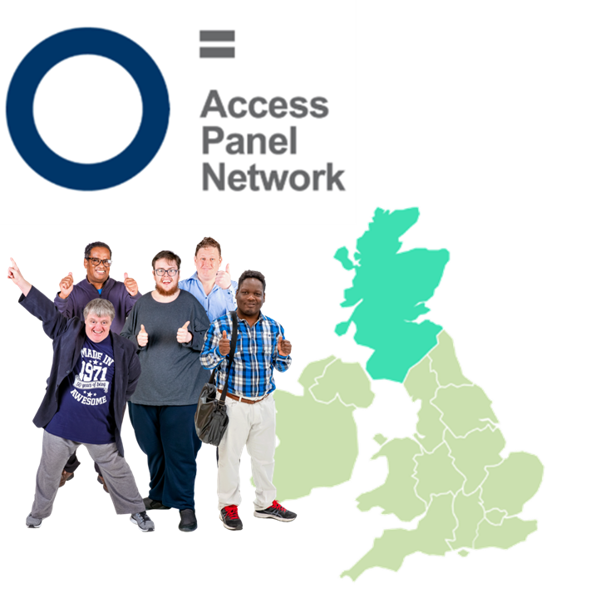 | 1. We work with Access Panels across Scotland.  Access Panels are groups of people who work to make their local areas better for disabled people.
2. We work with our members.

We ask our members what they think. We share their views with organisations.

We look for ways our members can take part in issues that are important to them.

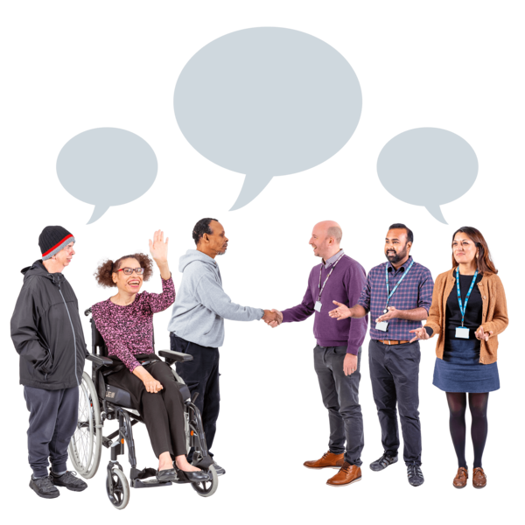 | 3. We work with organisations.  We believe that working with other organisations will make it easier for disabled people to take part in changes.

How we work

3 | Disability Equality Scotland uses 3 key words in all of its work:
 | 1. Positive – we look for ways forward
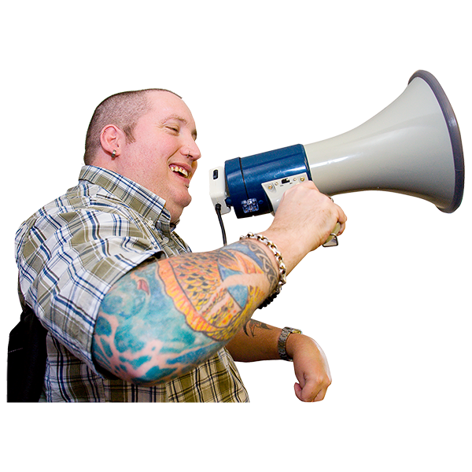 | 2. Promotion – this means we share good things and help the whole of Scotland to understand disabled people’s needs
 | 3. Partners – we work with other organisations to make things better

Our new strategy

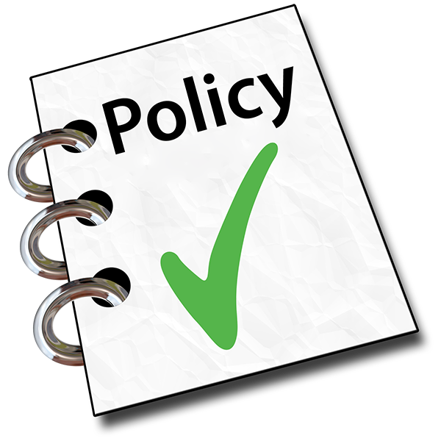 | We want to see more disabled people’s voices being used to change things like policies.  Policies are the written rules for the way things happen.
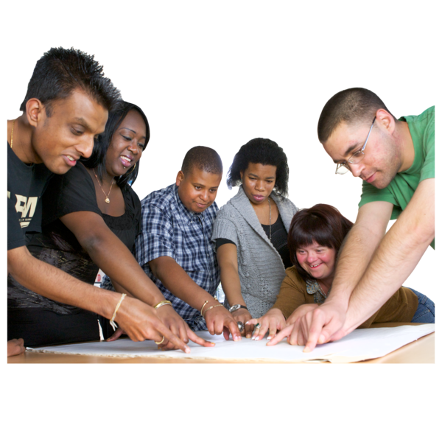 | We want to see support for organisations so that they can make sure everything they plan involves disabled people.
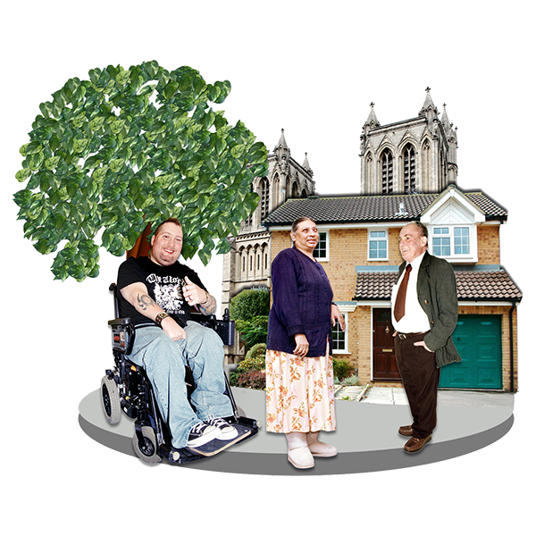 | We want to see disabled people included in all parts of life in Scotland.
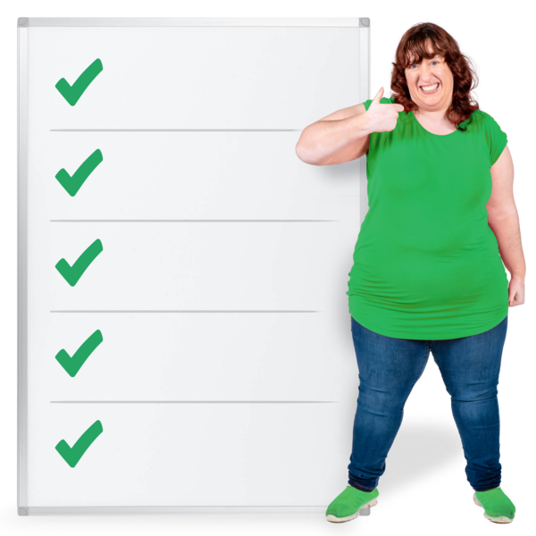 | Disability Equality Scotland plans to make these happen by doing these 5 things:
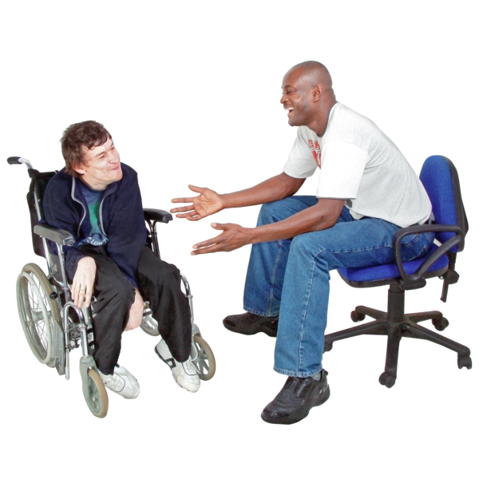 | 1. We will help more disabled people to talk with organisations.  We will share why this is such a good idea.
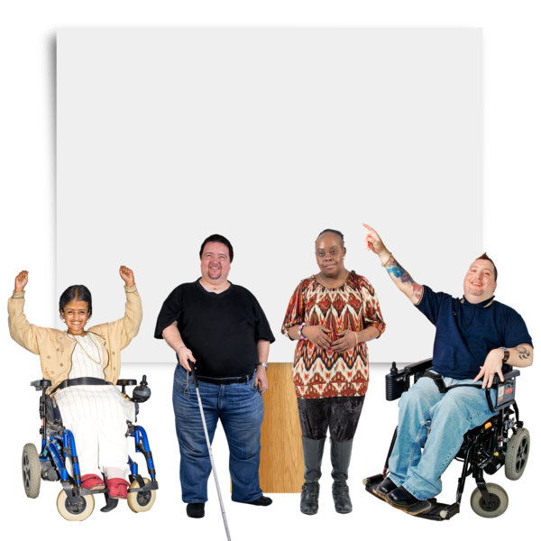 | 2. We will help more people to understand important issues by taking part in campaigns.  A campaign is a way to tell everyone about something important.
 | 3. We will work to get our Access Panels known and we will work with other disability organisations.
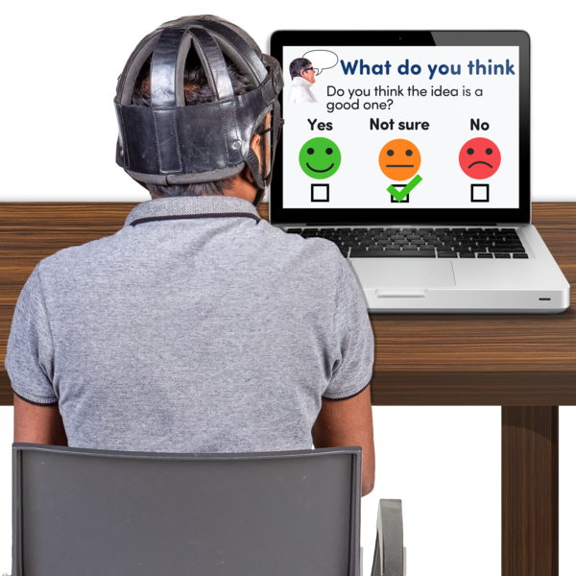 | 4. We will offer lots of different ways to hear our members views.  This will help us to collect together all the things our members think. And share it with organisations.
 | 5. We will look for ways to help the Scottish Government make good changes that help disabled people across Scotland.

Things we will focus our work on

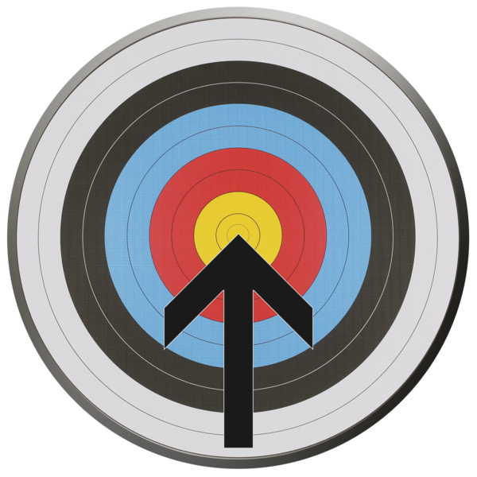 | These focuses are also called Our Priorities.
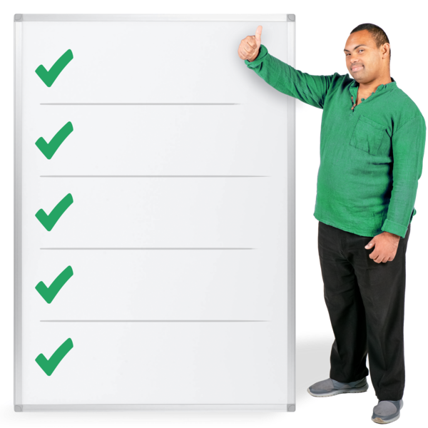 | Disability Equality Scotland has these 6 focuses:
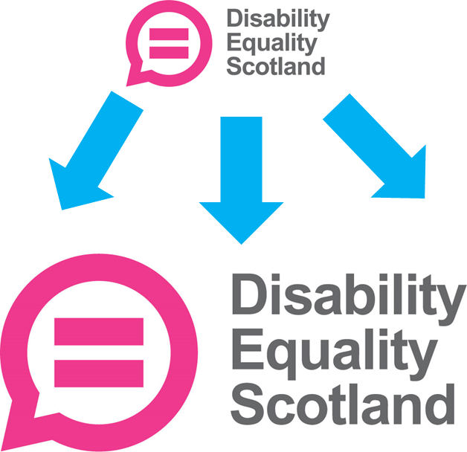 | 1. We want to get stronger as a national disabled persons’ organisation in Scotland.  We want our expert knowledge to be known.
2. We want to grow:

- our member numbers
- how we reach out
- what we write and do
- our funds

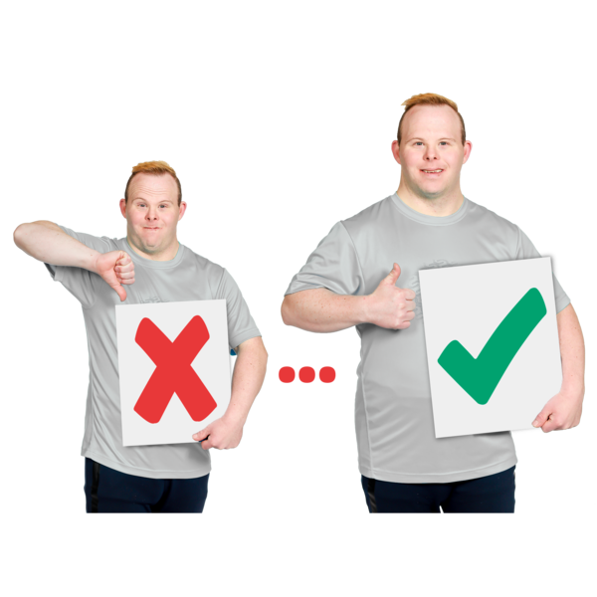 | 3. We want to make these things even better:  - our staff numbers  - our training services  - our Access Panels
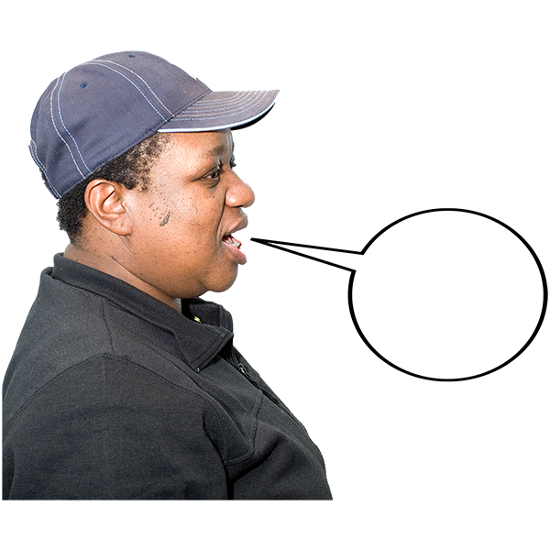 | 4. We want to have more ways for disabled people to join us and share their views with us.
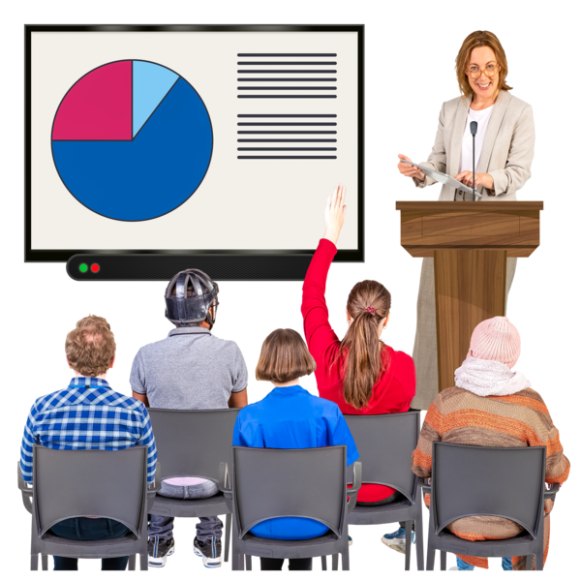 | 5. We want to lead and be confident.  We want to be an excellent organisation for making change happen.
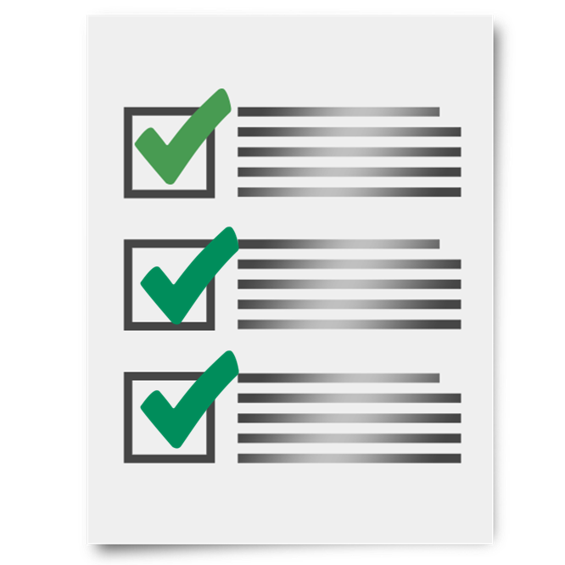 | 6. We want to build a future for Disability Equality Scotland that:  - is fairer for staff  - is better for the environment  - has good funding and savings

Finding out more

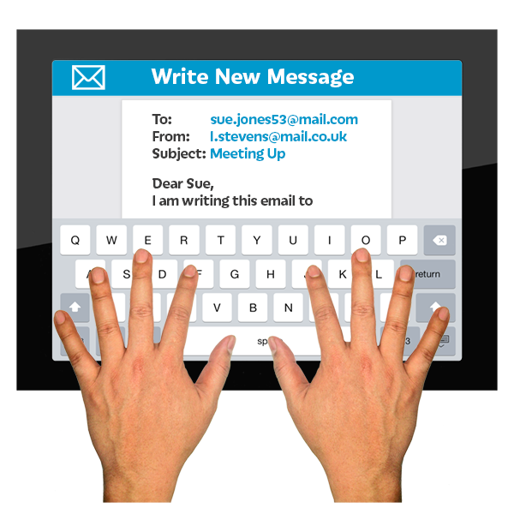 | If you want to know more about our Strategic Plan 2023 to 2028, please email  admin@disabilityequality.scot

