Disability Equality Scotland
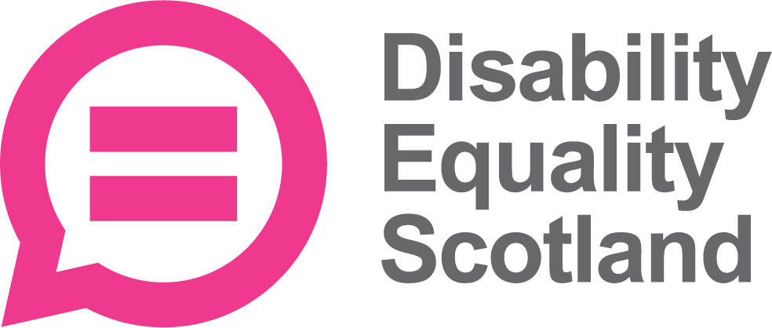

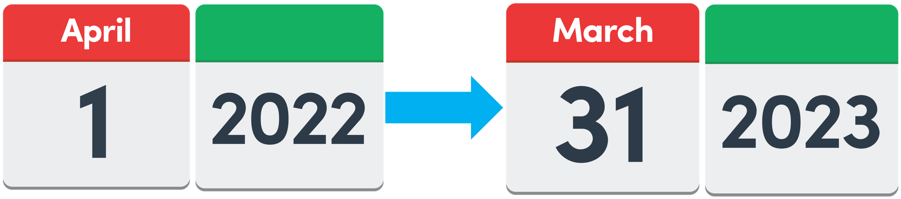
Our work from 1 April 2022 to 31 March 2023

Easy Read

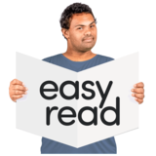

Copyright images © Photosymbols. Prepared by Disability Equality Scotland 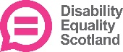

What this Easy Read document is about

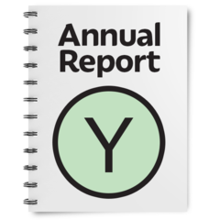 | This is our Annual Report.  It tells you about our work between 1 April 2022 and 31 March 2023.
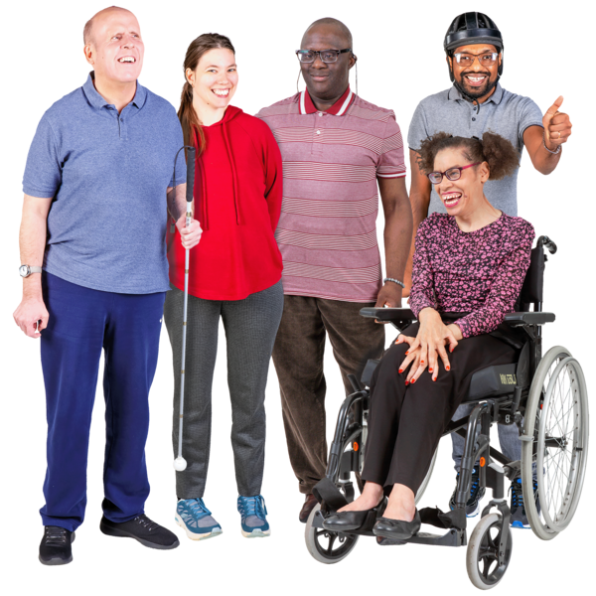 | Disability Equality Scotland is a charity that works to make life better for disabled people in Scotland.  We are also called DES for short.

What we want
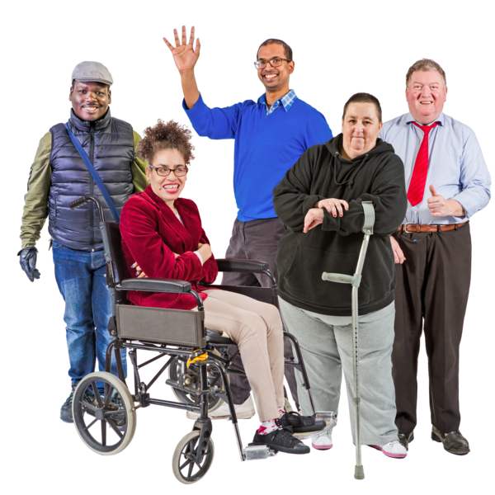 | Disability Equality Scotland wants these things for disabled people:  - equality – this means fairness and help to get the same chances  - inclusion – this means not leaving anyone out  - joining in with all parts of life  This is our vision – it’s what we want to happen.
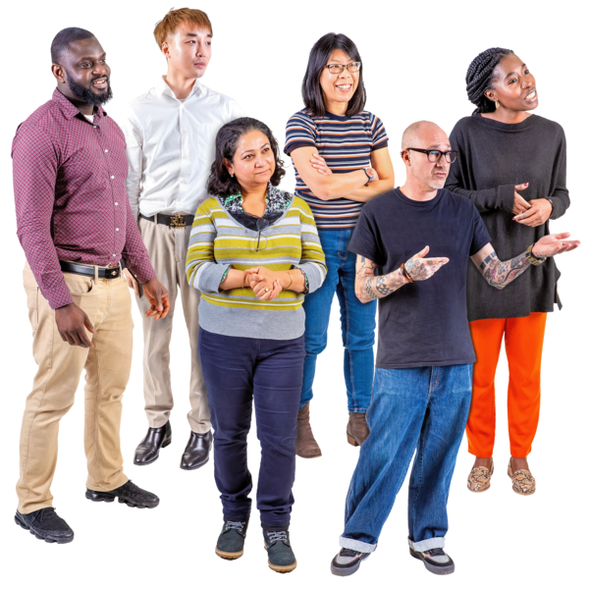 | We want every disabled person in Scotland to know they have:  - a voice – we will speak up for them  - trust  - care  - understanding and kindness  This is our mission – it’s what we are trying to do.

Our 8 aims this year

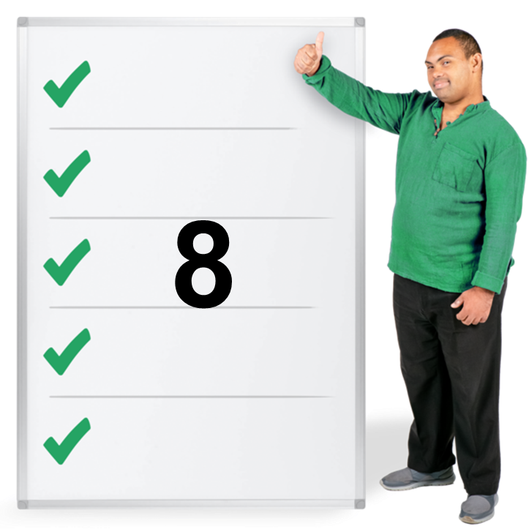 | This year we have had 8 aims.  Aims are our goals – what we want to get done.
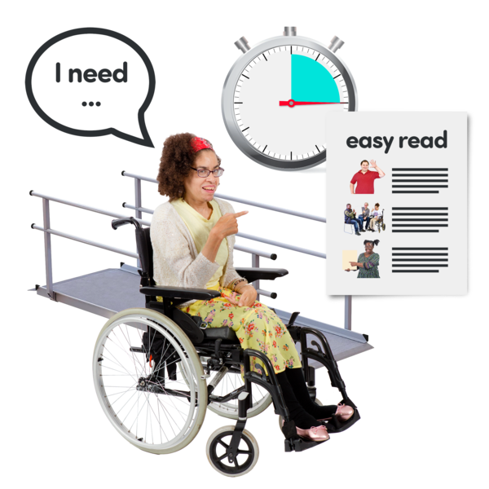 | 1. To make is easier and better for disabled people to join all parts of life.
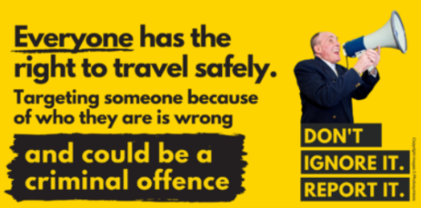 | 2. To help more people understand disability hate crime.
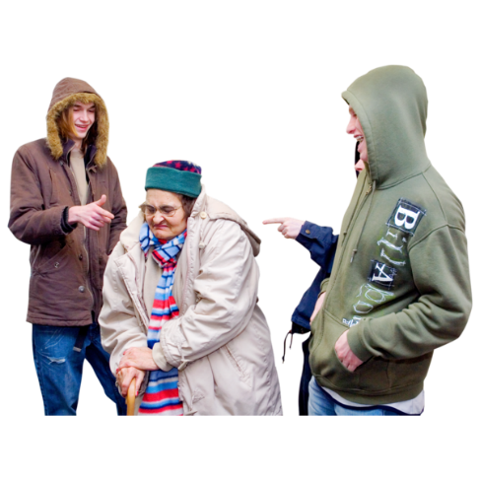 | A hate crime is when someone does something to hurt you because of who you are or who they think you are.  The criminal thinks you are different from them and hates you because of that difference.
 | 3. To help Access Panels chat with each other and share information.
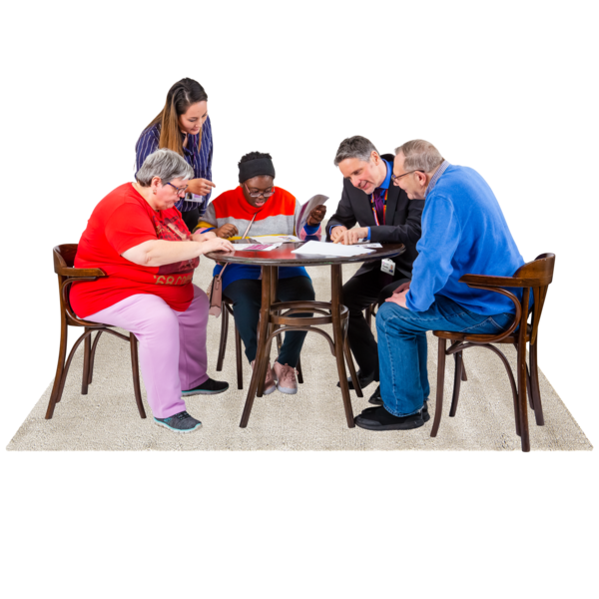 | 4. To help more people in our Access Panels to understand:  - access – getting to something  - equality  - inclusion
 | 5. To give people who plan and design very good guidance for making places like buildings easy for disabled people to use.
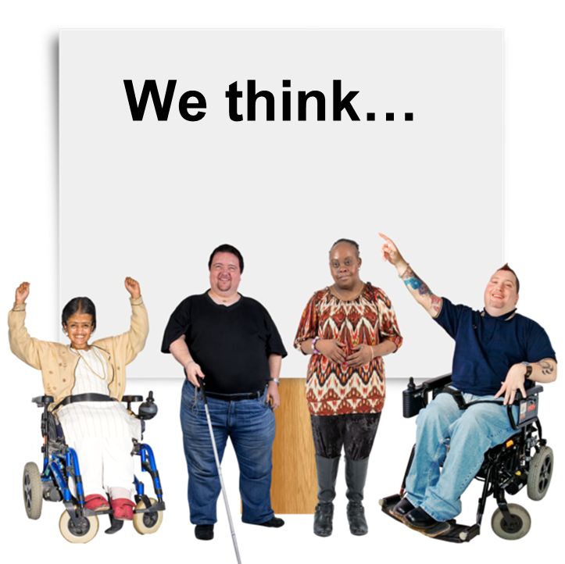 | 6. To help disabled people to have their thoughts heard about accessible transport.
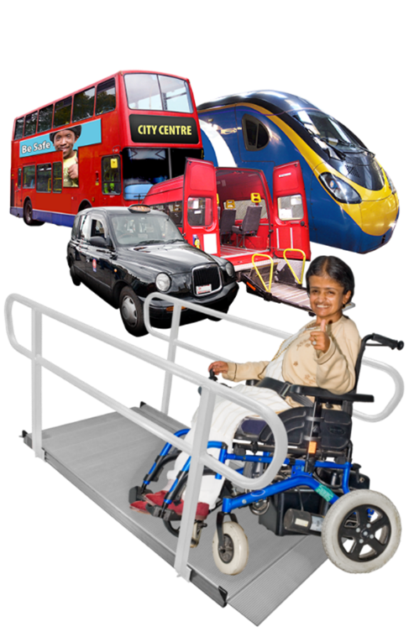 | Accessible travel is when transport is made so that everyone can use it.  This means things like pathways and toilets too.
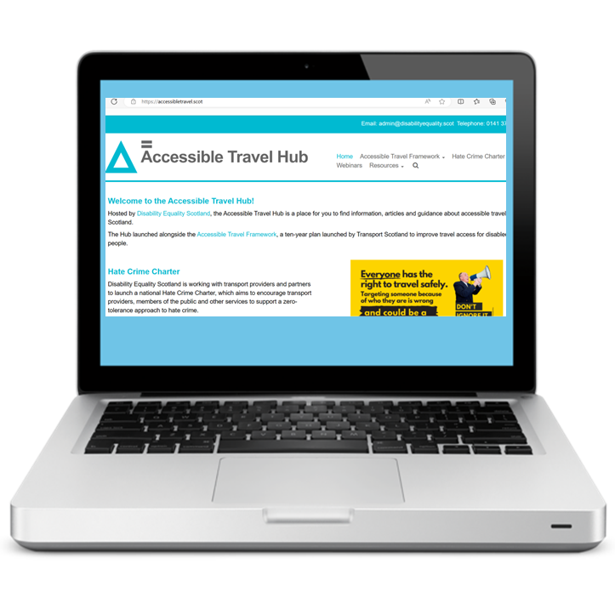 | 7. To make sure that everyone can get our guidance about accessible travel from our Accessible Travel Hub website.
 | 8. To help different travel organisations to work together to stop hate crime happening in Scotland.

Members

People who join Disability Equality Scotland are our members.

We often ask our members what they think about lots of different things.

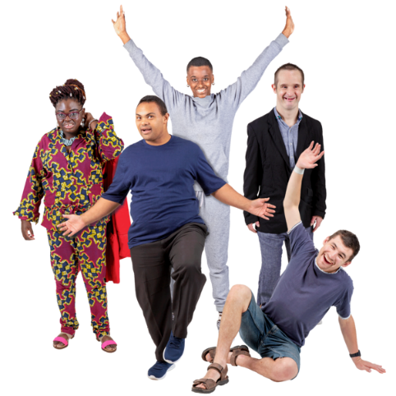 | This year we had nearly 80 new members joining us.  In total we have nearly 1 thousand 5 hundred members.
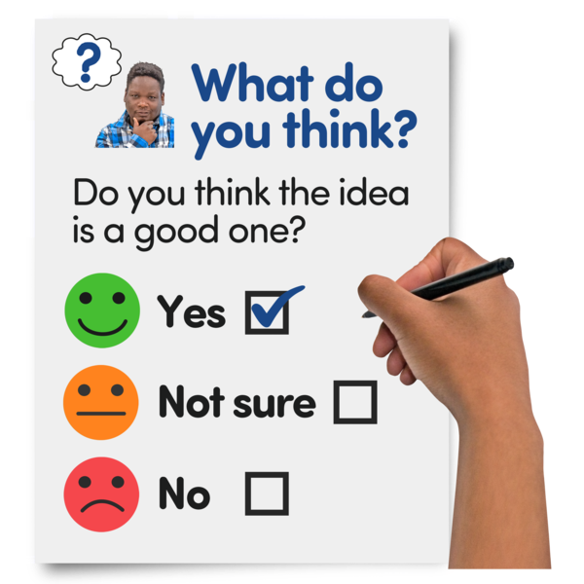 | In August 2022 we sent our members a questionnaire to see how we can be better.
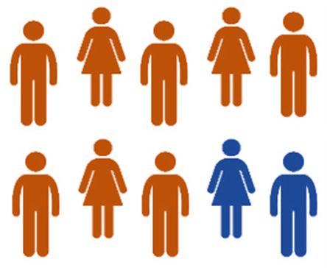 | We found out lots of helpful things.  For example 8 out of every 10 members said they feel they can tell us what they think about issues.

Our newsletters, magazine and polls
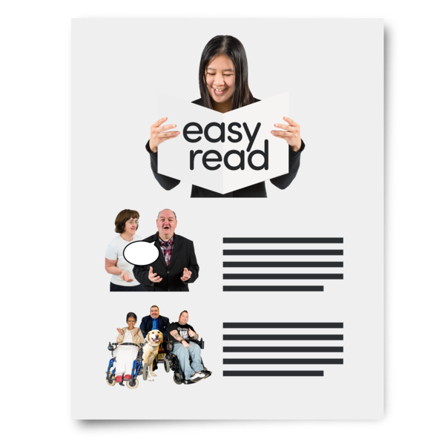 | Every month we send a newsletter to our members.  This year we worked with lots of other organisations to get the right information to our members.  For example, Scottish Fire and Rescue and NHS 24.
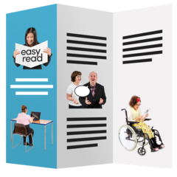 | We also sent out our members magazine, called Open Door.
We asked our members what they thought about new issues.

We did this with questions called polls.

For example, we had polls about the Adult Disability Payment and about loneliness.

Face Covering Exemption Card campaign

 | During the COVID-19 pandemic, the government asked everyone to wear face coverings.
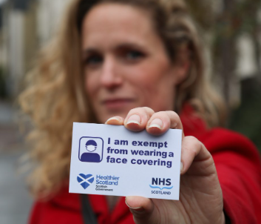 | But not everyone can wear a face covering.  Some people are exempt from wearing them.
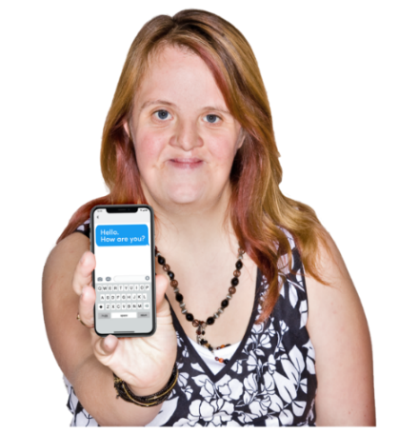   | The Scottish Government asked Disability Equality Scotland to organise special cards – called exemption cards.  During this year, more than 9 thousand cards were downloaded from our website www.exempt.scot

Webinars
 | Webinars are online meetings where information is shared and talked about.  This year we organised 5 webinars about disability.

Our Hubs
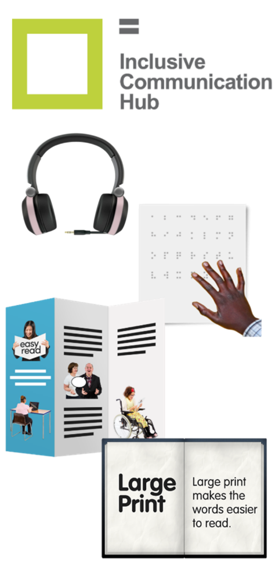 | We have a website called our Inclusive Communication Hub.  Inclusive Communication means offering information in ways like:  - audio – to hear  - braille  - Easy Read  - large print
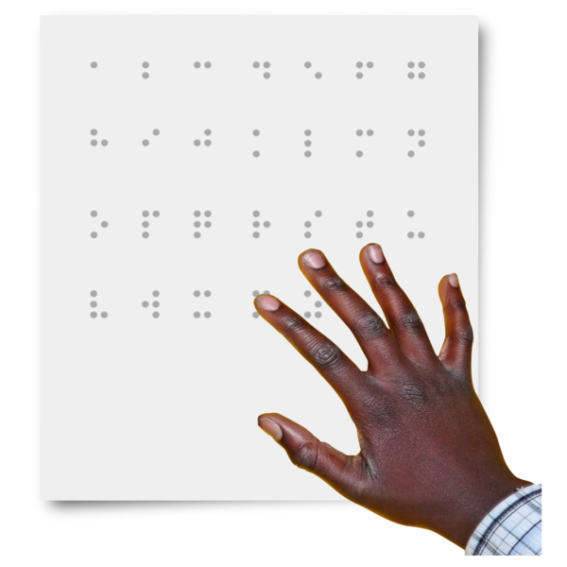 | On 4 January 2023 it was World Braille Day.  Braille means patterns of raised dots that can be felt and understood.
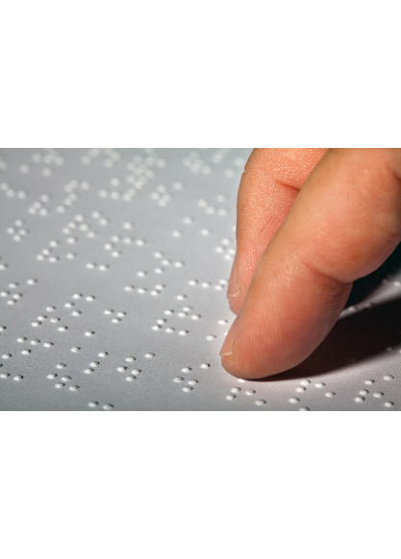  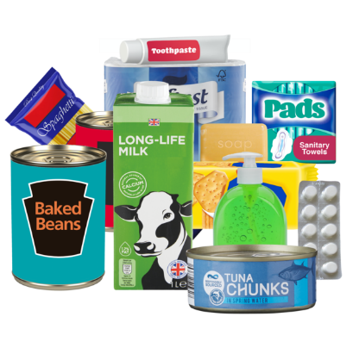 | We started our Braille Labelling campaign.  We want braille labels on food packaging.  We started a petition to the Scottish Government.  A petition is a list of signatures from people who agree about the change.
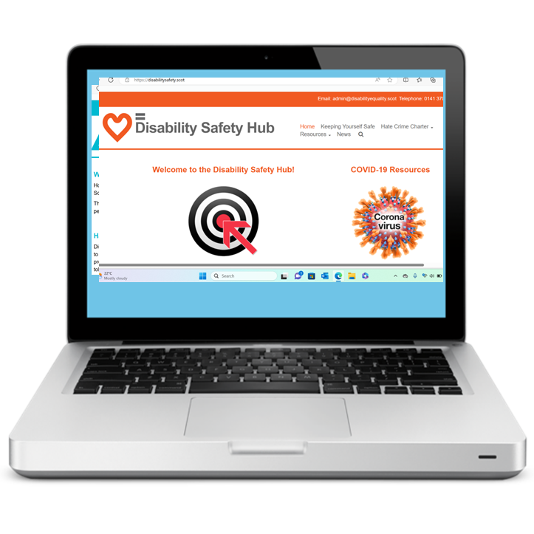 | We have a website called our Disability Safety Hub.
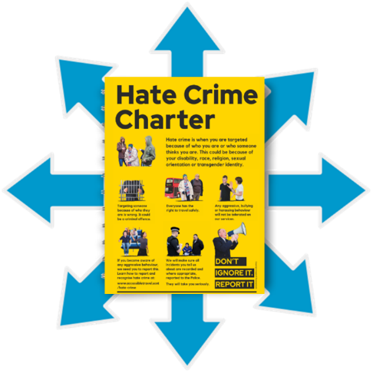 | We want this Hub to:  - tell more people about disability hate crime  - help more people report hate crime
 | We have a website called our Accessible Travel Hub.
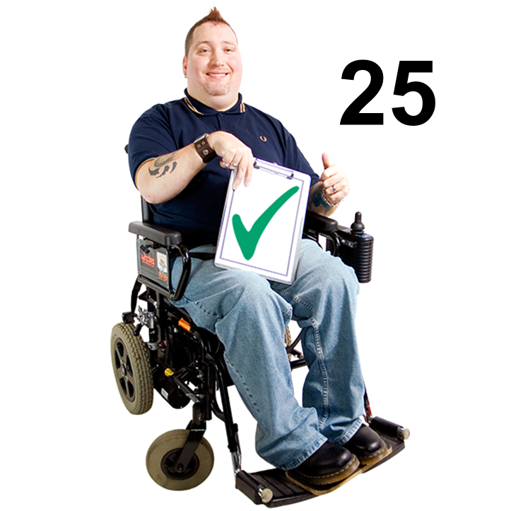 | We now have 25 organisations listed on the Hub who all support an agreement called the Hate Crime Charter.

Our Access Panels

 | Access Panels are local groups of volunteers who work to make their area better for disabled people.
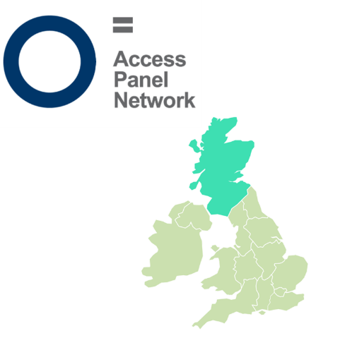 | We have 39 Access Panels all across Scotland.
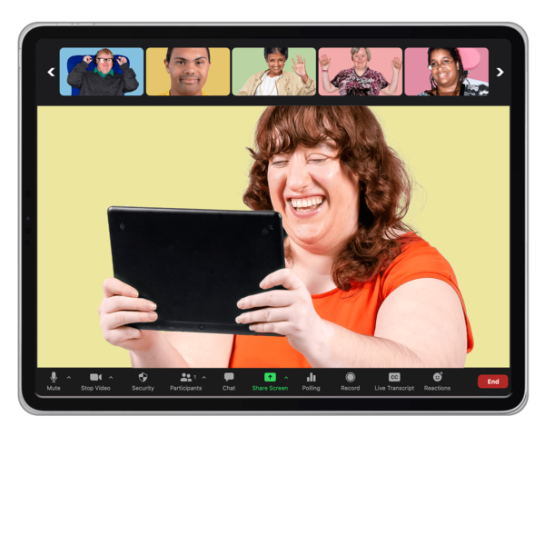 | Lots more Access Panel members came to our online conference.  They told us it was easier meeting online because there were no long journeys.
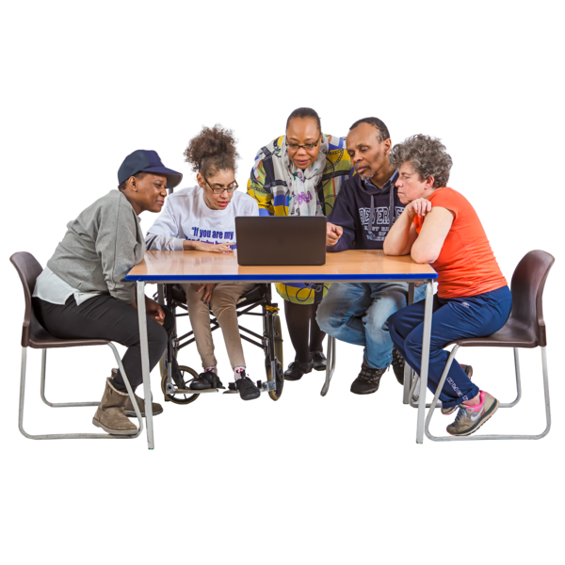 | We started a new Access Panel Hub this year.  It lets Access Panel members:  - ask questions  - share information  - feel connected
 | We have money in our Access Panel Grant.  More of this money has been spent on computer equipment and online meetings this year.

Easy Read
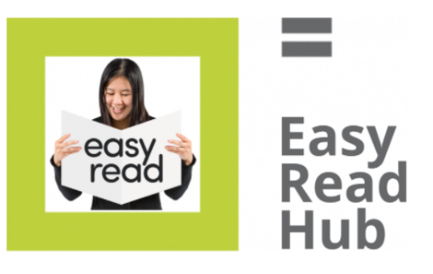 | We write Easy Read documents.
 | This year we wrote over 1 hundred and 30 Easy Read documents.
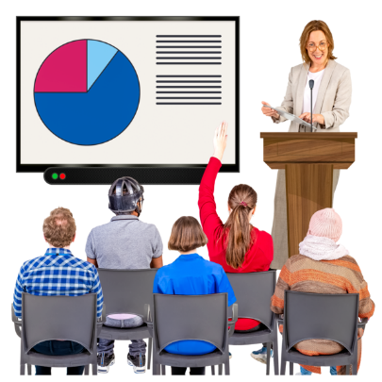 | We also train other people how to write Easy Read documents.  This year we led 48 Easy Read courses across the UK.
 | We have also got our Easy Read course agreed as a CPD course.  CPD means Continuing Professional Development.

Our Staff and our Structure
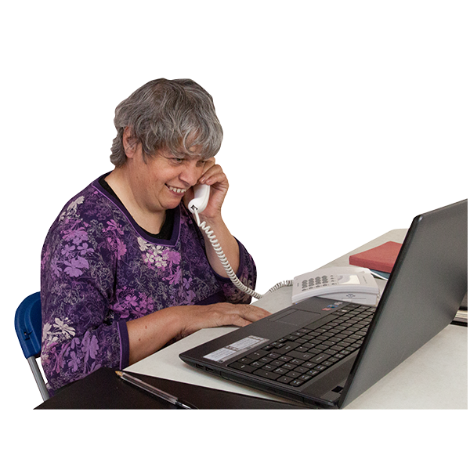 | Our staff have worked hard in the office and from home this year.
 | We are a charity and we have Board Members who have skills in things like:  - lived experience as a disabled person  - leadership  - planning  - risks
 | Our Convener leads the Board Members.  Their name is Kayla-Megan Burns.
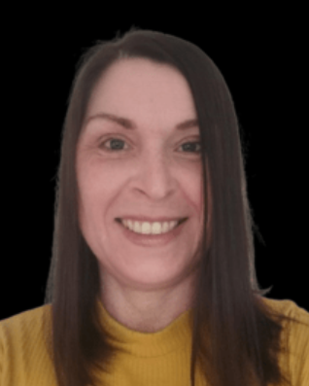 | Our Chief Executive Officer leads the charity.  Her name is Lyn Pornaro.

Our Funding and our Sponsors
 | We have had 4 organisations giving us money this year.
 | 1. Equality and Human Rights Fund from Inspiring Scotland  This money has helped us with our work on things like hate crime and our Access Panels.
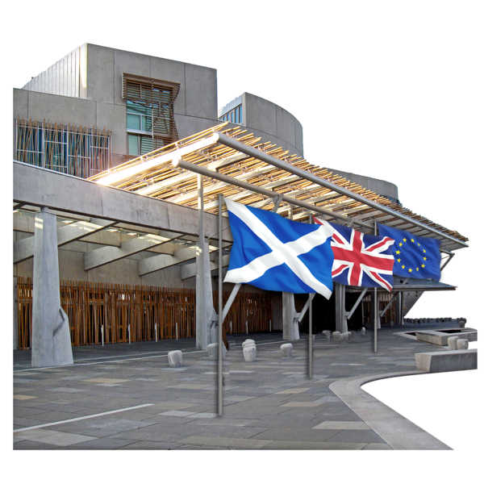 | 2. Section 10 fund from the Scottish Government  This money has helped us with our work with our Access Panels.
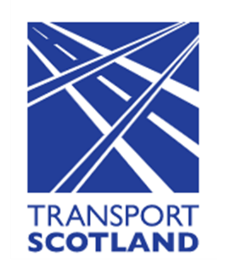 | 3. Accessible Transport for Disabled People Grant Funding from Transport Scotland  This money has helped us get disabled people’s thoughts heard on accessible transport.
4. Exemption Card Campaign funding from the Scottish Government

This money has helped us run a phone line and post exemption cards out.

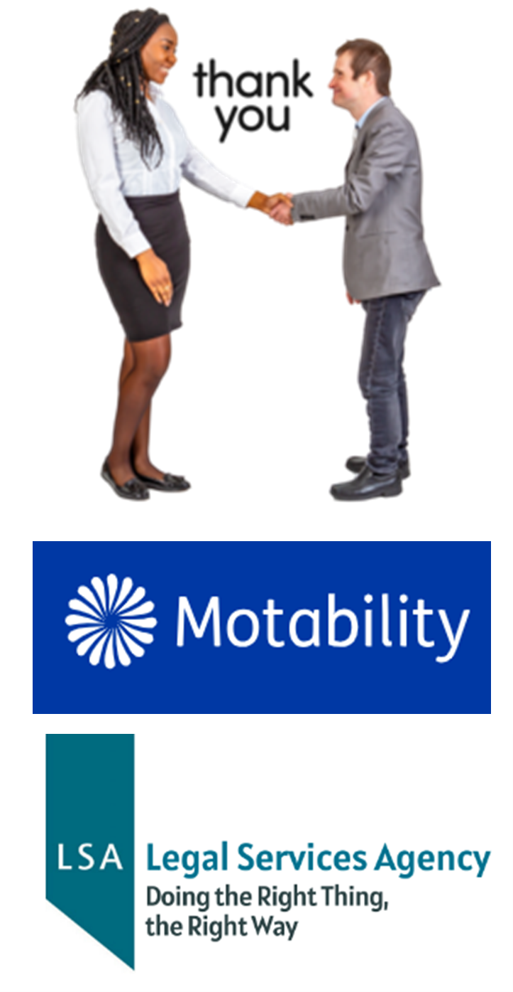 | Our sponsors this year have been:  - Motability  - Legal Services Agency  We thank them for their support.

