Disability Equality Scotland
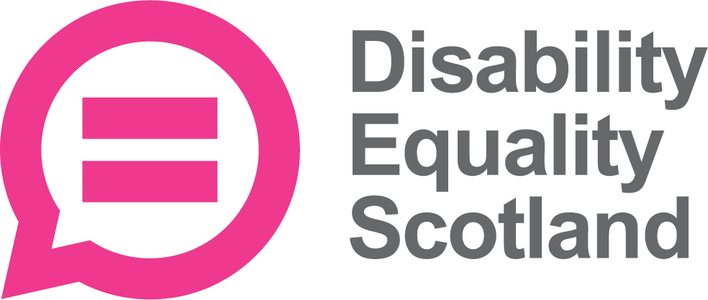

Equality Form
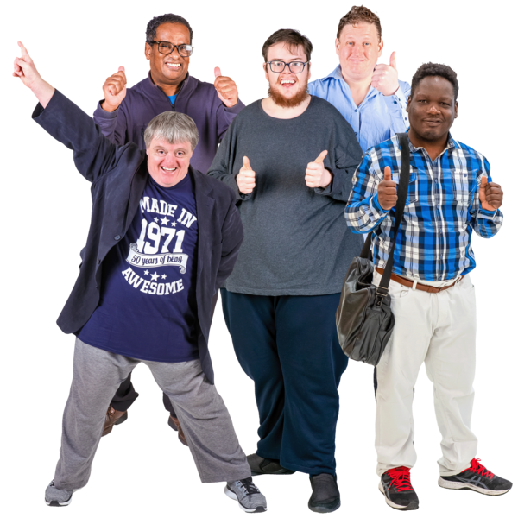

Easy Read
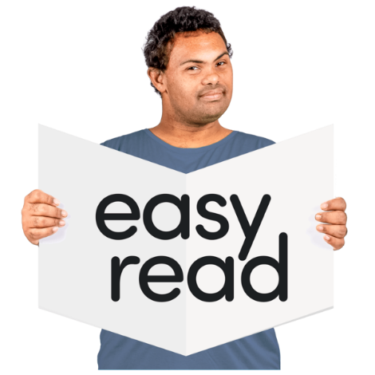

Copyright images © Photosymbols. Prepared by Disability Equality Scotland 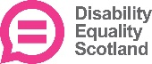
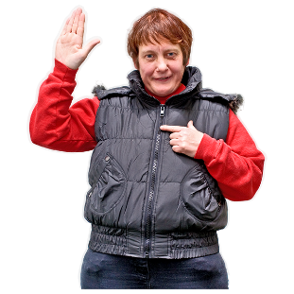 | Disability Equality Scotland want to ask some questions about you.  It helps us check if everyone has the chance to get a job with us.
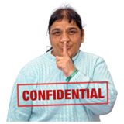 | Your information is private.  We will not share your information with anyone else.
 | You don’t have to answer any of the questions if don’t want to.
Tick the box of the answer you agree with and a tick will appear. √

If you change your mind you can click on it again to untick it.

Disability
Do you have a physical or mental health condition or illness that is lasting a year or more?
Tick 1 box.
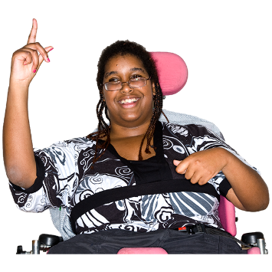 |  |   Yes ☐    No ☐  ? I don’t know ☐
Does it affect you in any of these ways?
Tick as many boxes as you need to.
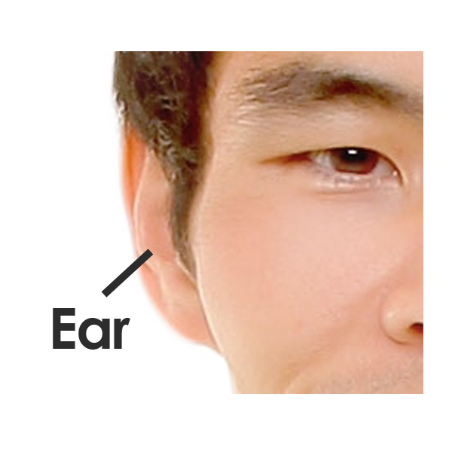  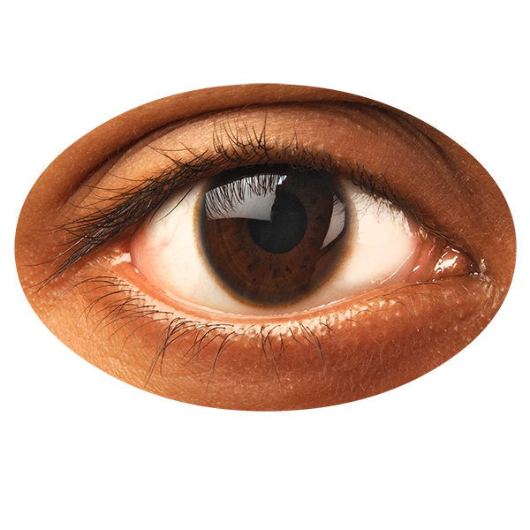 |  | ☐ Sight (for example blindness or partial sight)  ☐ Hearing (for example deafness or partial hearing)
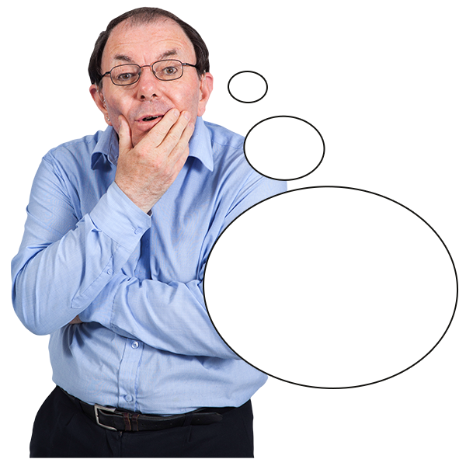  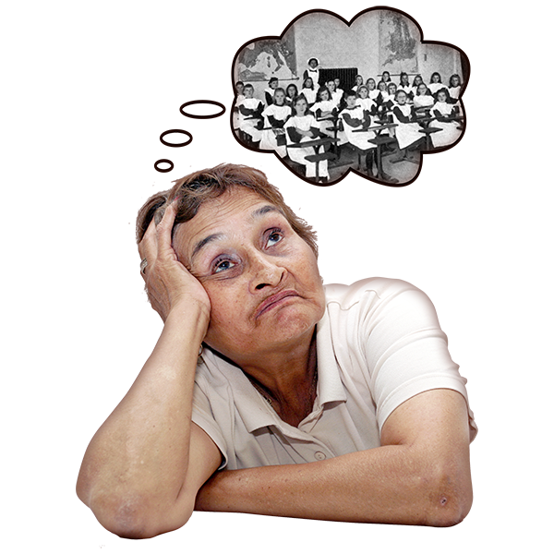  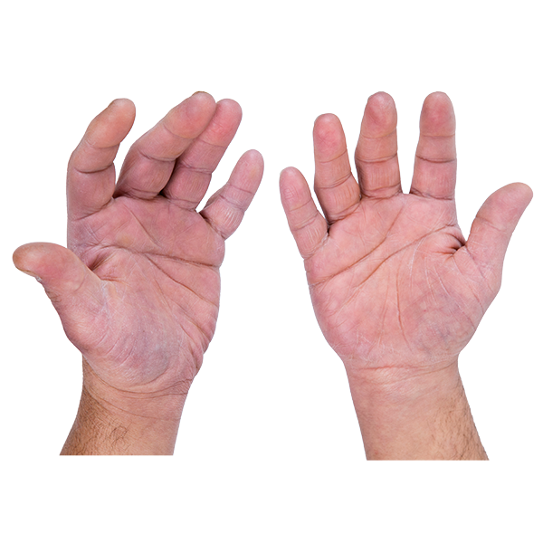  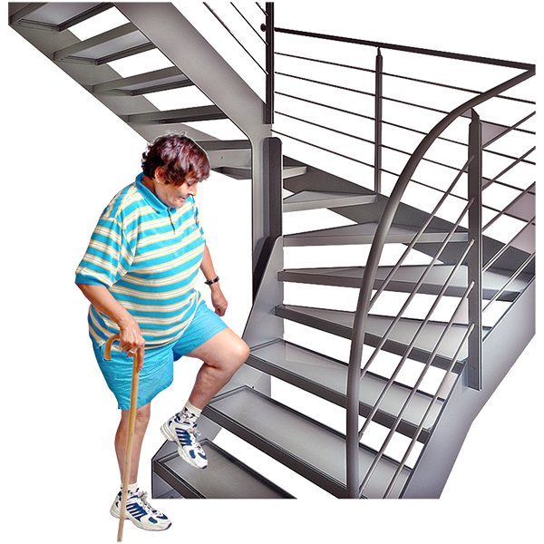 |  | ☐ Moving around (for example walking short distances or climbing stairs)  ☐ Using your hands (for example lifting or carrying objects, using a keyboard)  ☐ Learning, understanding or concentrating  ☐ Remembering things
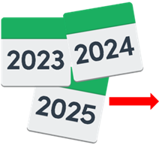  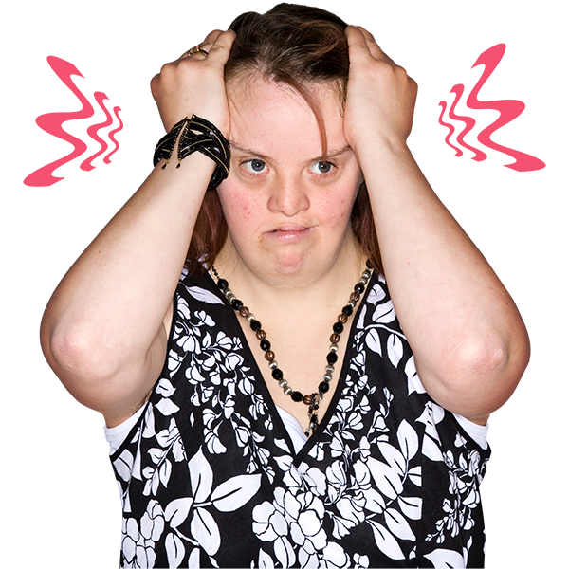  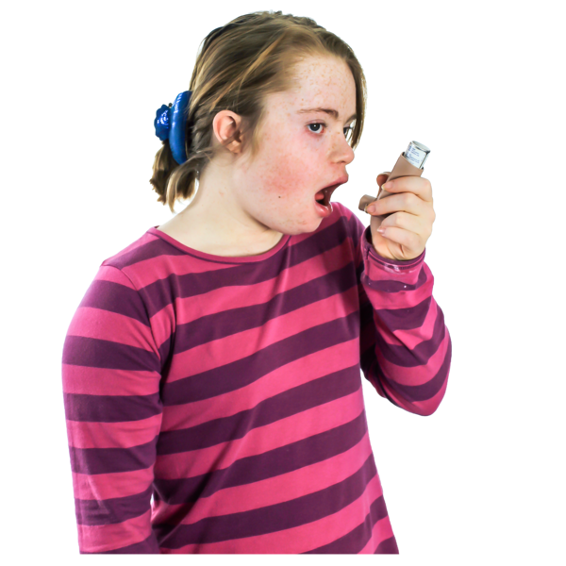  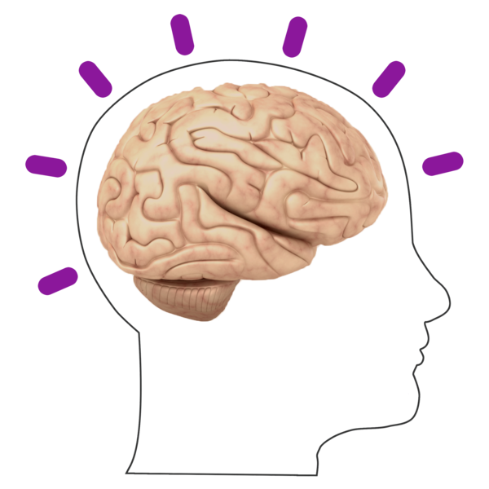 |  | ☐ Mental health  ☐ A long-term illness (such as diabetes, cancer, HIV, heart disease or epilepsy)  ☐ Breathing, tiredness or being able to do physical things for more than a short time.  ☐ Affecting the way you behave, or how you cope in social situations (for example autism, attention deficit disorder or Asperger’s syndrome)  ☐ Other – please write it here:  ☐ None of the above.
How would you describe your gender?

Tick the box that best describes you.
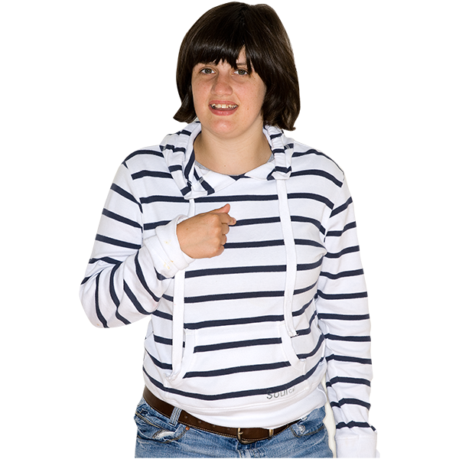  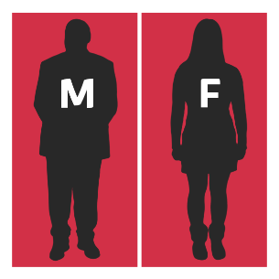 |  | Female ☐  Male ☐  Non binary ☐  Another way to describe me . ☐  I don’t want to say ☐
How would you describe your sexual orientation?
Sexual orientation means what kinds of people you love or have sexual or romantic feelings about.
Tick the box that best describes you.
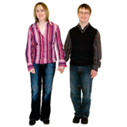 |  | Heterosexual or Straight.  This is where you are attracted to a person of the opposite gender.  ☐
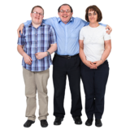 |  | Bi or bisexual. This is where you are attracted to both men and women.  ☐
 |  | Gay or lesbian. This is where you are attracted to a person of the same gender.  ☐
I don’t want to tell you.
☐
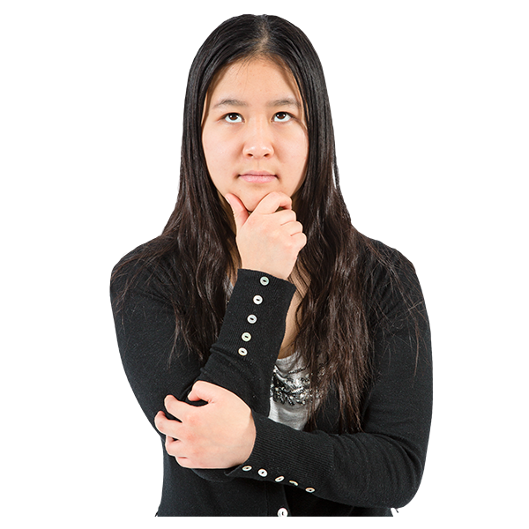 |  | I would describe it in another way.  ☐
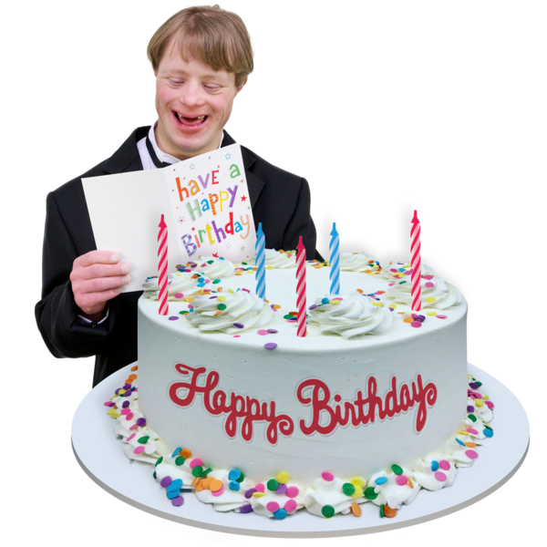 |  | How old are you?  Tell us your age on your last birthday.  Write it here:
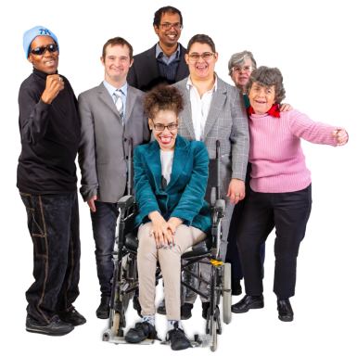 |  | How would you describe your ethnicity?  Ethnicity is the word we use to describe our background.  People from an ethnic group might have the same language, culture or religion.  Tick the box that best describes you.

White
☐ English
☐ Welsh
☐ Scottish
☐ Northern Irish
☐ Irish
☐ British
☐ Gypsy or Traveller
☐ I don’t want to say
☐ Other White background
Mixed or multiple ethnic groups:
☐ White and Black Caribbean
☐ White and Black African
☐ White and Black Asian
☐ I don’t want to say
☐ Any other mixed ethnic background. Please write it here:

Asian, Asian Scottish or Asian British
☐ Pakistani, Pakistani Scottish or Pakistani British
☐ Bangladeshi, Bangladeshi Scottish or Bangladeshi British
☐ Indian, Indian Scottish or Indian British
☐ Chinese, Chinese Scottish or Chinese British
☐ I don’t want to say
☐ Other Asian background. Please write it here:

Black, African, Caribbean and Black British
☐ African
☐ Caribbean
☐ I don’t want to say
☐ Other, please write it here:

Other ethnic group
☐ Arab
☐ I don’t want to say
☐ Other ethnic background
Please write it here:

Do you have a religion?
A religion is a set of beliefs that some people have. There are many different religions, each with a different set of beliefs. Tick 1 box that describes your beliefs.
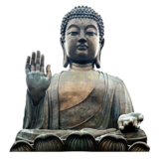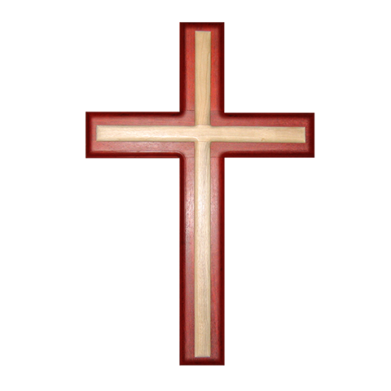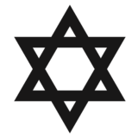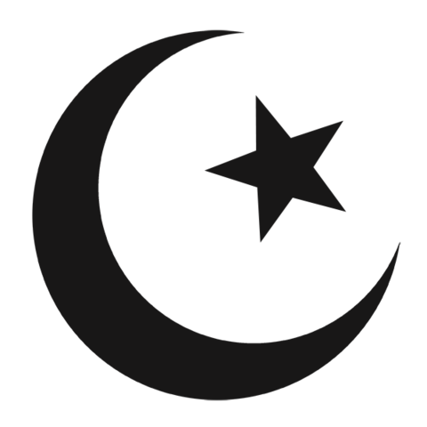
☐ No religion
☐ Christian – Church of Scotland
☐ Christian – Roman Catholic
☐ Christian – Other denomination
☐ Muslim
☐ Buddhist
☐ Sikh
☐ Jewish
☐ Hindu
☐ Pagan
☐ I don’t want to say
☐ Other - please write it here:

 | Please save your answers.  Send this form with your application to:  recruitment@disabilityequality.scot  Lyn Pornaro  Chief Executive Officer  Disability Equality Scotland

Copyright images © Photosymbols. Prepared by Disability Equality Scotland

