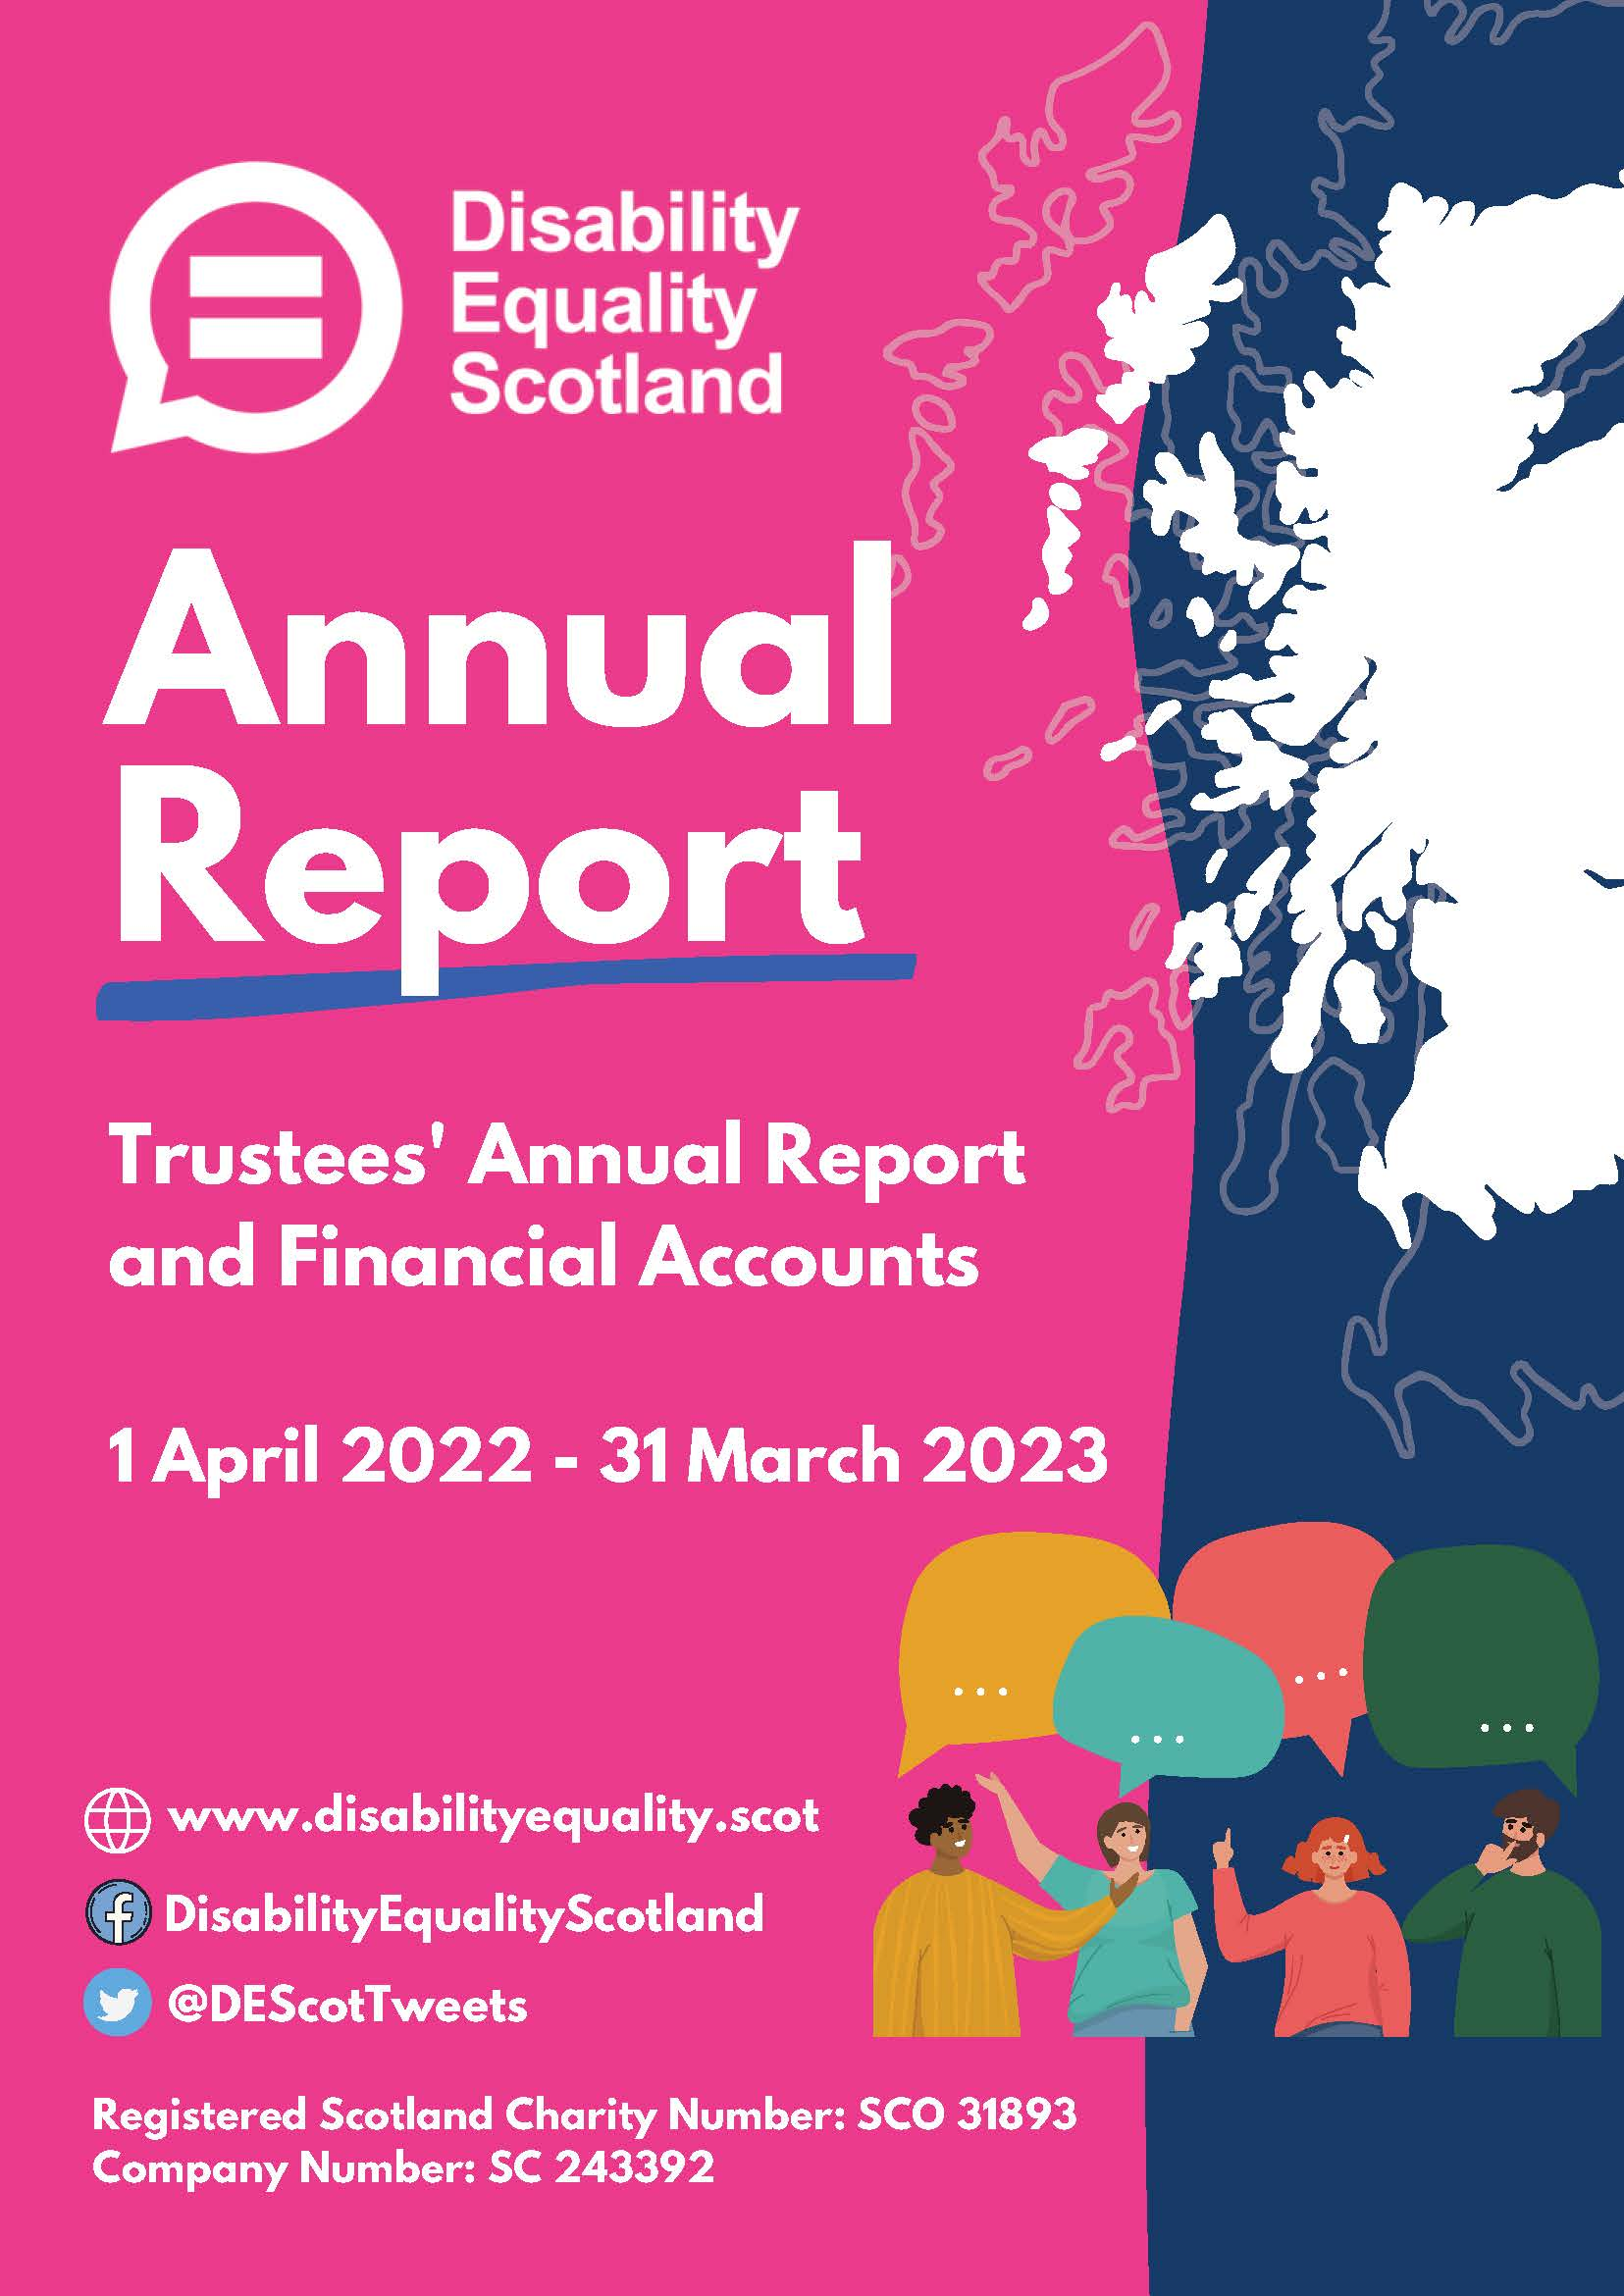

Contents

Page
Introduction from the Convener and
Chief Executive 3 to 5
Report of the trustees 6 to 25
Summary Presentation of Financial Accounts 26 to 28

Introduction from the Convener and
Chief Executive
A Year of Change
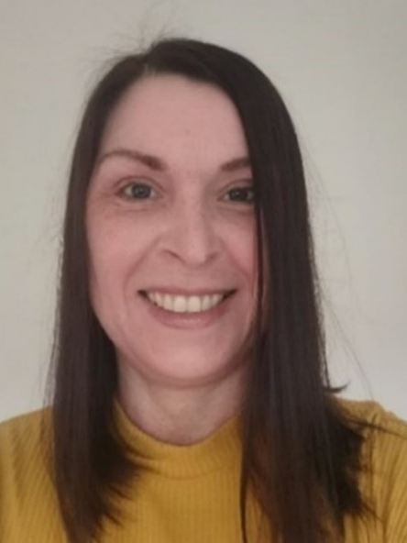

During this last year, Disability Equality Scotland has changed internally in what feels like a 360° turnaround. New staff internally, and new Board members at the helm. Yet we have continued to listen to our members and strengthened the alignment of our work to our aims, vision and mission.
While we might live in an uncertain world, there are some things that Disability Equality Scotland can rely on, notably our members and Access Panels who continue to champion access, inclusion and equality for all.
We have taken significant steps to raise awareness and help grow Disability Equality Scotland. We have achieved this with interviews on BBC radio and ITV Borders News. We continue to identify our members’ priority areas to focus on going forward.
Taking forward the views from Weekly Polls
Our weekly polls enable us to engage with a wide number of disabled people. This helps to gather their views and feed into various Scottish Government consultations, our Stakeholders’ policy making and much more. This ensures that disabled people feel included and that their views are heard and valued.

Engaging Events
We have continued to run engagement events and focus groups over the last year. These have been online as we know that 93% of our members found online easier. We are aware that this doesn’t suit everyone. We have taken support and advice to ensure our online meetings can be as accessible as possible.
We are keen to ensure those who have engaged digitally are consistently included going forward, especially those whom meeting in person is a challenge.
Some members are digitally excluded through lack of devices, internet, awareness or choice. We also want to ensure that they are included. Although we are a National Charity and wish to visit as many members as possible, we are conscious also that we have a part to play in Scotland moving towards a net zero culture, and therefore we must consider the impact of our travel.
New Board of Directors and staff
We are delighted that we have a new Convenor and Vice Convenor from April 2022, Kayla-Megan Burns, and Carolyn Wilson-Smith. It is with huge appreciation we say thank you to our previous Convenors/Vice Convenors, Linda Bamford and Dorothy McKinney. We also said farewell to a few other board members. A huge thank you to them as well as our current board members. They have all contributed to the success of Disability Equality Scotland by scrutinising and challenging us to remain passionate and focused on our vision.
During the year, we said farewell to some staff who were with the organisation for a long time, namely our CEO and Deputy CEO. This means we also welcomed their replacements, Lyn Pornaro and Douglas Bryce.
We have an opportunity for new sets of eyes to cast over the organisation, as well as new ideas and enthusiasm abound.
This report updates on some of our key achievements over the year and we would like to thank everyone that has been involved in delivering this progress.
Kayla-Megan Burns Lyn Pornaro
Convener Chief Executive Officer

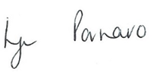
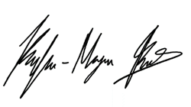
Trustees’ report for the year ended
31 March 2023
The trustees present their report, incorporating their strategic report and financial accounts for the year ended 31 March 2023. The financial accounts have been prepared in accordance with the accounting policies set out in the notes to the financial statements and comply with the charitable company’s Articles of Association and the Companies Act 2006.
Our Vision
Working towards Equality, Inclusion and Participation for Disabled People in Scotland

Objectives and activities
We are a national charity working to make life more accessible, equal, and inclusive for disabled people in Scotland.
Our aim is for every disabled person to have the opportunity to participate in a fulfilling life and to enable them to reach their full potential.
Our Mission
Our mission is to give all disabled people in Scotland a voice with trust, care and empathy.
This annual report covers progress on Disability Equality Scotland’s objectives and activities between 1 April 2022 and 31 March 2023.
Our objectives as set out in our governing document are:
- to promote the benefit of disabled people in Scotland by encouraging communication between disabled people and national and local organisations concerned with the inclusion of disabled people in society.
- to advance the education of the public about disability equality and accessible environments, and to effect positive change in attitude and awareness of disability.

Main Objectives for the Year
Disability Equality Scotland has been involved in many projects, all of which focus on the organisation’s principles to:
- Improve disabled people’s access to participation and engagement in society through increased support, services, and awareness around disability equality.
- Improve understanding and reporting of disability hate crime across Scotland.
- Promote connectivity between Access Panels and improve access to support for volunteer members in delivering on equality and inclusion-based work.
- Increase awareness and knowledge of Access, Inclusion and Equality within the Access Panel Network.
- Planning and design professionals will have access to a range of resources, best practice, advice, and solutions aimed at accessibility/inclusive design.
- Disabled people will have on-going involvement and further opportunities to provide their views on Accessible Transport in Scotland, contributing to the progress of the Accessible Travel Framework development and implementation.
- Disabled people, transport operators, staff and other stakeholders will have access to accessible travel guidance, information, and signposting via an Accessible Travel Hub.
- There will be a joined-up approach to tackling disability hate crime and negative behaviours towards disabled people on public transport across Scotland.
The following pages are the main areas of work delivered through funding and contracts:
- Inspiring Scotland: Equality and Human Rights Fund
- Section 10 Grant Scheme: Access Panel Project
- Transport Scotland (Bus, Accessibility and Active Travel Directorate): Accessible Travel Framework review and hate crime training
- COVID-19 Public Health Directorate: Face Covering Exemption Card contract

Membership
We work with our members to promote equality for disabled people in Scotland.
We regularly ask our members for their views on many diverse policy issues, which then directly feed into our policy work and government policies, plans and consultation responses. This last year has been no exception
We make sure members have opportunities to meet and network with relevant audiences. We help members make the right connections.
During the period from 1 April 2022 to 31 March 2023 we had 79 new members join us, resulting in a 5.6% increase in our overall membership, this brought our membership total to 1496 members.
Data cleaning:
We undertake a yearly data clean on our database. Checks on the database identified 29 membership records as incomplete, and letters were sent asking them to update their details to be re-added to the database.

What difference has our Membership made?
Members are at the heart of all our work and projects. Our members have a direct say in what we do and how we do it, inputting ideas and evidence to inform and direct our work and sharing their lived experiences to allow us to identify what changes are required in our pursuit for full access and inclusion for disabled people.
We conduct a yearly survey with our members to understand where we can make improvements and understand what we are getting right. The last survey was conducted in August 2022 and received 98 responses.
- 77% of respondents felt they could contribute their views on topics that affect them
- 65% of respondents felt they could participate in discussions about topics that affect them
- 89% of respondents felt they are presented with information in an accessible format which meets their needs
We’ll look to improve on these figures by exploring hybrid events for engagement and remind our members that we have alternative formats available.
- 80% of respondents were satisfied with our weekly poll topics and 94% were aware of our weekly polls
We will continue to communicate what we do with the poll information and to which policy areas the data contributes.
- 73% of respondents felt they benefit from being a member with Disability Equality Scotland
- 75% of our members agree we represent the views of disabled people in Scotland
We will ask members in the next year to indicate areas of importance for further exploration. We’ll also continue to look for innovative ways to increase the benefits of membership with Disability Equality Scotland.
We will also promote the survey in different formats, such as Easy Read, to increase the number of respondents from our membership. We will also provide different avenues for members to feedback throughout the year.

Disability Equality Scotland Newsletter and Open Door Magazine
Over the past year, the monthly newsletter has been an important channel for distributing important information to our members. This includes ongoing public health advice relating to COVID, cost of living support and various information and engagement opportunities for members through consultations, surveys, and events. Examples of partners we worked with to gather content included:
- Health and Social Care Alliance
- I Am Me
- Lead Scotland
- Legal Services Agency
- Motability
- NHS 24
- Oxfam Scotland
- Scottish Fire and Rescue
- Police Scotland
- See Me
- Sense Scotland
- Social Security Scotland
- Zero Waste Scotland
Our Open Door Magazine is our members’ magazine. In the last year, we published a bumper edition theme on Accessible Transportation.
We share our communications with members, Scottish Ministers, key partners and stakeholders, highlighting and promoting our work widely.

Face Covering Exemption Card Campaign
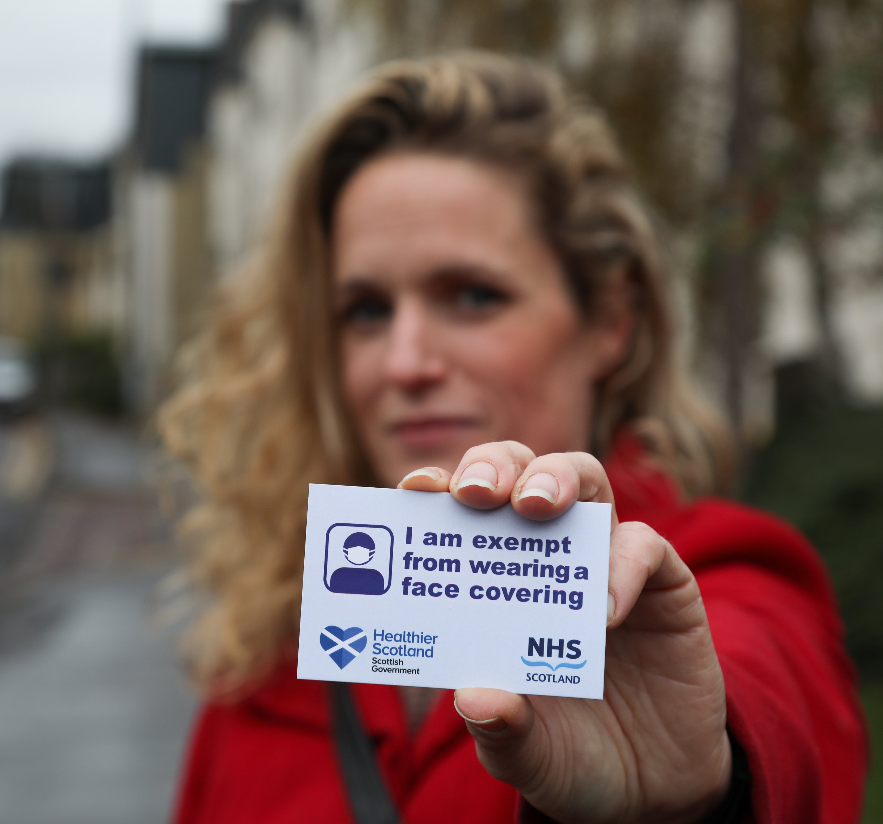
There are situations where some people are unable to, or it would be inappropriate for them, to wear a face covering. The reasons why someone might be exempt are explained on the face covering exemptions page https://exempt.scot/face-covering-exemptions/
Since the introduction of the mandatory wearing of face coverings, and in light of Disability Equality Scotland’s members’ concerns raised through our weekly poll on the subject, we were very happy to work with the Scottish Government to introduce a national exemption card. The card is available through our dedicated website www.exempt.scot. The project was launched to the public in late October 2020.
During the first two weeks of the campaign, we received over 1,150 calls to the helpline and nearly 28,000 applications in total. This moved to a digital download version only in line with demand in September 2021.
For the reporting year 01 April 2022 - 31 March 2023, 9,213 cards were downloaded.
We issued a feedback survey to card holders. A full report and analysis will be completed at the end of project. it is clear to see that the success of the scheme has allowed disabled people to be more confident when visiting venues as we moved out of compulsory wearing of coverings.
Disability Webinars
Our webinars help to bring disabled people together with experts on different topics as well as providing an opportunity to meet with other disabled people. During the period April 2022 to March 2023, we delivered five Disability Webinars across the following topics:

- Social Security Scotland Consultation: Consultation on their new disability payments, what will be required and how disabled people can apply/move from Personal Independent Payment.

- A Fair and Just Scotland for all: encouraging disabled people to share their voices around Scotland being a fair and just country.

- Building Regulations: updates on building regulations and specifically those that affect disabled people.

- Accessible Travel to discuss our review of the Accessible Travel Framework and hear barriers and/or progress of this from disabled people’s views.
- Accessible Travel Hub feedback – raising awareness of the Accessible Travel Hub and ensure this is relevant and up to date for disabled people.
Each event welcomed an average of 42 delegates (local disabled people, local authority staff, statutory bodies, MSPs, local private companies and third sector organisations).
Our webinars help to bring disabled people together with experts on different topics and gives an opportunity to mix with other disabled people.
The webinars encourage disabled people to engage with us as an organisation and help to create new memberships.
raised and addressed.”


Inclusive Communication Hub www.inclusivecommunication.scot
We have continued to advocate for the adoption of the principles of Inclusive Communication via the Inclusive Communication Hub. The Inclusive Communication Hub has experienced steady growth through on-going content development and sustained promotion with key partner organisations.
On World Braille Day (4 January 2023) we launched our #JoinTheDots Braille Labelling campaign in partnership with Oban and District Access Panel and Sight Scotland. As part of the campaign, we are asking for a statutory duty to be placed on businesses and retailers to provide braille labels on food products detailing the name of the item and the use by/sell by dates. This is an essential requirement for blind and partially sighted people, which would allow visually impaired individuals to safely identify, buy and use food items in both retailers and when at home.
As part of the campaign, a Scottish Parliament petition was created. We have utilised the Inclusive Communication Hub to promote the key campaign messages and signposting to the Scottish Parliament petition: www.inclusivecommunication.scot/braille-campaign
We created a dedicated resources page which signposts to information and guidance about the response to the pandemic that is being produced in accessible formats, such as audio, British Sign Language (BSL) and easy read.
Easy Read Service
www.disabilityequality.scot/easy-read-service

Disability Equality Scotland provides a professional and sector-leading Easy Read service as part of our commitment towards improving access to information for all.
Easy Read is an accessible format that makes written information easier to understand by using simple, jargon free language, shorter sentences and supporting images.
In this reporting period we have completed 131 Easy Read projects for key partners and funders. By producing Easy Read documents, we provide disabled people with the chance to interact and engage with relevant topics and have their views heard. We are encouraged that the Scottish Government continues to recognise the need for Easy Read. We have had a steady increase of Easy Read requests over the last 12 months, which is very encouraging.
Easy Read Training
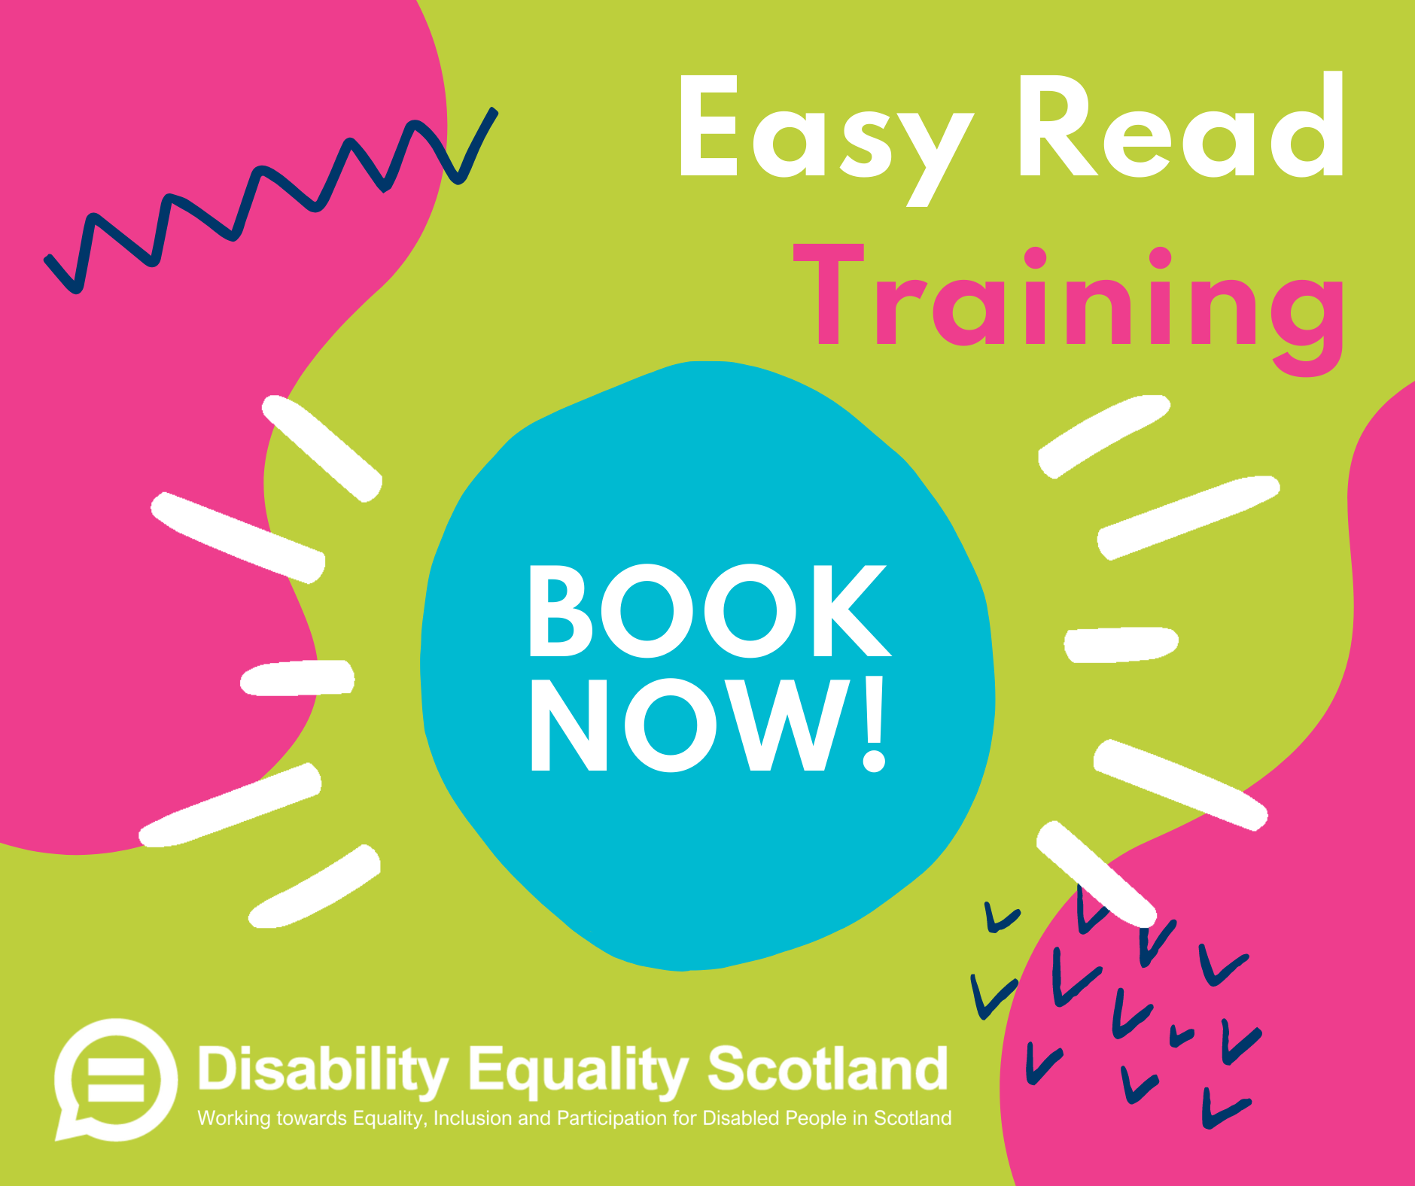
The overall aim of the Easy Read Training course is to help professionals produce best practice easy read information that works for their audience.
The delivery of the course ensured we continued to deliver this online. The training sessions have been designed to be interactive, with practical exercises and plenty of opportunities for discussion. We tailor the training course for each client’s needs, discussing what they hope to get out of the course in advance.
The training course is now available at cost and proving to be very successful. Disability Equality Scotland has in this reporting period:
- delivered 11 Easy Read public courses
- registered with the CPD Standards Office and submitted our course for accreditation
- We have delivered Easy Read training to 37 organisations across Scotland and the rest of the UK
Since the launch of the public Easy Read training courses, there has been a good demand for courses from a range of organisations in Scotland. Some organisations are choosing to send multiple staff, and some have asked delegates to report back to their teams. Importantly, 100% of trainees would recommend the training to a friend or a colleague.
In addition, 100% of trainees have reported an increase in their easy read knowledge and skills and 95% have increased their confidence and awareness of accessible information. Beyond Easy Read, many trainees say they will be more mindful of their general communications in the future.
Weekly Polls
www.yoursayondisability.scot

Our weekly polls are a way of gathering feedback from our members on issues that affect everyone. We have conducted 48 poll questions, covering various issues including:
- A New National Park for Scotland
- COVID – social isolation
- Transport Scotland Accessible Travel Framework (series)
- Single Use Plastic Cups - Communicating the Charge
- Winter Energy Blackouts
- Hate Crime Charter
- Face Coverings
- International Day of Disabled People
- Social Isolation and Loneliness Over Winter
- National Entitlement Card
- LEZ Blue Badge Exemptions
- NHS Strikes/Stress; Employment Barriers
- DES 20th Anniversary; The 'A Scotland that Cares' Campaign
- Adult Disability Payment (series)
- Energy Price Cap
- Restricting Alcohol Advertising and Promotion
- Dental Care
Our polls have contributed to the following consultation responses:
- Braille Labelling
- the Disability Commissioner Bill
- Charges on Single-use Drinks Cups
- an Equality Impact Assessment in reviewing the NHS 24 Breathing Space resources
They have also supported:
• Scottish Government on the Public Sector Equality Duty, specifically relating to Inclusive Communication and its adoption throughout public sector
• a series of meetings as part of the Plastic Straws Advisory Group to finalise plastic straw exemption regulations along with helping to develop a communications toolkit.
Weekly polls have received praise and recognition from key stakeholders and contributed to developing legislation, service improvement, consultations, Equality Impact Assessments (EqIAs) and influenced policy and guidance relating to disabled people.
We have also taken the opportunity to raise the importance of our members views from poll as evidence in Scottish Parliament Committees, Cross Party Groups and in Parliamentary Questions. We also share this evidence in various strategic Stakeholder groups.
Scottish Parliament Cross Party Groups
  - Disability: From June 2021, Disability Equality Scotland took on the Secretariat role for the Cross- Party Group on Disability, convened by Jeremy Balfour MSP, and co-convened by Pam Duncan- Glancy MSP. We are fortunate to continue to have a positive working relationship with both MSPs and we have opportunity to influence the agenda items discussed in this forum, helping to keep pertinent issues for our members on the table.
  - Sustainable Transport: Disability Equality Scotland is a non-MSP Group Member.
  - Deafness: Disability Equality Scotland is a non-MSP Group Member.

Disability Hate Crime
www.disabilitysafety.scot
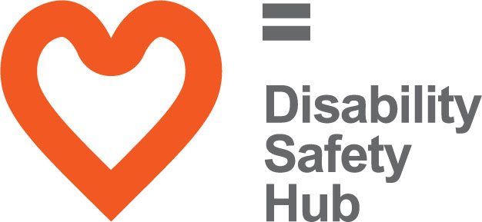
The Disability Safety Hub launched in October 2018 to coincide with National Hate Crime Week. This hub has two main aims:
- To raise awareness of disability hate crime, helping disabled people to understand what a hate crime is.

- The Hub also wants to help disabled people to report hate crime and shows the different ways you can do this.
On this Hub you will find helpful resources, including case studies and videos of disabled people talking about their own experiences of hate crime.
In response to COVID-19, we adapted content on the Hub to reflect guidance and resources, which were being produced to provide support to people during the pandemic. We developed our own mental wellbeing guide, which signposts to relevant resources, including the SAMH ‘Mental Health Information Hub’. We also developed a new resource category that is dedicated to scam awareness in response to the increase in scam related crime during the pandemic.

Accessible Travel
www.accessibletravel.scot
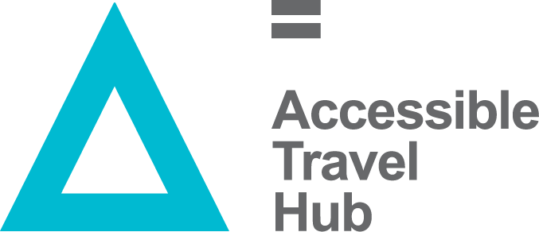
The Accessible Travel Hub has continued to receive positive levels of engagement, which has been achieved through on-going updates from transport providers on the measures they have introduced to make transport more accessible and safer for disabled people. Members of Transport Scotland’s Accessible Travel Framework Steering group also provide content for the hub to promote shared learning.
We continued to utilise the Accessible Travel Hub to promote the Hate Crime Charter and were delighted to have continued support from the Community Transport Association (CTA), ZetTrans Regional Transport Partnership and the Mobility and Access Committee for Scotland (MACS).
These logos were added to the Hate Crime Charter supporters page on the Hub We now have 25 supporters of the Hate Crime Charter and we look to increase this in the coming year.
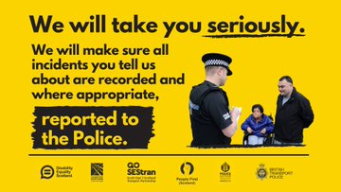
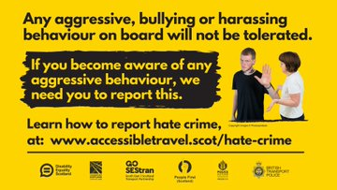
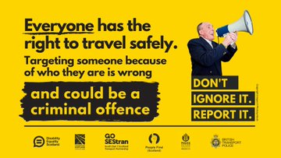
We spent time working with Police Scotland to relaunch our Hate Crime Charter specifically for Transportation and this occurred during National Hate Crime week in October 2022. Resources were created and delivered to all transportation organisations who signed up to the Charter.

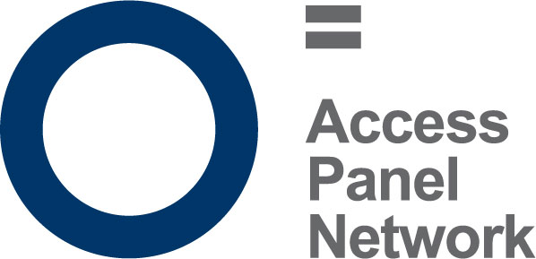
Access Panel Network
Access Panels are the community experts when it comes to improving accessibility in the built environment. Their lived experience puts them in a unique position to provide advice and support to a wide range of organisations and bodies across society. Access Panels are primarily made up of volunteers, the majority of which are disabled people, or care for a disabled person.
They meet on a regular basis to discuss issues in their local community, which affect disabled people, and work towards removing barriers to independent living in their communities to ensure disabled people have access to the same choice, dignity and control as others in our society.
There are currently 39 active Access Panels across Scotland, from Harris and Orkney to the Scottish Borders and everywhere in between. Panel membership varies between 5 and 150 disabled members, and it is estimated that there are around 1000 Access Panel members in total across Scotland.
As Access Panels have typically grown organically around the needs of their locality, they vary greatly in their focus and remit. They are primarily committed to improving access and equality in its widest form which means access to the physical environment, Education, Housing, Health, Transport, Leisure & Recreation and Social Justice amongst other areas.
Access Panels have told us that they have continued to ensure that accessibility remains at the forefront of people’s minds, even as we continue to work remotely. Despite the challenges of remote working for the past few years, we have seen an increase in Access Panels activities. With new Access Panels joining the network, this increases the representation for disabled people’s voices to be heard.
Disability Equality Scotland continued to see increased attendance at the yearly Access Panel Conference. Feedback suggested that this was because many disabled people didn’t need to spend hours travelling to and from the event and could instead join from the comfort of their own homes.
Our new Access Panel Hub was launched this year. It includes features our Access Panel members requested such as a members’ area, news and blog section and general information around Access Panels.
The forum is a closed group with the facility for panel members to post questions, updates and improve peer support across the network. All Access Panels are encouraged to contribute to the forum, as well as the news and blog section.
We remain aware of the fact that public transport still isn’t accessible for disabled people and we will work with the Access Panels to make sure that remote working isn’t used as a substitute for a poorly accessible transport infrastructure.

Access Panel Grant Overview and Progress
The Access Panel Grant is a fund designed to help increase the capacity and outreach of Access Panels right across Scotland. The majority of Access Panels are staffed solely by volunteers who are passionate about increasing access and social inclusion for disabled people in their community.
Specifically, the Access Panel Grant has enabled Access Panels to remain incredibly active and continue their vital work even throughout lockdown, by using this grant in inventive and resourceful ways. Naturally, we have seen a decrease in the amount claimed for things like travel expenses and room hire but an increase in the number of claims for things like ICT equipment, software packages, Zoom subscriptions, and closed captioning services.
Access Panels have still been active in their local communities and as such have needed access to these vital funds to ensure they can carry out their work. Access Panels have continued to ensure that premises are accessible and used the Access Panel Grant to help support their access auditing activities.
With support from Disability Equality Scotland, Access Panels have successfully moved their activity online where possible, continuing to provide crucial input to proposed changes to their local areas. Increased engagement opportunities with elected representatives and their local Councils has also been possible through the grant funding and support from Disability Equality Scotland.
Staffing
Our staff team have continued to work effectively and efficiently from home and in the office this last year. Our operational outcomes continue to align with our growing strategic aspirations, and our success is down to the commitment, talents and diversity of our staff. That is why we value and develop our employees to succeed in their careers, as well as contribute to our success.
We aim to provide good jobs at a fair pay and purposeful work, along with the structure and skills to make a difference.

Structure, governance and management
Disability Equality Scotland was established under a Memorandum of Association, which established the objects and powers of the charitable company and is governed by the Articles of Association.
Disability Equality Scotland is a charity limited by guarantee and has no share capital. The liability of each member in the event of winding up is limited to £1.

Recruitment and appointment of new trustees
Although not a public body, our board recruitment is competency based.
The skills, knowledge, and experience on our board during 2021-2022 include HR Management, Governance, Strategy Planning, Business Management, Risk Management and Business Continuity Planning, Inclusive Design Principles, Equalities, Access Panel involvement and personal lived experience as a disabled person.
Board members serve a term of three years and are voted in at our Annual General Meeting. Board members can serve a maximum of two terms.
The role of the Board is to oversee the work of the organisation and to make strategic decisions about its future.
Our Convener leads the board and offers support to our Chief Executive Officer.

Our Funding
Equality and Human Rights Fund, Inspiring Scotland
Our focus with this fund is Disability, Equality, Access and Engagement.
As a national Disabled Peoples’ Organisation, we will continue our work to make life more accessible, equal and inclusive for disabled people in Scotland.
We will do this by giving disabled people a voice and opportunity to participate in a fulfilling life through our consultation, engagement and inclusive communications.
This fund allows us to develop our work around Hate Crime, Accessible Travel, Inclusive Design and Inclusive Communication, working with our members and Access Panel Network to promote access in its widest sense, thus promoting a life of dignity, respect, choice and independence.

Section 10, The Scottish Government
We are the umbrella organisation for Access Panels across all of Scotland and work with other partners to improve access and inclusion. We work to empower and promote the rights of disabled people. Our role is to influence and effect change, both locally and nationally, through the network of Access Panels and to support them to work in partnership to address local issues.

Accessible Transport for Disabled People Grant Funding, Transport Scotland
The aim of this project is to work with Transport Scotland and relevant groups to improve the accessibility of transport in Scotland. Our role is to ensure disabled people are informed and included in each stage of the process, including proposing the issues to agreeing actions, to monitoring and feeding back on successes and areas for improvement.
To ensure our member’s voices are heard and integral to plans and policies we also sit on the Accessible Travel Framework Steering Group, which looks to progress the Accessible Travel Framework for Scotland (Going Further).
More recently, and through our input to transport transition planning for emergence from lockdown, we have been invited by Transport Scotland to sit on the Transport Equalities Network to feed in the lived experiences of our members to work towards making public transport more accessible for everyone.

Exemption Card Campaign, The Scottish Government
This project developed in response to the continued demand and need for face covering exemptions for many disabled people and those with long term or limiting conditions who are being challenged for not wearing a face covering. We administer the Scottish Government’s exemption card scheme, including fielding telephone and online requests for exemption cards and fulfilling these requests via post and digitally.
We regularly provided feedback to Scottish Ministers on the issues being raised with us through the helpline.

Our Sponsors
We are grateful for the generosity of our sponsors from 1 April 2022 to 31 March 2023:
- Motability
- Legal Services Agency

Reference and Administrative Details
Registered Company number - SC243392 (Scotland)
Registered Charity number - SCO31893
Registered office
Suite 204B, The Pentagon Centre, 36 Washington Street, Glasgow G3 8AZ
Board of Trustees
The following trustees served from 1 April 2022 to 31 March 2023.
- Lauren Asher
- Kayla-Megan Burns
- Rhianne Forrest
- Kenny Milne
- Carolyn Giffiths
- Marie Harrower
- Maureen Morrison (Resigned April 2023)
- Scott Stewart
Other Trustees who served during the period noted:
- Linda Bamford Resigned March 2023
- Dorothy Jane McKinney Resigned March 2023
- Colin Millar Resigned September 2022
Independent examiner
Anne Knox FCIE, Cameron House, Forthside Way, Stirling FK8 1QZ
Approved by order of the board of trustees on 30 August 2023 and signed on its behalf by:
Kayla-Megan Burns, Convenor

Summary Presentation of Financial Accounts
1 April 2022 - 31 March 2023
Income 2023 2022
Restricted Fund
Access Panel Grant £27,000 £36,500
Scottish Government Equality Unit £ - £47,500
Scottish Government Equalities and
Human Rights £139,637 £71,179
Scottish Government Section 10 £80,000 £80,000
Transport Scotland £90,579 £49,996
Scottish Government Ferries Accessibility £ - £13,959
Scottish Government Exemption Card
Campaign £5,807 £16,506
Garfield Weston Foundation £ - £20,000
Inclusion Scotland (internship funding) £5,791 £ -
Other £180 £2,570
Total Income £348,994 £338,210

Unrestricted Fund
Earned Income (Donations, Sponsorship,
Webinars) £ 3,690 £4,129
Easy Read Training £10,213 £5,000
Easy Read Translation £47,531 £47,965
Total Income £61,434 £57,094

Expenditure 2023 2022
Staff Costs £251,828 £234,594
Rent and service charges £12,517 £13,446
Telephone £3,449 £3,364
Printing, Postage and Stationery £7,965 £7,828
Subscriptions. recruitment and training £24,058 £15,469
Travel and subsistence £11,948 £3,859
IT Development £6,089 £16,082
Interpretation £4,706 £5,788
Bank charges and Payroll £751 £674
Depreciation of tangible fixed assets £2,290 £1,229
Grants to Access Panels within Scotland £30,400 £9,783
Legal and Professional Fees £10,216 £10,427
Insurance £5,351 £4,624
Events and Promotional Materials £352 £ -
Governance £1,050 £1,025
Sundries £474 £ -
Staff costs – other £2898 £ -
Total £376,343 £328,192

Net income / (expenditure) £182,015 £67,112

Balance Sheet
as at 31 March 2023
2023 2022
Fixed Assets
Tangible Assets £ 4,971 £ 2,131
Current assets
Debtors £ 7,621 £ 13,575
Cash at bank and in hand £179,772 £140,418
Total current assets £187,393 £153,993
Creditors
Amounts falling due within one year £ 10,349 £ 7,954
Total assets less current liabilities £182,015 £148,170
Funds
Unrestricted funds £136,920 £ 88,053
Restricted funds £ 45,095 £ 60,117
Total funds £182,015 £148,170
Full financial statements which have been examined Anne Knox FCIE are available from the company on request.

