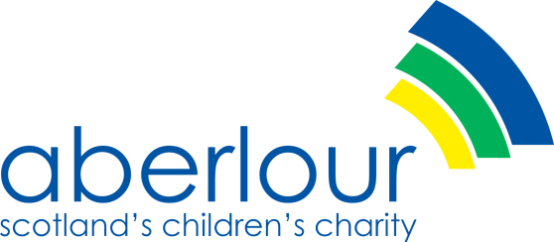
Job Description
Member of the Board of Directors
Job Purpose: To further the organisation keeping with its charitable objectives
Main Tasks:
- To take part in formulating and regularly reviewing the strategic aims of the organisation.
- With other Directors, to ensure that the policies and practices of the organisation are in keeping with its aims.
- With other Directors to ensure that Aberlour functions are with the legal and financial requirements of a charitable organisation and strives to achieve bets practice.
Main Duties
- Formulating strategic Aims:
Consider the organisation as a whole and beneficiaries, whether as a member of the Directors or any of its committees.
Reflect Aberlour’s vision and principles, strategy and major policies at all times.
Contribute specific skills, interests and contacts and support the organisation in fundraising activities.
- Ensuring Policies and practices are in keeping with aims:
Attend the meetings of the Board of Directors four times each year, and meetings of its Committees as agreed.
Reflect the Board’s policies and concerns on all its committees and when representing the organisation.
- Ensuring best practice:
Be an active member of the Board in exercising its responsibilities and functions.
Maintain good relations with senior managerial staff.
Take part in training sessions provided for the benefit of the Directors. Fulfil such other duties and assignments as may be required from time to time by the board.

