Purpose: Report from GNWCAB Strategic Development Day
Paper author: Duncan Dunlop
Subject: GNWCAB Strategic Review
Dates of sessions: 13th and 26th Aug 2025
Participants: Representatives from GNWCAB Board, staff & volunteers
For: Information and distribution
____________________________________________________________

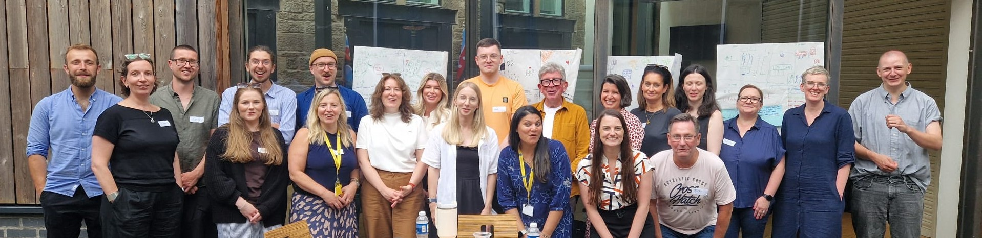
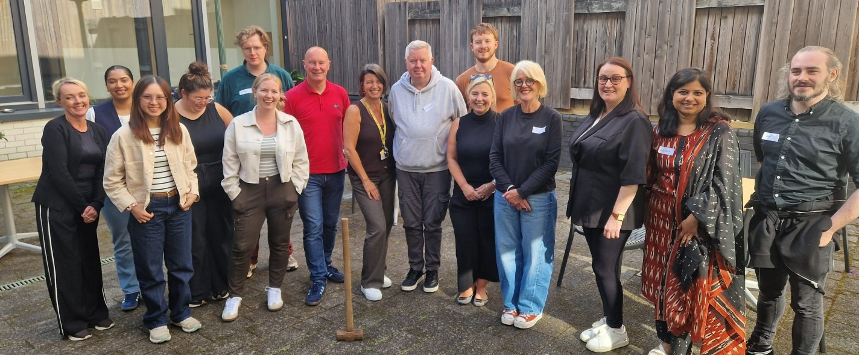

“We have an excellent culture - the change needed is all external.”
“Our strategic plan will deliver Fairness for everyone”.
“Reaffirmed to me, this is a great place to work.”
(Participants reflections)

- Purpose of this paper
To give an outline of the staff and volunteers key discussion points and ideas to inform the GNWCAB strategic plan.
- Objectives for the planning sessions
- Reflect on why GNWCAB matters.
- Explore GNWCAB qualities, operating context reviewing opportunities and challenges and how they can be overcome.
- Develop a vision for the future for GNWCAB and what needs to be done to deliver it.
- Agree values that will underpin the behaviours and culture for how we work as a team to realise our vision.
Due to the limited time available in the first session Objective 4 was focussed on during the second session.
- Introduction
3.1 Overview
The planning process was designed to help participants reflect on what really matters to their clients and how best GNWCAB should be strategically focussed to meet their needs over the next 3 to 5 years. There was a great energy present with all participants engaging in exercises to give a depth of insight and broad consensus with ideas presented that will frame the core of GNWCAB’s final strategic plan. Core areas of the plan from vision to broader mission and strategic objectives (priority areas of action) and values were explored. For each area, this paper presents the draft wording developed through the work of both sessions.
A key point that was re-emphasised throughout the sessions was that it is the process of planning rather than the plan as a product that matters most. All participants should view it as their plan, and see the clients they serve represented by the plan. It will continue to be a living document that will evolve as the circumstances surrounding GNWCAB change too. As part of future induction processes, it is helpful to share the individuals we remember and invite new colleagues to reflect on their own, seeing them within the vision and plans we have created.
An underlying objective of each session was to give staff and volunteers time together, to remind themselves of the value that they add individually and the collective impact they have as a team. GNWCAB culture is strong and supportive. People felt valued as individuals and for how effective they are as a team, this culture was overwhelmingly recognised and appreciated by participants.
Each session began with participants reflecting and remembering the people that they serve and who gives them purpose. They then used the injustices affecting these clients to identify the central issues GNWCAB aims to tackle. These issues were later transformed into vision statements, imagining a world where they are resolved. Alana gave an oversight of GNWCAB’s operating context – the successes, pressures and opportunities present. Participants then engaged in a SWOT exercise to reflect on the key challenges and strengths facing the organisation. They assessed GNWCAB's current activities, identifying the most effective projects and programmes, while considering areas that may no longer be viable. They were encouraged to think about how GNWCAB could evolve and address its central challenges by imagining its future and defining its role, this led to the draft mission statement and strategic objectives.
In the longer second session, participants had time to reflect and discuss with colleagues the values in action, that matter most for supporting clients and shaping how GNWCAB works going forward.
The sessions did not draw firm conclusions on the exact wording of vision, mission, objectives or value statements, but it has given the basis from which final versions of these can be formed. Drafts for all of these are included in the report and collated at the end of the report. It was emphasised throughout the day that exact phrases participants created during the day may not make the final plan, but that they should see their influence and imprint in the ones that are finally chosen. When they see the plan, what matters is that they can see the client they started the day talking about, as being present, welcomed and helped by the strategy set out. The plan should be viewed as a live framework that is able to be personalised to aid all who need GNWCAB assistance.
- Why GNWCAB matters to me
As an exercise to help the participants reflect on the value of GNWCAB and ground the strategic plan in the clients they serve, they all came prepared to share a personal story or a story of a client in need and how GNWCAB had helped them.
Memorable and moving stories were shared within the group included; the delightful, but unintended consequences of motivating a sibling group of children to remain in education; to the fishing rod given by a man struggling with trauma and arthritis who was so relieved when he was supported to win his appeal to gain disability payments; to a family just grateful to receive a foodbank voucher, far-less having their debt written off; to the kindness of a man given back-dated payments he was due, only to pass it on to those who had helped and cared for him; to the joy of seeing the relatively rare longer-term positive impact of support given to people, as a dear neighbour was supported to restructure their mortgage and stay in their home. Each story highlighted how the CAB has always been a non-judgemental, inclusive and precious place to so many people in their time of real need.
This was an emotional process, with personal stories and feelings shared in a confidential space. It allowed each participant to reflect on why GNWCAB matters, both to themselves and their colleagues, while also setting a meaningful foundation for the rest of the day. It was good to hear that sharing the stories of clients and the emotional impact they have is a common and regular occurrence in GNWCAB. This is a sign of an engaged and connected culture which was evident throughout both sessions.
- Developing a vision statement
Participants were asked to distil out from their stories the injustices and core issues that their clients were facing. They were then asked to write down a positive word that meant the opposite and would represent how the client would feel if the injustice wasn’t present. They were then asked to summarise the positive words into one aspirational statement – which could be read as the vision for a positive future.
Problem | Solution | Vision for a better reality
Lack of knowledge | Access to knowledge | ‘Accepted and heard, informed and empowered to lead financially comfortable lives which they can control’
Poverty | Financial security
Lack of safety | Availability of resources
Isolation | Social Support

Problem | Solution | Vision for a better reality
Poverty | Wealth/Prospects | ‘A world with fairness & justice for everyone without judgement or exclusion’
Injustice | Justice
Bureaucracy | Accessibility
Discrimination | Inclusivity

Problem | Solution | Vision for a better reality
Lack of safety | Security | ‘No one faces things alone’
Prejudice | Understanding | ‘No one faces things alone’
Inequality | Fairness | ‘No one faces things alone’
Barriers | Access | ‘No one faces things alone’
Isolation | Connection | ‘No one faces things alone’

Problem | Solution | Vision for a better reality
Isolation | Community | ‘A community of equals with the tools to thrive’
Discrimination | Equality | ‘A community of equals with the tools to thrive’
Poverty | Thrive | ‘A community of equals with the tools to thrive’

Problem | Solution | Vision for a better reality
Isolation | Community | ‘An informed community where people are loved, heard and understood’
Discrimination | Acceptance
Poverty | Stability
Complexity | Knowledge

Problem | Solution | Vision for a better reality
Geog. isolated | Better mobility | ‘GNWCAB exists for a community that is safe, inclusive, empowering with access to rights’.
Injustice | Justice
Threats to people’s safety | Security and safety
Language barrier | Open Communication
Insecure work | Flexible stable jobs

At the end of the day participants were asked which vision statement they liked best.
In the first session certain words and phrases across the statements resonated with participants. Including: thriving, justice, fairness, community, without judgement or exclusion.
And from the second session the preferred phrases and statements were: community, heard, loved, thrive, equals and belongs.
Merging the statements focussing on the positive versions of the words that resonated and merging those with similar meaning creates a vision statement like this:
“North West Glasgow is a fair and just community where everyone belongs, is loved, heard, and thrives”
In addition the simplicity of “No one faces poverty alone” appealed to many people as a statement. It could form a powerful strapline that embodies the action at the heart of delivering your vision.
It was emphasised to participants that the purpose of the exercise was to ensure the vision was rooted in the stories of the people they care about. The aim was to create a vision that, if realised, would address the injustices these individuals face and help them thrive.
The next step is to sense-check this vision and strapline with participants to see whether it describes a community in which the person they remembered would have been able to thrive.

- Presentation on GNWCAB’s progress and its current operational context
Alana gave a presentation on the performance of the organisation and how it has developed over the last few years. She reaffirmed that this staff engagement event was a genuine opportunity to share their thoughts on the organisation’s operating context and enable them to meaningfully influence the next strategic plan. Alana noted the challenges, strengths and successes that GNWCAB was managing, giving grounds for realistic optimism for the future. The key points she covered were as follows:
Key service indicators
- From a central location GNWCAB delivers a comprehensive service to meet local needs.
- ⅓ of the clients they see are ‘new Scots’, which reflects the high percentage of different ethnic groups living in their community. But GNWCAB is not just a place of information, as they also help people connect together reducing their isolation.
- ⅔ of the 6000 clients supported are disabled, but only 7% of clients are under 25. Clients are on average getting over 3 pieces of advice each, resulting in over £4million client financial gains.
Effective at working with partner agencies from GP practices to schools, but there is more that can be done to make sure GNWCAB is present in all communities.
6.1 Challenges and Responses undertaken
There are significant changes to the community and operating environment. More clients are in crisis and it often feels like GNWCAB is the ‘last man standing’ for them.
- Challenge: Case work has become lengthier and complex. Response: Complete redesign of their service incorporating effective triage. And introduced the session support role and specialist debt adviser.
- Challenge: Shrinking public sector budgets places more pressure on Local Authority budgets and CAB accessing resources. Response: Grown and diversified income reducing their reliance on statutory funding. And have enhanced relationships with elected representatives to improve their understanding of the essential nature of our service
- Challenge: Even though GNWCAB has over 20 active volunteers there has been a reduction in active volunteers, mirroring wider issues with reduced volunteer numbers across bureau and the wider vol sector. Response: Targeted training for volunteers to match specific gaps in service provision.
- Challenge: CAB has become a backstop for other failing services elsewhere, where doors have already closed. Response: Continually re-assess our service provision and ‘all things to all people,’ model. Campaigned and lobbied decision makers for improved funding for the sector.
- Challenge: The ongoing saga with the premises – proving a resource intensive distraction and inhibiting the work of the CAB. Response: Increased our unrestricted reserves via robust financial management in preparation for premises move.
6.2 Reflection on CEO presentation
Alana’s presentation framed the operating context and reiterated to the team that they are incredible and essential in making the difference to so many clients’ lives. This was evident throughout the day. And that whilst there are evolving challenges confronting GNWCAB, with this team driving it forward, she is confident it will continue to step up to the challenge and thrive.

- Reviewing GNWCAB: Strengths, Weaknesses, Opportunities and Threats
Participants were then encouraged to reflect on their own perceptions as to what GNWCAB is doing well and its areas for improvement. A summary of the key points are listed below:
7.1 Strengths (internal to the organisation):
- Good People: Laughter; Our people - staff, vols and board; Good team that’s bonded together; High levels of trust and support; Led by quality leadership and management who give and receive constructive feedback. We are aspirational and strive to be the best.
- Great working culture: No secrets, friendly culture; Supportive working environment apparent with the open-door policy; Self-reflective organisation; Work-life balance is encouraged - Good holidays and 4 day working week; Continual push and appetite for growth; Prioritising time and resources for in-person staff development days; Openness to new ideas, challenge and change; People feel valued. Values underpin decisions. Internal communication is regular and honest.
- Care and compassion to clients and each other: providing safe dignified space for clients so they trust us.
- Resilience: To keep going no matter the challenges we face from premises and IT facilities to managing challenging situations with clients.
- Quality of advice: Knowledgeable and skilled staff & vols; pass CAS audit and high level of positive results achieved for clients.
- Detailed data and information: used to influence social policy and inform decision makers.
- Quality reputation: With partners, politicians, funders and clients.
7.2 Weaknesses (internal to the organisation):
- Staffing: Onboarding/induction for new staff; staff development and training opportunities are restricted due to a lack of time. High level of staff and volunteer turnover - low salary and burn out. Long team meetings.
- Volunteers: Low numbers and high turnover of volunteers; lack of social opportunities to connect them.
- Impact of the role: Giving holistic advice can feel overwhelming with limited time to learn everything; not good enough at saying no or maintaining boundaries as staff too committed.
- Clients: Feels like those who shout loudest can get the most attention; we end up being reactive and not planning our responses.
- Organisation of staff and resources: Siloed working leading to imbalanced caseloads; Inconsistent allocation of labour and resources and on consistency of implementation of processes.
- Insecure employment contracts; Need to make sure staff have the skills to take on other roles if funding reduces/ends for their project.
- Limited and insecure funding: Restricted funding results in postcode lottery for clients access to services; Funders have too high expectations – need more unrestricted funding!
- Premises: ongoing struggles inhibits: togetherness, effective communication; accessibility; space to work and causes angst for staff.
- Being a landlord: detracts from our core purpose and skills
- IT and equipment: Too old! And time intensive to use – CASTLE needs an overhaul as too much time spent on case recording.
7.3 Opportunities (external to the organisation)
- New Premises: Chance for a relaunch to increase visibility; it’ll be accessible, fit for purpose and safe improving client experience in our premises.
- IT and Equipment: New CASTLE system to be more user-friendly; embrace AI potential to aid case notes, reporting, case notes and Adviser net.
- Service developments: New Outreach projects and locations across our region (Possil/ NG Homes) which make us more accessible to clients; Triage to focus on empowering clients to connect with others services eg GP.
- Build on Respected Reputation: Further inform key stakeholder relationships like Glasgow City council, politicians; MSP and councillors; Maximise Scottish and local elections to campaign for social policy changes and resources.
- Communications: Strengthen our brand recognition with the impact we make; Influence change through our stories and data, determine how to use this to tell an engaging compelling story; Target different stakeholders from clients, potential volunteers, the community, and funders.
- Fundraising: Maximise new opportunities to directly raise unrestricted income and public fundraising – individual, corporate legacy etc; Lobby for unrestricted and secure funding;
- Volunteering: Build a volunteer base via quality marketing; aim for those who can commit longer-term to bolster advice delivery.
7.4 Threats (external to the organisation)
- Competition: Potential for competition from other similar local advice agencies; Issues with the Glasgow network model and risk of postcode wars; capitalisation of welfare advice by private operators like Digby Brown.
- Politics: Change of government and social policy changing regressively (immigration, economic policy, retirement age, criteria for benefits changing). GCC – Housing Policy and financial inclusion redesign. All leading to increased demand.
- Public opinion: negative attitude towards poverty, migrants and clients – need to use platforms to educate and inform the public of actual needs and why their support matters.
- Clients: ongoing impact of cost of living and benefits reform, resulting in overwhelm from increased numbers of clients and increasing inequality/poverty.
- Costs increasing and funding scarce: more charities chasing less funding; ethical issues over who gives.
- Leadership changing – Need to develop the future management potential within the GNWCAB.
- and funding priorities change.
- AI – Make sure tech developments don’t come at the cost of offering face-to-face contact.

Whilst the above exercise raised issues and opportunities, the most important reason for optimism lay in GNWCAB strengths and in particular its culture. Repeatedly staff highlighted how inclusive and supportive it was. That its actions were based in its values and that this is driving them to overcome challenges (premises, funding or competition) to continue to break new ground and strive to deliver continually improving services. This strength is what all successful and ambitious strategies and structures are founded upon.
- Portfolio Analysis
After reflecting on their internal operating context participants looked at what they do and the extent to which it gives a high return and value to clients and whether this comes at a high or low cost.
8.1 Cash Cows (High return for clients, relatively low resource cost)
- Human Resources:
  - Being Friendly and supportive! Creating a safe space and acting with compassion - makes life so much easier.
  - Meeting people in-person - helps build trust and uncover all issues efficiently.
  - Experienced volunteers – add so much value and have low financial cost but need social support.
- Services:
  - Sim cards & phones
  - Crisis support – Food & Fuel/Energy Vouchers (Warm home discount); Aberlour UAF,
  - Simple MAPs and Statutory moratorium
  - Benefit reviews with no other changes.
  - SPEN – funding given is high cash per outcome.
  - Letter writing and email advice
  - Effective Triage; 10 to 8; GAIN helpline
  - FSM, Bus pass, Blue badge, E-Visas.
  - Advocating for others
  - Digital Inclusion – empowering to show a client how to help themselves.
- Relationships and partnerships:
  - Good relationship with CAS opening up further opportunities and funding
  - Partnership working in the community makes it much more efficient to help clients (eg collaborating with medical staff).
8.2 Stars (High return for clients, relatively high resource cost)
- Face-to-Face services – including Home and bedside visits and outreach services.
- Premises:
  - Reception and in person triage
  - Face-to-face space and service offer – costs more but worth it.
- Human resources:
  - Maintaining culture - Team time – away days, updates and staying connected
  - Volunteers – investing in them so they have skills and are valued part of the team.
  - Level and volume of training.
  - Business Dev Mngt role - worth the investment. (funding applications…)
  - Co-design work – builds internal buy-in.
- Governance:
  - Robust governance structure & Board meetings takes time to service and keep informed/engaged.
- Relationships: CAS membership get out what you put in.
- Services:
  - Tribunal preparation
  - Foreign language - Interpretation services.
  - Immigration work – especially if funding is not available
  - PTD- trust deed
  - Mortgage to rent
  - Bankruptcy – complex MAP/FAB
  - Debt Arrangement scheme
  - Pro-rata payments
  - Benefit application – bureaucracy
  - Adult Disability Payment – (including redetermination and appeal)
  - Housing repair and factor fee issues
  - Eviction support

8.3 Dead Ducks (Low return for clients, relatively high resource cost)
These are issues that will continue to niggle and be a source of struggle unless they are at least in part attended too.
- Services:
  - Housing application - should be signposted to others eg Shelter. Plus it has little positive outcome.
  - WAHP (Warmer homes) reports -tells us nothing.
  - Hopeless cases – advice to those with £100K savings need to signpost or triage out
  - Unwinable tribunals
- External Recording and Reporting
  - Scottish National Standards
  - CASTLE data entry /Functionality
  - Funders – reporting requirements and ineffective engagement events – like handing out energy advice flyers.
  - Glasgow Advice and Info Network… how can it be more useful?
- Internal processes:
  - 5 day a week drop in – are there better times it could be offered?
  - Weekly meetings – do they have purpose and are they too frequent.
- Premises: Being a landlord adds a burden and few benefits to the core work of the CAB
8.4 Question Marks
These are projects we have yet to invest in or try but would if we had the time and resources (currently low return and low resources).
- Human Resources:
  - Staffing: Advocacy staff and volunteers; Employment specialists;
  - Volunteer Trainer - and dedicated support to raise our numbers as a priority!
  - F/t Receptionist and larger triage staff
  - Bi-lingual advisers/interpreters
  - Rotate staff and give increased training and resource. To increase staff skills so they are able to be redeployed if funding reduces for specialised projects.
  - Conditions and progression: Pay to rise with equivalent in the sector. Including better sick, maternity and paternity pay.
  - Pathway for progression and development within the CAB. Develop the leadership and professional development skills in staff so they can progress within the CAB.
  - Training - more time for training.
    - Specialist addiction training
- Premises:
  - Milton – have a permanent presence in this community and others so that we are visible regularly across our area - or at least a drop-in.
- Services:
  - Waiting lists - cease to exist
  - Drop in- Being properly resourced and reviewed
  - Advice clinics – in evening/weekend and home visits
  - Specialist immigration support
  - Law clinic
  - Flexibility of service – Get funders to allow CAB to meet all clients needs – eg being able to give housing advice on WHAP.
  - Preventative work in the community - Like the fire service and smoke alarms.
- Recording and reporting:
  - Better tech – CASTLE and case recording more efficient and user friendly.
  - Outcome loop – find out more of the impact of our services on clients – what happened next?
- Fundraising:
  - Corporate fundraising (start of our journey) – need to tell our story well.
  - Income generation: Selling training and accreditation
- Communications
  - Rebrand to explain and excite about our purpose and impact on people in need, and tackle stigma and prejudice.
  - Volunteers - focus social media and publicity materials to attract them.
- Relationship and partnerships:
  - Share our data with councillors and new funders to embed our value and create longer-term relationships.
  - Community steering/liaison group to inform and listen to issues so data and local knowledge can be used to campaign for change.
The portfolio analysis is quite a cathartic process and enables everything to be put out there. Question Marks can feel like an unachievable wish list, but also uncover interesting ideas, like how a CAB can engage in preventative work? Whilst many of the themes interlink, for example, improved communication to advertise your culture and tell your story can have multiple benefits from bringing in funders, volunteers and clients. They pose question about premises - do we need to take further stock to make sure we don’t become too focussed on a new central office and being a landlord to the detriment of the other communities in NW Glasgow? What can we do to alleviate fears but also make sure we have looked at all options, so staff don’t become disengaged by maintaining premises.
The Portfolio and SWOT analyses enabled staff to have engaged fully with the perspective on what the organisation needs going forward. Combining this with the personal stories of Why GNWCAB matters, helped them determine what they felt should be central to GNWCAB mission, its core activities and how it should operate going forward.
- Depicting the future - what will GNWCAB look like and what will it do?
The discussions and activities had supported participants to reflect on their current context and a vision for a world GNWCAB would aspire to creating. Participants then started to think about what GNWCAB
Examples of the vision for GNWCAB, today and in the future
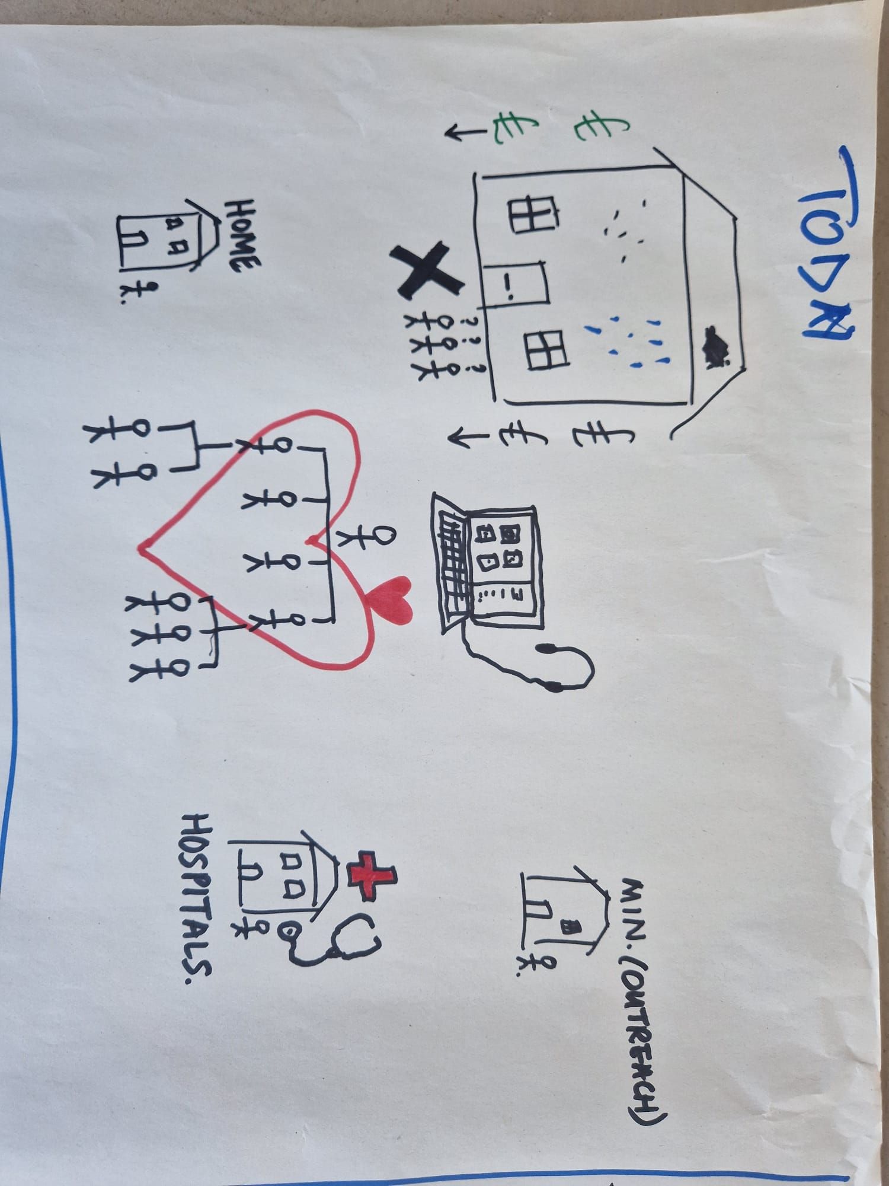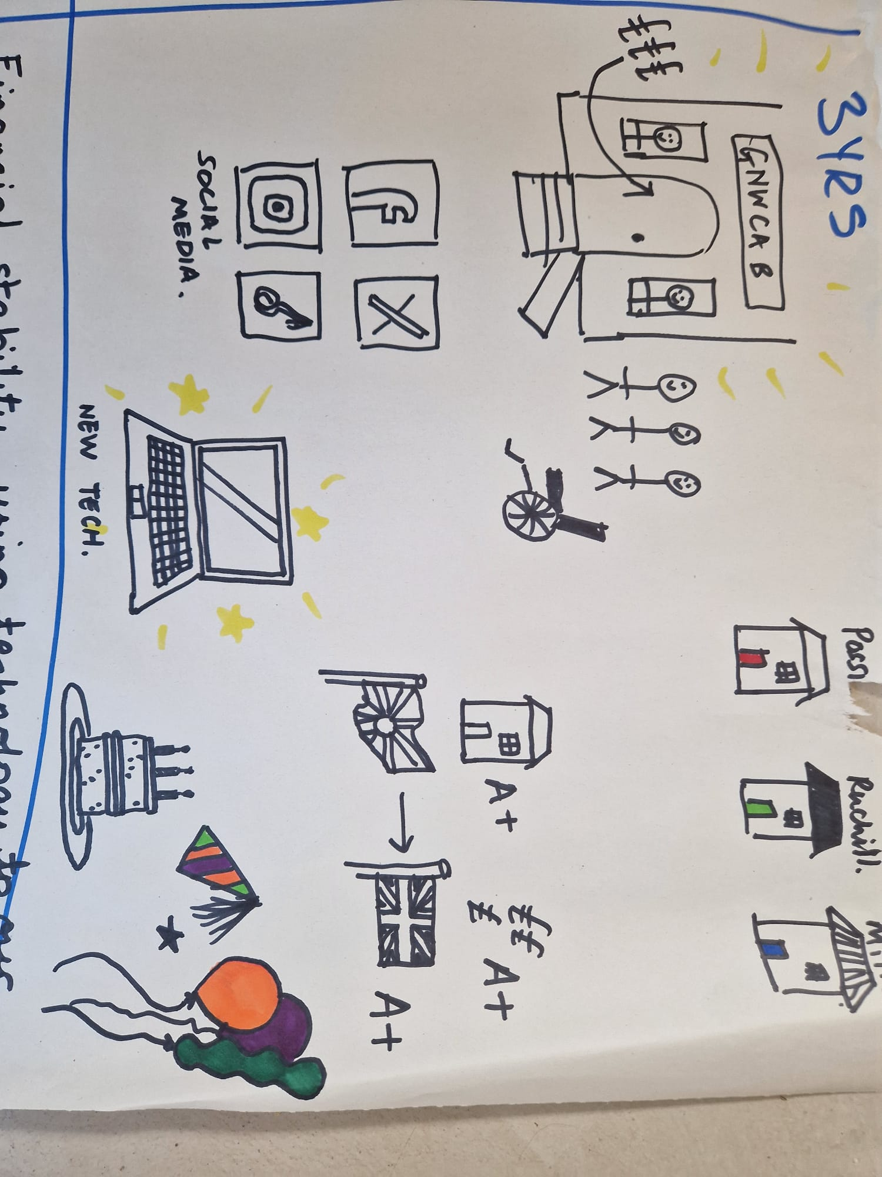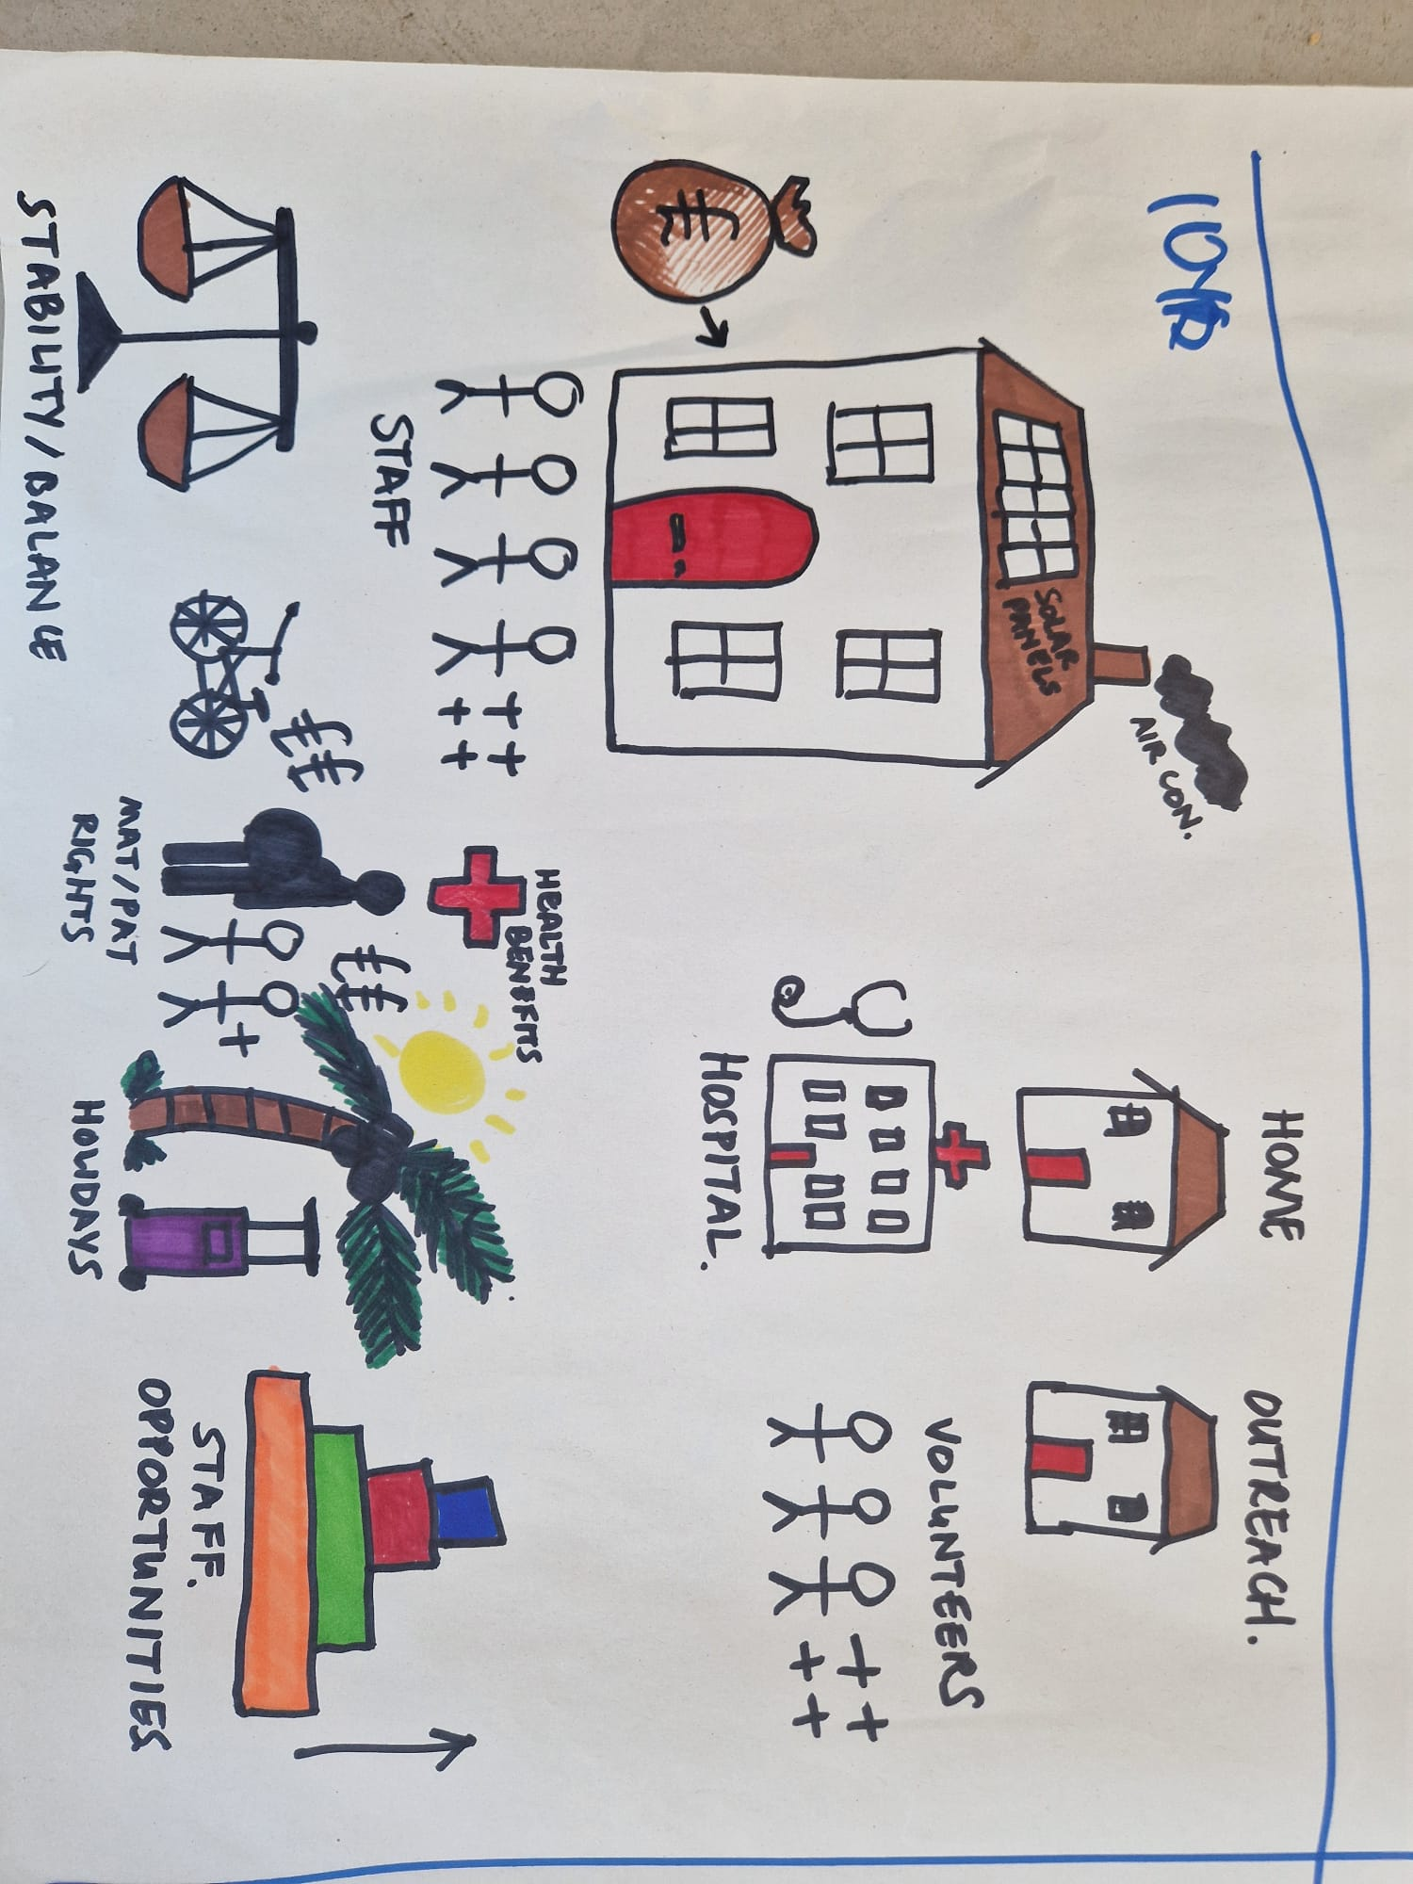

GNWCAB Today
GNWCAB in 10 years
GNWCAB in 3 years
would look like in 2025, 2028 and 2035. This creative activity reinforced how much change GNWCAB had already embraced, what it could do in the short-term and how it could transform over the longer-term too. The aim of this was to help participants stretch their thinking about what role GNWCAB should be playing over the course of the next strategic plan. It aimed to generate mission statements and core areas of work which could form the strategic objectives.
9.1 GNWCAB today – 2025: shared common identifiers
The GNWCAB 2025 diagrams reflected the insights from earlier context and reflection exercises. They show an organisation that, despite ongoing challenges with premises, continues to deliver high-quality services thanks to a strong culture rooted in its values and a deep respect for the inclusion of staff and volunteers.
Retention of staff and volunteers remains a challenge, influenced by local demographics. It was also recognised that the service is somewhat Maryhill-centric. While GNWCAB has many strong partnerships, there is scope to strengthen its presence in Possilpark, Milton, and Springburn. In addition, it was reflected that most clients were in the 30- 50yrs age group and that ought to be extended to reach all those in need.
Overall, GNWCAB’s culture is a major driver of performance. The consistency with which this was highlighted across groups cannot be overstated. It stands out as a genuine source of optimism and a powerful foundation for shaping a progressive future.
9.2 GNWCAB in 3 years – 2028: shared common identifiers
Increased presence across NW Glasgow: Within three years, GNWCAB aims to resolve its premises challenges, establishing a stable, respected central office at the Frampton. This will work seamlessly alongside community outreach services across the area. Accessible provision in Possilpark, Ruchill, Milton, and Springburn will ensure more people can engage, as both practical and emotional barriers are reduced. Where needed, the most vulnerable clients will continue to be supported through home visits, at times that suit them.
Communications cutting through to all: A refreshed brand will share GNWCAB’s story more powerfully, demonstrating its positive impact on the lives of local people – particularly the most vulnerable. By making smarter use of social media and digital platforms, GNWCAB will reach clients, commissioners, funders, and the wider community, building stronger understanding and support for its work.
Demographic: GNWCAB’s services will be accessible and trusted by people across a broad age range, from 16 to 90. By adapting approaches – such as home visits and working with new, trusted partners – GNWCAB will reduce barriers to engagement and help more people understand the value of the support it provides.
Active campaigning: Stronger communications will also amplify GNWCAB’s campaigning role. Using evidence from its frontline work, GNWCAB will highlight the impact of poverty across communities, influence change at a local level, and lend weight to national campaigns that address inequality and hardship.
9.3 GNWCAB in 10 years – 2035: shared common identifiers
A robust organisation: With strong partnerships across community services and council support, GNWCAB is a leading organisation in NW Glasgow. Its reputation attracts dedicated staff and volunteers, while greater visibility ensures that those in need know where to turn. At the same time, GNWCAB has both the skills and funded capacity to meet the needs of clients within their own communities.
Diverse range of points of access: GNWCAB delivers an efficient service that meets people where and how they want to engage. Expanded outreach across NW Glasgow, supported by home visits and a network of thriving, welcoming community bases, will make services even more accessible. This work will sit within a wider ecosystem of community services, strengthened by technology that provides seamless access – whether through WhatsApp, virtual and phone support, or the opportunities emerging from the next generation of AI and digital tools.
Happy, motivated and growing workforce: GNWCAB’s culture is built on strength and compassion – empathetic to the needs of clients, staff, and volunteers. Maintaining this culture is central to keeping the workforce connected, motivated, and happy. Practically, this includes improved maternity and paternity provision, clearer professional development pathways, and opportunities to develop the next generation of leaders from within the bureau.
Well- funded charity: By embracing new approaches to fundraising, GNWCAB will build diverse and stable income streams. This financial security will allow the bureau to invest with confidence in innovative services, while creating further opportunities for staff and volunteers to develop and the organisation to thrive.
GNWCAB at the cutting edge: GNWCAB will continue to have the courage to lead – shaping policy, innovating services, and representing its clients with integrity. In doing so, it will not only improve the lives of individuals but also strengthen the wider community.
- Creating a mission statement and strategic objectives for GNWCAB
Each group was asked to summarise what needs to be done to create this effective future GNWCAB. From their feedback and the explanations of their visions for the future, an overarching mission or goal for GNWCAB could be summarised into the following mission statement:
10.1 Mission Statement
“North West Glasgow Citizens Advice Bureau serves all residents impacted by injustice or poverty, by providing free, quality and impartial advice and by influencing change through campaigning and advocacy. We are a well-resourced accessible bureau at the heart of the community, our valued staff and volunteers deliver responsive services that help build stronger, more connected communities.”
The feedback from depicting what GNWCAB would need to look like in the future to deliver this mission could be distilled into core strategic objectives.
10.2 Strategic Objectives
- We deliver targeted and effective support to those who need it most, by providing free, high-quality, and impartial advice, ensuring services are accessible, responsive, and compassionate.
- Our services are accessible through a central hub and a strong presence in high-need areas of Maryhill, Milton, Possilpark, and Springburn, with support delivered from community bases to home visits in partnership with local services.
- We communicate effectively, advocating and campaigning for better social policy, practices and attitudes by using our comprehensive data and lived experience to educate decision makers and our community.
- We are a resilient and compassionate charity, sustained by stable and diverse funding. We invest in our staff and volunteers, providing high-quality training and strong leadership so they can deliver excellent, compassionate services and drive continuous improvement.”
- Values statements
Towards the end of the day in the second session participants were asked to reflect on the values and the associated behaviours that would matter most to the client whose story they had shared at the start of the day. Time was quite limited, but there were clear groupings of values that mattered to participants. Similar statements have been merged into one for each statement.
GNWCAB Values
- Kindness & Compassion: We care about people. We treat them with empathy, respect and understanding and listen without judgement.
- Authenticity and Honesty: Our word is our bond. We are honest, we will set realistic expectations and will do what we say we will do.
- Committed and determined: We are committed to take time to fully understand every issue, no matter how complex, and work determinedly and patiently towards the most effective solution for each individual.
- Trust & Integrity: We create safe and respectful spaces where people feel secure to share openly, enabling us to provide the most effective support.
- Welcoming & Passionate: We create a calm and supportive environment that breaks down barriers and builds trust. We approach every interaction with enthusiasm, giving our best to ensure people feel comfortable, valued, and confident to seek our help.
- Listening: We listen with patience and respect, without interruption, creating an inclusive and positive environment. We remain attentive to both what is said and what is unspoken, ensuring people feel truly heard and understood.
These value statements make up the culture of GNWCAB. They provide a foundation for behaviour statements that are meaningful to participants, as they can see the benefit for their clients. Some work has already gone into refining these into expected behaviours, and further collaboration with staff and volunteers will help define them further to continue to uphold GNWCAB’s values and culture. This process will help articulate a clear benchmark of what all current and future staff and volunteers can expect from colleagues and give clarity on the standards they should also uphold.
- Conclusion
This planning process was there to enable the staff and volunteers to give their perspective on the strategic priorities for GNWCAB. A lot of ground was covered. The staff were commendably engaged and committed throughout two long sessions, respecting the process and each other. This approach encouraged participants to stretch each other and quickly generate valuable perspectives and suggestions for moving forward. The process was reinforced by regularly prompting them to consider how their actions would impact the clients they serve. The vision, mission, objectives, and values & behaviour statements are in a final draft form.
It was emphasised that a strategic plan should not be a passive document, well-written but left to gather dust on the shelf. Instead, it should be concise, dynamic and open for any new stakeholder to engage with and feel ownership over. Once finalised the broad strategic objectives and values statements should be accompanied by more detailed operational plans which are reviewed regularly to check they remain relevant overtime.
For all organisations, and especially charities, it is their people who matter the most – GNWCAB has committed people. Then what matters is the culture, that enables them to thrive and develop the charity – GNWCAB is clearly well led and has a dynamic culture which was evident as all participants talked about how they felt valued and able to contribute. Great People operating in an open culture then create innovative strategy, which is at the heart of this document. With this foundation they can then determine what they need to do and how they should be structured to deliver it. This will enable them to confidently go forward making continual improvements to the organisation and the services it delivers to the people and communities across NW Glasgow.
- Evaluation
A brief evaluation of the day was undertaken asking participants to reflect on their observations from the day and what they want to take forward.
The feedback received was overwhelmingly positive. Many highlighted how much they enjoyed the process, and areas they were keen to see be delivered. But the main thread of the feedback, as was evident throughout the day, was how much everyone valued being part of this team and its culture. This gave them confidence that GNWCAB will thrive as it develops in the future.
The statements below demonstrate the positive intent that the majority of the participants held:
“We are so comfortable and open with each other, that without even needing to discuss it too much, we are on the same page.”

“Excellent, Engaging, Valuable.
What a TEAM!”

“What a talented and bright bunch we have, who are here for the right reasons.”

“Most of the change needed is external – as we have an excellent culture.”

Duncan Dunlop
Duncdunlop@gmail.com;
Tel: 07841 203 141

Appendix 1: Central Elements to GNWCAB Strategic plan:
Vision statement:
“North West Glasgow is a fair and just community where everyone belongs, is loved, heard, and thrives”

Strapline: “No one faces poverty alone”
Mission Statement:
“North West Glasgow Citizens Advice Bureau serves all residents impacted by injustice or poverty, by providing free, quality and impartial advice and by influencing change through campaigning and advocacy. We are a well-resourced accessible bureau at the heart of the community, our valued staff and volunteers deliver responsive services that help build stronger, more connected communities.”
Strategic Objectives:
- We deliver targeted and effective support to those who need it most, by providing free, high-quality, and impartial advice, ensuring services are accessible, responsive, and compassionate.
- Our services are accessible through a central hub and a strong presence in high-need areas of Maryhill, Milton, Possilpark, and Springburn, with support delivered from community bases to home visits in partnership with local services.
- We communicate effectively, advocating and campaigning for better social policy, practices and attitudes by using our comprehensive data and lived experience to educate decision makers and our community.
- We are a resilient and compassionate charity, sustained by stable and diverse funding. We invest in our staff and volunteers, providing high-quality training and strong leadership so they can deliver excellent, compassionate services and drive continuous improvement.”
Value Statements:
- Kindness & Compassion: We care about people. We treat them with empathy, respect and understanding and listen without judgement.
- Authenticity and Honesty: Our word is our bond. We are honest, we will set realistic expectations and will do what we say we will do.
- Committed and determined: We are committed to take time to fully understand every issue, no matter how complex, and work determinedly and patiently towards the most effective solution for each individual.
- Trust & Integrity: We create safe and respectful spaces where people feel secure to share openly, enabling us to provide the most effective support.
- Welcoming & Passionate: We create a calm and supportive environment that breaks down barriers and builds trust. We approach every interaction with enthusiasm, giving our best to ensure people feel comfortable, valued, and confident to seek our help.
- Listening: We listen with patience and respect, without interruption, creating an inclusive and positive environment. We remain attentive to both what is said and what is unspoken, ensuring people feel truly heard and understood.
ENDS

