Agenda Item 10b. Appendix 1



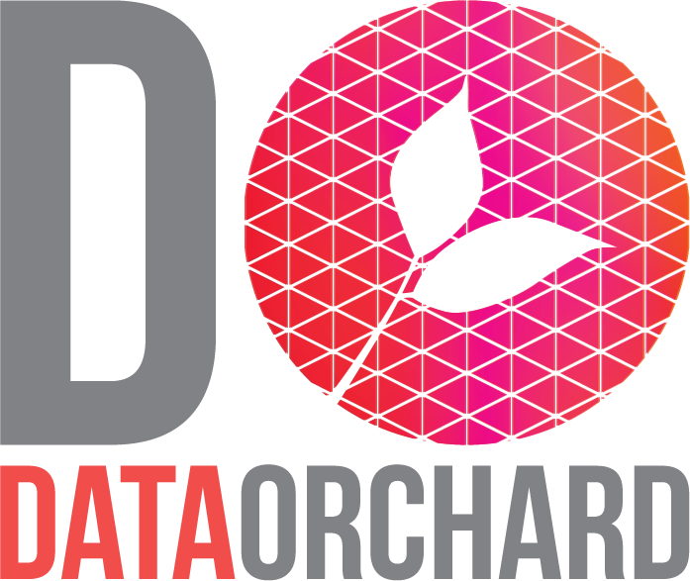

May 2026
Authored by Hannah Khwaja, Lindsay Hodgson
and Madeleine Spinks
info@dataorchard.org.uk

Data Strategy 2026-2029
for Children’s Hearings Scotland
About Data Orchard and Children’s Hearings Scotland
Data Orchard combines specialist skills in research, statistics, and data with a passion for making the world a better place socially, economically, and environmentally. Our mission is to enable every nonprofit organisation to use data effectively to achieve their goals.
Our services include research and analysis, data maturity assessment, data strategy, impact measurement, training, and capacity building. Since 2013, we’ve worked on hundreds of projects supporting more than 150 organisations to get better with data, resulting in better planning and decision-making, increased impact, and improved service design and delivery.
Children’s Hearings Scotland recruits, trains and supports around 2,300 volunteers who are key to the children’s hearings system, including Panel Members and Panel Practice Advisers. CHS works to ensure that hearings make child-centred decisions which respect and protect children’s rights and support them to thrive.
In this document, we provide a data strategy for Children’s Hearings Scotland, based on a programme of engagement carried out between January and March 2026.
The remainder of this report is written from Children’s Hearings Scotland’s perspective so that the content can be used for your own strategic document.
Contents
Introduction and purpose 3
Our vision for data 4
Our approach 4
Implementation 5
Governance 5
Conclusion 5
Our strategic roadmap: Principle 1 7
Our strategic roadmap: Principle 2 11
Our strategic roadmap: Principle 3 14
Our strategic roadmap: Principle 4 17
Appendix A: Information and Data Governance 20

Introduction and purpose
The development of Children’s Hearings Scotland’s first data strategy was an objective in the 2025-26 Business and Corporate Parenting Plan. The objective included the following aims:
- establish our future data needs and develop a pathway to meet those needs
- identify the required structure to deliver the strategy
- work with partners to develop effective data sharing practices.
In accordance with the 2024-27 Strategic Outlook, this strategy will establish the foundations for CHS to become a data-informed and data-driven organisation. Staff at CHS will be empowered to make data-driven decisions that use evidence to drive change and progress, create and communicate evidence-based insights, and demonstrate impact.
As with all our work at CHS, the data strategy is underpinned by our values (challenging, creative, child centred, respectful, fair, and open) and supports our ambitions across the three themes of Delivering Positive Outcomes, Valuing Our People and Driving Transformation. It sits alongside our Quality Strategy, Learning Strategy and Digital Strategy as well as the Vision for Public Sector Data in Scotland, supporting us to provide positive experiences for our volunteers and all infants, children and young people who experience the hearings system.
This strategy is informed by a comprehensive desk research and stakeholder engagement process carried out by Data Orchard CIC. This included an organisational data maturity assessment in spring 2024 and engagement with staff in January 2026 through key stakeholder interviews and purposeful workshops. Findings from the assessment and engagement showed that:
- Data is an organisational priority and leadership are engaged in harnessing its value, but there is room for further investment in data-related resources and more coherence in roles and responsibilities.
- Data held by CHS is secure, but fragmented, inconsistent, and often difficult to access for those who need it; as a whole, data assets are poorly understood across the organisation, and data quality needs monitored.
- Staff share and discuss data together, but it is not necessarily seen as a team effort.
- The organisation has room for improvement in terms of both specialist data skills and general data literacy.
- CHS is making some use of data to support services and operations, but there is room for improvement, particularly in relation to volunteers’ and children’s experiences and organisational efficiency.
- There is a general lack of understanding of and confidence in the digital tools at CHS.
- Data is analysed in useful and meaningful ways at CHS, but there are opportunities to increase the use of more advanced analytical techniques and automation.

Our vision for data
Our vision is that all staff at Children’s Hearings Scotland have access to high-quality data and are equipped with the skills to confidently use data to make informed decisions, evidence change and progress, and improve experiences for our volunteers and the children in the hearings system.

Our approach

Principle 1: We will take good care of our data
We will improve data governance and ensure that our policies, processes and tools effectively maintain the security and quality of our data. We will ensure we have clear records of what data we have, where it is held, how it should be used, who has access to it and who is responsible for it. We will agree what should be collected, define it clearly, input it consistently, and archive or dispose of it when no longer needed.

Principle 2: We will improve our data infrastructure
We will improve access to our data in our core hearings data management system and continue to work with partners to strengthen data sharing practices. We will improve the digital tools that hold core data and continue to review our tools where appropriate. We will develop methods for accessing, linking and integrating different datasets and across different tools to enable extraction of deeper and more meaningful insights.

Principle 3: We will use data to improve our work
We will use our data to deliver more efficient and effective services with greater impact. We will ensure that staff have access to relevant insights so that they can make informed decisions in their roles and reduce siloes by identifying opportunities for shared insights across functions. We will agree and execute priority data use cases and explore opportunities to use automation and/or AI to drive improvement. We will communicate insights effectively to external audiences, enabling us to clarify our role and purpose and demonstrate impact and change.

Principle 4: We will develop our data skills, confidence and culture
We will ensure we can get the best value from the data we have by creating learning plans and investing in skills development for a wide range of roles across the organisation, including senior leadership. As part of Principles 1 and 2, we will provide central resources that give all staff a clear shared overview of the organisation’s data, systems, and definitions. We will empower staff to use data themselves where appropriate with the support of a distributed community of data champions and a community of practice. We will also obtain additional specialist skills to help us govern and use data well. We will encourage the use of evidence in all roles across the organisation, including in the development of processes, policies, guidance, training and strategic planning. We will create time and space for reflection and sharing around data within existing meetings and working groups as well as in new spaces.

Implementation
The data strategy will be delivered through a series of tangible steps described in terms of a strategic roadmap. This is summarised in the diagrams on the following pages and supported by further detail on each step.
A roadmap is not the same as a plan. The roadmap shows the likely order and broad timescale for the steps but is subject to change as the organisation develops. Some steps might have to be delayed, while others might be brought forward as opportunities present themselves.
We have not used fixed timescales in the roadmap. This is to emphasise its provisional nature and the fact that steps may move as a result of changes across the organisation. That said, as a planning assumption, we have suggested the timeframe in which each activity will be completed in relation to year 1, year 2, and year 3 of this strategy.
The pathways in our roadmap are organised into 4 sections according to the principles identified in our approach: taking good care of our data, improving our data infrastructure, using data to improve our work, and developing our skills and confidence. These are visualised and broken down into more detailed steps over the following pages.

Governance
Delivering this strategy will require clear sequencing, alignment with corporate planning and investment decisions, and visible leadership. The monitoring of progress against our data strategy will be reviewed biannually by the leadership team, and the order and duration of steps may be redrawn when necessary.

Conclusion
This first data strategy for Children’s Hearings Scotland represents the start of a journey towards developing a data-informed and data-driven organisation. By the end of this strategic period in 2029, we hope to be in a position where:
- we have a good understanding of what data we have and who is responsible for it
- our infrastructure supports us to make good use of our data
- we are actively using trusted insights for decision-making
- and we are more confident, cohesive, and advanced in our use of data as an organisation.






Our strategic roadmap: Principle 1
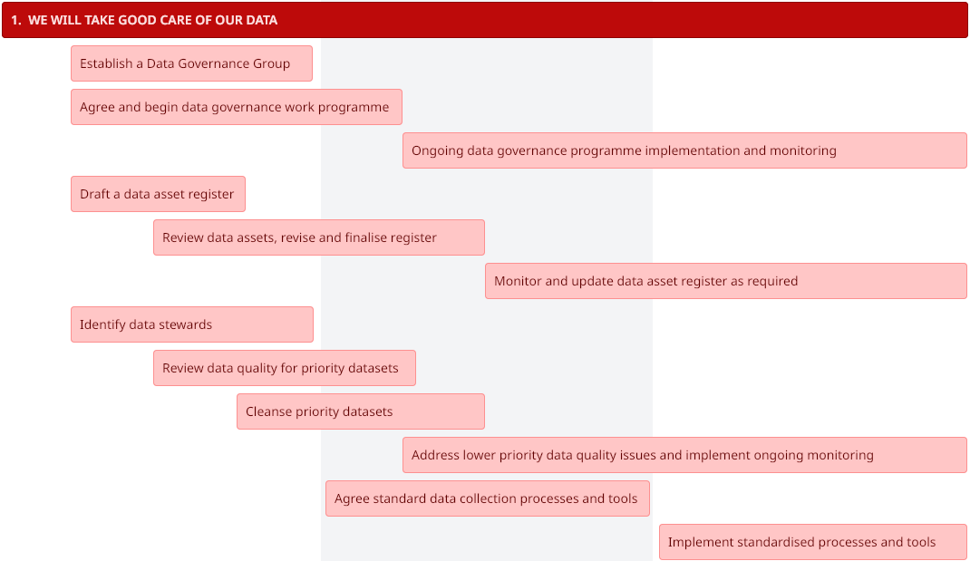

1. Taking good care of our data

1.1 Establish a Data Governance Group (Y1)
We will establish a Data Governance Group that is empowered to guide an organisation-wide approach to data and related infrastructure. Data, information and digital tools governance are intertwined so one group should have oversight of all these functions and key decisions, led by a director. Appendix A provides further explanation and comparison of these focus areas.

1.2 Agree and begin to implement a data governance work programme (Y1-Y2)
Data governance is a constant process. A work programme will ensure that we allocate an appropriate level of effort to the most critical areas at CHS. The programme will aim to provide assurance and improvement in the areas of processes, data access and security, quality, usability, data linkage and AI use. This will include a review of appropriate data related policies such as data protection, information security, user access management, artificial intelligence and data sharing and usage. Where there are trade-offs in terms of these areas, the Data Governance Group will decide on priorities.
The work programme will incorporate some of the steps in this data strategy, such as identifying data stewards, but will also be informed by the data quality review and the organisation’s risk register.

1.3 Ongoing data governance programme implementation and monitoring (Y2 onwards)
We will implement the governance programme and monitor progress on an ongoing basis.

1.4 Draft a data asset register (Y1)
A data asset register is a comprehensive register detailing dataset information, ownership, and usage guidelines. It will help identify and communicate what data exists across the organisation and what its purpose is. The initial process of drafting a data asset register will be used to inventory current datasets.
The register will answer the following questions:
- What is the dataset?
- What is its purpose?
- What can it be used for?
- Who is the data controller?
- Who is the data steward and who looks after it day-to-day?
- How big is it?
- Where is it stored?
- Who has access to it?
- Who can it be shared with?
- What types of data does it hold? (particularly personal or sensitive data)
- How/when should it be archived/deleted?
- What is the quality of the data?

1.5 Review data assets, revise and finalise the data asset register (Y1-Y2)
We will use the initial draft to make decisions about what data we might want to start, stop and continue collecting, where it is stored, and responsibilities and access permissions for each dataset. We will revise and finalise the register accordingly.
The data asset register will become embedded in data governance practices and routinely updated, maintained and reviewed by specified member(s) of staff. Importantly, it will help members of staff to locate datasets maintained outside their teams and request access to them when needed.

1.6 Monitor and update data asset register as required (Y2 onwards)
We will monitor and update the data asset register as and when required, ensuring that responsibilities for doing so are clear. We will also ensure that the design, hosting and content of the data asset register is iterated with opportunities for feedback to ensure it is clear and useful to staff across the organisation.

1.7 Identify data stewards (Y1)
Data stewards will be subject matter experts who are accountable for one or more data assets (or in some cases, a subset of a data asset). They define and control the data they are accountable for and monitor and improve its quality. Being a data steward is part of the responsibilities of a wider role in the delivery of services. We already have staff across the organisation who are informally undertaking this role; this process will make the responsibilities explicit. Data stewards will be identified in the data asset register, and the Data Governance Group will ensure there is a process to replace them when people leave the role. Support will be provided to ensure that data stewards are able to confidently fulfil their responsibilities.

1.8 Review data quality for priority datasets (Y1 – Y2)
The new data asset register can be used as the basis for a data quality review, focusing initially on priority datasets that:
- have been judged to be of low overall quality, or
- are important in terms of impact, or
- are crucial to running the business, or
- another reason decided by the Data Governance Group.
Stewards of the data assets in the data quality review will work to assess the quality of the data asset in the following ways:
- completeness (all the critical data required for a particular use is present and available to be used)
- uniqueness (the data is free of duplicates)
- consistency (the degree to which values in the dataset do not contradict other values representing the same entity)
- timeliness (the degree to which the data is available when it is most useful)
- validity (the extent to which the data conforms to the expected format, type, and range)
- accuracy (the degree to which values match reality – bias may impact accuracy)

1.9 Cleanse priority datasets (Y1-Y2)
Following a data quality review, the staff accountable for the data asset will agree an action plan with the Data Governance Group to identify how data quality can be improved and prioritise which data assets should be addressed first. This will require obtaining dedicated data quality skills and contractors to work on the prioritised datasets.

1.10 Address lower priority data quality issues and implement ongoing monitoring (Y2 onwards)
Staff accountable for the data asset will agree an action plan with the Data Governance Group to identify how data quality can be improved. The Data Governance Group will implement a data quality monitoring programme. This may require obtaining dedicated data quality skills.

1.11 Agree standard data collection processes and tools (Y2)
We will develop clear protocols for collecting and inputting data using consistent definitions and standards. This will be informed by the findings of the data quality review to ensure that quality issues are reduced going forward. As part of this process, we will review current digital tools and systems and assess whether they are fit for purpose, aligned across the organisation and what improvements can be made.

1.12 Implement standardised data collection processes and tools (Y3)
We will implement the protocols developed in 1.11 across the organisation.

Our strategic roadmap: Principle 2
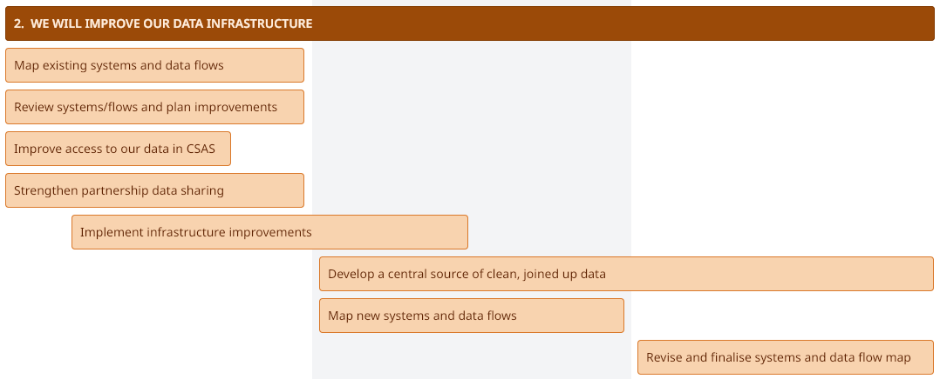

2. Improving our data infrastructure

2.1 Map existing digital systems and data flows (Y1)
We will develop an overview of the systems used across the organisation and how data flows between them. This will include where key datasets are stored, how data moves between systems and where manual processes or duplication currently occur.

2.2 Review systems and flows and plan improvements (Y1)
Data at CHS is currently held across several systems, including CSAS, CRM, our learning platform, G:Drive and a number of standalone operational systems. While these systems support key organisational processes, they operate largely independently and data is not consistently integrated across them. This can make it difficult to access data across systems and may require manual extraction or specialist knowledge to combine datasets for reporting and analysis.
We will develop a clearer plan for strengthening the organisation’s data infrastructure. Building on the systems and data flow mapping exercise, we will identify opportunities to improve how data is accessed, integrated and prepared for analysis across key systems.
This will include exploring options for improving relational access across CSAS databases, identifying opportunities to link operational systems such as CSAS, CRM and the learning platform, and linking with other relevant datasets. We will consider approaches to combining data across systems where this supports priority reporting and analytical needs.
This work will guide future improvements to data infrastructure and support the longer-term development of joined-up reporting and analysis.

2.3 Improve access to our data in CSAS (Y1)
We work closely with SCRA and rely on data within our shared system, CSAS, to support aspects of our operational and analytical work. We will improve our ability to access and analyse CHS data held within CSAS while ensuring that appropriate governance and security arrangements remain in place.

2.4 Strengthen partnership data sharing (Y1)
We will seek opportunities to strengthen partnership data sharing to enable us to better understand hearings operations and volunteers’ and children’s experiences and journeys where possible.

2.5 Implement infrastructure improvements (Y1-Y2)
We will take action to implement the infrastructure improvements identified in 2.2.

2.6 Develop a central source of clean, joined up data across different areas of the business (Y2-Y3)
We will create a unified, easy-to-access data environment with appropriate access rights, where data is cleaned and joined centrally ready for analysis. This environment will bring together data from key operational systems and provide a consistent source of trusted reporting data.

2.7 Map new digital systems and data flows (Y2)
We will update the map created in 2.1 following the implementation of infrastructure improvements.

2.8 Revise and finalise digital systems and data flow map (Y3)
We will finalise the map created in 2.1 following the implementation of infrastructure improvements. We will monitor and update the map as and when required going forward, ensuring that responsibilities for doing so are clear.

Our strategic roadmap: Principle 3

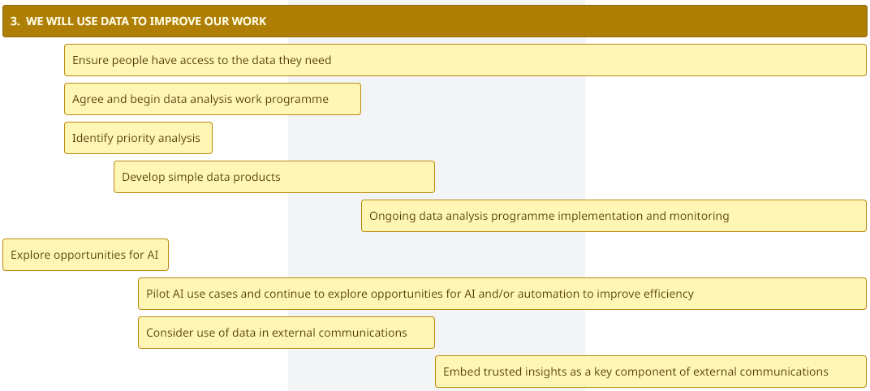

3. Using data to improve our work

3.1 Ensure people have access to the data they need (Y1 onwards)
Using the data asset register developed under Principle 1, we will review access to systems, datasets and reports for roles across the organisation. Our aim is to ensure that staff can access the information they need to perform their roles while maintaining appropriate governance and security controls. This will also reduce reliance on staff to pass on information.

3.2 Agree and begin implementation of a data analysis work programme (Y1-Y2)
The work programme will guide the work of the data team and other data specialist resource, enabling them to more easily prioritise their activities and helping CHS to understand demand and inform plans for improving data skills in the organisation.
It will also help the Data Governance Group to have visibility of what data requirements are likely to be surfaced and to ensure that such data is available at the appropriate quality.

3.3 Identify priority analysis (Y1)
We will grow the Data Action Stories drafted as part of the strategy development process to review and prioritise analysis needs. We will assess what data will be required to create each insight, any legal and ethical issues that might be involved in collecting or accessing this data, and what other enablers will be required to achieve the desired outcome, as per the LOTI Data Methodology framework. We will execute data use cases starting with the highest priorities and/or ‘quick wins’ (based on access to data and other barriers/enablers).

3.4 Develop simple data products (Y1-Y2)
In this context, a data product is a dashboard, report, chart or other object created by analysing some of the organisation’s data. Data products will be developed based on the priority use cases identified in 3.3. The types of analysis and insight that the organisation can make use of will evolve as staff become more familiar with what can be done in terms of data insights.

3.5 Ongoing data analysis programme implementation and monitoring (Y2-Y3)
We will continue to monitor and implement the data analysis programme established in 3.2.

3.6 Explore opportunities for AI (Y1)
As data infrastructure improves and datasets become more consistent and accessible, we will explore opportunities to use automation and artificial intelligence to improve operational efficiency and reporting. This may include automating routine reporting processes, identifying patterns in operational data, analysis of qualitative data or developing tools that support better forecasting and planning.

3.7 Pilot AI use cases and continue to explore opportunities for AI and/or automation to improve efficiency (Y1 onwards)
Pilot projects will be used to test priority use cases and ensure that any future adoption of AI is aligned with organisational needs and governance standards. We will continue to explore opportunities for AI and automation going forward.

3.8 Consider use of data in external communications (Y1-Y2)
We will review the use of insight and evidence in our external communications and seek to improve the frequency with which we do so, while ensuring that this is based on quality data.

3.9 Embed trusted insights as a key component of external communications (Y2-Y3)
As we improve our data quality and analysis, we will communicate insights effectively, enabling us to clarify our role and purpose and demonstrate impact and change. This will improve our influence in the sector as a trusted, evidence-based, impact-focused organisation.

Our strategic roadmap: Principle 4

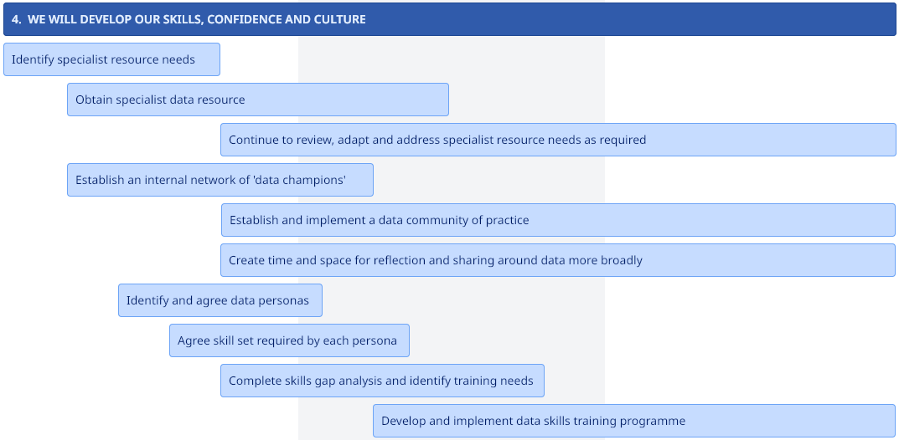

4. Developing our data skills, confidence and culture

4.1 Identify specialist resource needs (Y1)
It is likely we will require increased specialist capacity in data analysis, data governance, data engineering and data literacy training in order to meet our ambitions around data. We will consider how we can best meet these needs, including the potential for in-house roles, shared roles with partner organisations, contractors, and/or external consultants.

4.2 Obtain specialist data resource (Y1-Y2)
We will obtain the specialist resource identified in 4.1, prioritising data governance resource in the first instance.

4.3 Continue to review, adapt and address specialist resource needs as required (Y2 onwards)
We will review our specialist resource needs on an ongoing basis and address those needs as required.

4.4 Establish an internal network of ‘data champions’ (Y1-Y2)
We will identify and support an internal network of data champions in roles across the organisation to help support the use of data in different teams/functions and establish a community of practice. The champions are likely to include the data stewards identified as part of the data asset register development, but also individuals from across teams who work closely with data.

4.5 Establish and implement a data community of practice (Y1 onwards)
The data champions will establish and implement a community of practice that will meet regularly to share use cases and knowledge and consider the usefulness of data surgeries.

4.6 Create time and space for reflection and sharing around data more broadly (Y1 onwards)
We will work to utilise organisational space, such as the Quality Reference Group, and to create new spaces to reflect and share around data. The Quality Reference Group will be important in building a culture around data and evidence related to the hearings.
To maximise the value of data and analytics, it will be important to increase the level of comfort and confidence people find in sharing data, analysis, what is working and what they have learned openly (and by extension when things have gone wrong), so that things can be done differently in the future. This is an area where managers and leaders will have a big impact on the organisational culture. The data champions network will also be developed as a space for discussion.
The senior leadership team will encourage and support self-questioning and embrace the practice of working in the open, building in ways to learn from each other and hold each other to account. It takes time and concerted effort to move cultural norms, and we anticipate the need to focus on culture change for some time.

4.7 Identify and agree data personas (Y1-Y2)
We will develop a data skills framework that shows what skills are required by people in different roles in the organisation by using data personas. Using the Scottish Government data personas as a basis, we will identify and agree on data personas relevant to our staff, Clerks, and volunteers at CHS.

4.7 Agree skill sets required by each persona (Y1-Y2)
Once the personas have been identified, we will agree the set of skills that are required for each persona.

4.8 Complete skills gap analysis and identify training needs (Y1-Y2)
Using the data skills framework we have developed, it will be possible to compare the skills of people in each persona to the skills the organisation has identified as necessary for that persona. Where there is a gap identified, this will inform training plans.

4.9 Develop and implement a data skills training programme (Y2-Y3)
The data skills training programme will need to address the skills gaps identified in the data skills gap analysis as well as ensure that as people join the organisation and change roles, they can access training that meets their needs. The programme will mix in-house content, mentoring and learning with training accessed from specific training suppliers. For example, informal data surgeries could be developed using data champions/data stewards to coach people in their service areas to make the best use of data.
Training should ideally be implemented for managers, leads and senior leaders as a first priority to ensure that they are then in the best position to demonstrate the importance of data and skills development, support their teams to develop, and harness their new skills.
We will develop an induction module/centralised resource that provides an overview of the organisation’s data and systems, supporting both new and existing staff to understand the role of data in CHS’s work.

Appendix A: Information and Data Governance

Information Governance (IG)
Primary focus: Compliance, legal obligations, security, and risk management.
Key question IG asks: “Are we protecting and managing information responsibly and legally?”
Typical concerns
- Privacy and GDPR compliance
- Information security
- Records management
- Freedom of Information requests
- Retention and disposal policies
- Information classification
Typical artefacts
- Information Asset Register
- Retention schedules
- Information classification policies
- Data protection impact assessments (DPIAs)
Typical roles
- Information Asset Owner (IAO)
- Data Protection Officer (DPO)
- Information Governance Manager

Data Governance (DG)
Primary focus: Managing data as an asset for operational and analytical use.
Key question DG asks: “Is our data reliable, well defined, and usable?”
Typical concerns
- Data quality
- Data definitions and standards
- Data ownership and stewardship
- Metadata and lineage
- Data catalogues
- Data sharing and access
Typical artefacts
- Data asset register
- Data catalogue
- Business glossary
- Data quality metrics
- Data lineage maps
Typical roles
- Data Owner
- Data Steward
- Data Governance Lead
- Data Architect

Roads and traffic analogy
Information Governance =  The Traffic Laws  Sets the rules everyone must follow to stay safe and lawful. | Data Governance =  The Road Signs and Maps  Helps people understand where things are and how to get there. | Data Management = Building and Maintaining the Roads  Helps keep data flowing and prevents accidents.
Purpose:  Prevent harm, protect people, and ensure compliance. | Purpose:  Help people navigate data confidently. | Purpose:  Make sure the system physically works.
Examples:  - Speed limits  - Drink-driving laws  - Seatbelt rules  - Vehicle safety standards | Examples:  - Road signs  - Street names  - Maps and sat-nav  - Lane markings | Examples:  - Building roads  - Fixing potholes/blockages  - Maintaining bridges  - Installing traffic lights
In organisations it covers:  - GDPR  - Information security  - Records retention rules  - FOI obligations  - Information classification | In organisations it covers:  - Data catalogues  - Business glossaries  - Data definitions  - Data ownership  - Data quality standards | In organisations it covers:  - Databases  - Data pipelines  - Integration  - Storage platforms  - Data engineering


Data Orchard CIC, Lower House Business Park, Staunton-on-Wye, Herefordshire. HR4 7LR.
Company Number: 08674626 | Information Commissioner’s Office Registration Reference: ZA045001 | VAT number: 239272885

