CHS Digital Priorities 2026 - 2027
Foreword

CHS are in a period of transformational legislative and non-legislative reform which will be understood in detail through 2026/27. This priority document therefore focusses on single year activity in 2026-27 to enable development of a longer-term strategy aligned to reform; the new CHS Data Strategy, and CHS’ longer term strategic outlook, which will all be developed in 2026/27.

The digital landscape is evolving and continually transforms the potential for how organisations work. As we look to the future, our digital journey must accelerate to enable CHS to fulfil its statutory functions; take forward reforms to meet the needs of the Promise, providing systems and tools that enable life-changing decisions for children every day through the Children's Hearings System. We are committed to building a resilient, user-centred, and innovative digital organisation. The priorities for 2026/27 outlines how we are developing our capabilities, strengthening our infrastructure, and leveraging both data and artificial intelligence to build strong foundations that better serve our stakeholders and deliver reform. Our focus will be on achieving Best Value, in line with expectations of Public Service Reform.

Successful digital transformation requires more than technological investment, it requires understanding of stakeholder needs, streamlined organisational processes, and a focus on creating integrated platforms that facilitate engagement, learning, and preparation. These priorities address the foundations of these dimensions through a user centred approach which continues to build organisational capability and value.

Strategic Alignment

This single year digital priorities are aligned with the Children's Hearings Scotland Strategic Outlook 2024 – 2027:

Our purpose is to ensure our hearings make child-centred decisions which respect and protect children’s rights and support them to thrive.

Our vision is for all infants, children, young people and their families to be safe, loved, and supported to realise their full potential.

Our Strategic themes:

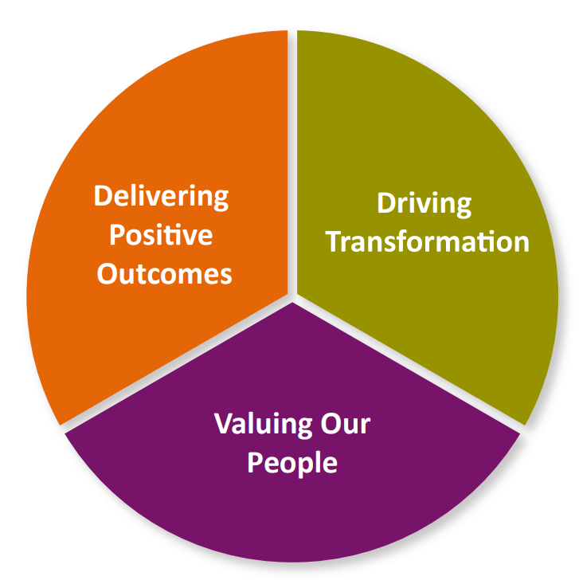
Our priorities in 2026/27:

Strengthen leadership capability/capacity Shaping our digital future
Delivering innovation in learning Planning for reform

Our Aims 2026/27

  - 1. Invest in Digital Architecture that provides flexible, cost-effective foundations for future reforms
We will strengthen our digital infrastructure to support the effective implementation of reforms:
- We will continue to develop CSAS, the data platform we share with SCRA to consolidating this as our core data centre for hearings information.
- We will further develop our @chscotland tenancy to maximise potential for cost effective and flexible development more closely connected to CSAS services and our core data centre.
- We will strengthen security and compliance of our @chscotland platform to enable us to transfer digital information between our systems, to ensure our data is accurate and easy to use and analyse.
- We will work with Learning colleagues to identify the technology and systems we need to put in place to meet our digital learning ambitions

  - 2. Embrace new technology to enable Insight, Innovation, and Efficiency
Aligned to the CHS Data Strategy (in development), we will transform how we use data and artificial intelligence tools and machine learning to drive evidence-based decision-making, improve services and efficiency by:
- Working with SCRA to widen and maximise CHS access to hearings system data that will enable us to drive improvement and efficiency
- Utilising people skills and technological tools to analyse CHS core hearings data to drive improvement and efficiency.
- Exploring use of AI tools and Machine Learning to support Quality Assurance and process driven operational activity i.e Rota Management
- Exploring use of AI tools such as Co-pilot to drive business efficiency
- Exploring AI-powered support to provide 24/7 assistance while reducing staff workload

  - 3. Build Strategic Digital Capacity
We will develop the organisational capabilities needed to deliver effective digital services and manage our own platforms by:
- Building Digital Leadership and resources required to meet current and future digital and data requirements.
- Continuing to build skills and processes that support compliance such as ISO27001
- Establishing robust product management frameworks aligned with government digital standards
- Building user research and engagement capabilities

  - 4. Continue to develop our digital offer to staff and volunteers
Drive security, efficiency and improvement through provision of hardware and software that meets user needs:
- Work with ITECs to maximise use of SCOTs available tools to drive National Team efficiency
- Expand Windows device offer to CHS community, enabling inclusive secure, user friendly, access to CHS systems and driving efficiency through centralised security and controls.
- Enable a pipeline of continuous improvement of CHS digital services based on user feedback

5. Strengthen Governance, Security and Support
We will enhance our ability to protect information assets and support users while optimising resources:
- Achieving ISO27001 certification by strengthening our ability to keep systems and data safe in a structured, organised way.
- Implementing comprehensive automated device management across Windows devices
- Building internal capabilities to support and manage our connected system of Microsoft tools
- Creating automated workflows for common support tasks and device custody changes
- Aligned to the Strategic Planning and Delivery function, review current governance approaches and develop proportionate, business integrated governance structures for technology, data, and AI oversight

  - 6. Create a Digital Strategy Fit for a transformed Hearings System
Develop a Digital Strategy aligned to CHS Strategic outlook from 2027 onwards that will enable CHS to deliver against required reforms utilising transformational tools and technology that will derive Best Value for the hearings system:
- Considering Digital Leadership and resources required to meet current and future digital and data requirements.
- Work with SCRA and Hearing System Partners to identify opportunities for joint strategic planning and development to maximise ROI and impact of reforms

Our Principles
Our digital priorities are guided by five high-level, core principles that shape our approach and decision-making:
First, Do No Harm
- We ensure that any digital changes or implementations protect the integrity of the Children's Hearings System and never compromise CHS’ staff and community ability to fulfil their vital role. We will carefully assess potential impacts before making changes, prioritising continuity of essential services and volunteer support.

User-Centred Design
- We place users at the heart of everything we do, designing services based on genuine understanding of user needs and continuously improving them based on user feedback.

Security by Design
- We embed security considerations from the start of any digital initiative, ensuring that protecting information and maintaining privacy are fundamental aspects of our approach.

Data-Driven Decision Making
- We make decisions based on evidence and insights derived from data, building the capabilities to collect, analyse, and act on data responsibly.
Sustainable Capability Building
- We focus not just on implementing technologies but on building the skills, processes, and culture needed to sustain digital transformation for the long term.

These principles will guide our implementation approach, helping us make consistent decisions aligned with our strategic direction.

